Autumn 2 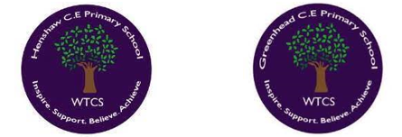
Year 3.4
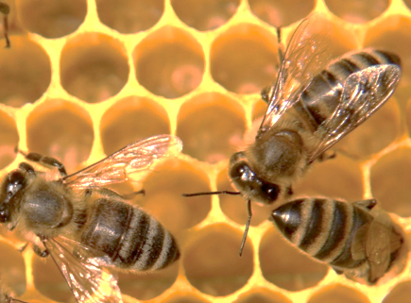
Food, Farming and Bees
Year 3: Foundational Skills (Food, Farming and Bees)
- Location: I can give examples of where food in the UK originates and use a map to illustrate these examples.
- Mapping & Tech: I can explore geographical locations on a map and describe where different food sources are located compared to my local area.
- Characteristics: I can describe the three main farming types in the UK: arable, pastoral, and mixed.
- Habits & Change: I can describe how family food habits have changed since the 1950s and give simple reasons for these changes.
- Settlement: I can talk about the simple reasons why people choose to make settlements in specific areas linked to farming and food production.
- Change & Legacy: I can identify the job of an environmental geographer and know that Diane Borden explores the geography of pollinators.

Golden Geographical Threads
- Where is the location of this learning sequence compared to other places I have studied? What does it look like on a map?
- Why do people make settlements in this place?
- How has this environment changed over time?

Autumn 2
Year 3.4
Food, Farming and Bees
Year 4: Complex and Comparative Skills (Food, Farming and Bees)
- Location: I can describe the location of farming regions in relation to other places I have studied and explain what these look like on a map.
- Mapping & Tech: I can use fieldwork techniques to evaluate the suitability of my school grounds for pollinators like bees.
- Characteristics: I can explain the specific ways that science and technology are changing different farming types in the UK today.
- Habits & Change: I can explain how changes to farming practices have increased food production while evaluating the negative effect this has had on pollinators through the use of pesticides and insecticides.
- Settlement: I can explain the specific geographical reasons why people originally chose to make settlements in certain regions and describe in detail how the environment has changed over time.
- Change & Legacy: I can explain exactly how Diane Borden explores the geography of pollinators and describe the importance of the work done by environmental geographers in protecting our world
Golden Geographical Threads
- Where is the location of this learning sequence compared to other places I have studied? What does it look like on a map?
- Why do people make settlements in this place?
- How has this environment changed over time?

