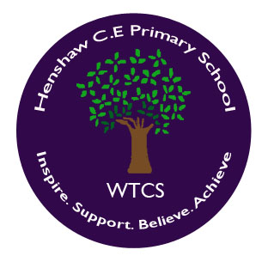
Welcome to Reception!
At our school we are known as Tyne Class. Our teaching team is made up of caring and experienced staff who have a passion for Early Years. Mrs Hulbert is Early Years Lead across our Federation and works three days a week. Miss Thompson is a class teacher and works two days a week at Henshaw and three days a week at Greenhead. The children spend one afternoon a week with Mrs Bowes, the Henshaw Nursery Manager. Children also benefit from sessions with NUFC doing Commando Joe’s, every other half term.
At Henshaw School we aim to provide the highest quality care and education for all our children therefore giving them the strong foundation for their future. We aim to ensure that all our children develop into independent and lifelong learners.
During our time in Reception class we learn the importance and joy of being part of our school community, by joining in with school routines and events. By the end of the year we are confident, independent and firmly established within school life.
Beginning School
We know how important it is for your child to feel happy and secure during the time they are in school. We are very proud of the excellent relationship that we have with Henshaw Nursery and work closely with them throughout the year.
During the summer term we invite all children, who will be starting in the September, to attend a range of transition sessions. This helps the children become more familiar with us and the setting so that when they start in September they are completely prepared and settle quickly.
Parents will also be invited into school towards the end of July to meet Mrs Hulbert and Miss Thompson, to learn more about what their child will be doing in school once they start and to buy uniform ready for September.
Curriculum
We provide a progressive curriculum which ensures our children are ready for transition into Year 1 at the end of the year. Our Long Term Curriculum plan shows how we ensure our curriculum is broad and balanced. We have topics in mind for each half term but we follow the childrens’ interests.
Our Reception class follows the curriculum as outlined in the Statutory Framework for the Early Years Foundation Stage. The EYFS is based on seven key features of effective practice as set out in Development Matters 2020. Please see the attached EYFS Policy for further information regarding our curriculum.
Our EYFS policy will also provide you with information regarding:
- inclusion
- assessment
- transition
- health and safety and safeguarding
- home/school links
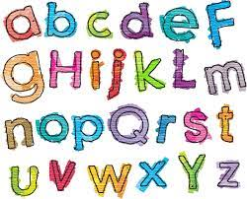
How can parents help?
Phonics
At Henshaw we follow the Read Write Inc phonics programme. Lots of useful information and resources can be found at OxfordOwl.co.uk. This explains clearly how the RWI programme works and we would encourage you to have a look.
Reading
Reading is ever so important and highly valued. We encourage you to share books with your child as often as possible. This helps your child in so many ways including:
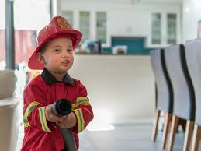
- improvement in cognitive and language skills
- developing vocabulary
- developing listening skills
- improving attention span
- learning life lessons
- improving speech and language
- developing creativity
- social and emotional development
Your child will be sent home with a school reading book along with a reading record. Please encourage your child to read daily if possible. Please record each time you read with your child. This can just be a page or two. It is really beneficial for your child to read the book several times during the week before it is changed. Please send your child’s book and reading record into school each day so we can also read with your child.
Most children will start with a picture book. Please talk to your child about what is happening in the pictures. You can ask questions about the story such as:
What do you think might happen next?
What happened first, next, last etc?
What characters were in the story? What names would you give them? What did the characters do?
What happened in the story?
How were the characters feeling?
Word books will be given when your child in confident in their knowledge of the first set of RWI phonics sounds and has practised lots of blending and segmenting in class. Children will be practising how to say each sound (not the letter names) and then blend the sounds together to make words.
Writing
- Encourage and celebrate all mark making e.g. this could be a shopping list your child has ‘written’ which you can chat about together or a picture of a recent outing.
- Please encourage correct ‘pinchy pinchy’ pencil grip and letter formation.
- Children can practise writing their name using correct letter formation.
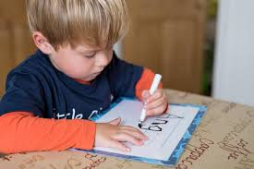
- Practise fine motor skills activities (these are activities that strengthen the muscles in your child’s fingers in order for them to be able to have the finger strength and pressure to write).
Maths
In Reception we use the Mastery approach to teach maths. Mastering maths means pupils acquire a deep, long-term, secure and adaptable understanding of the subject. Everyone is a mathematician.
Make the most of real-life situations to practise maths with your child e.g. counting tins at the supermarket, measuring ingredients, looking for numbers and shapes in their environment, laying the table. Sing lots of number songs. Play number games – practising matching, sorting, 1:1 counting, ordering.
We invite parents in for information meetings at the beginning of the school year to further explain how we teach phonics, reading, writing and maths and to show you how you can support your child at home with this.
School 360 – Busy Things
Children will be introduced to this wonderful resource at school and log in details and further information will be sent home at the beginning of the academic year. Busy Things provides a whole host of activities which your child will love and which will support them with their learning and development.
Rewards and sanctions
There is lots to learn in Reception and we are all about positive reinforcement. We praise and celebrate all that is good. This might be verbally, by giving a sticker (which the children love!), a bit of extra playtime, a class round of applause, etc. We have a traffic light system in class to support children with their behaviour in a positive way. Each week we hold a celebration assembly where children are given certificates relating to the areas of our school promise. This can be given for all sorts of achievements e.g. being a great friend, helping to tidy up, super listening, a super piece of work…
Northumberland School Readiness Passport
If your child has already attended a pre-school setting in Northumberland you may already be aware of the Passport which is used to gather information about key events in a child’s early life. In Reception we continue to use this system to monitor and document your child’s developments and to ensure they are on track.
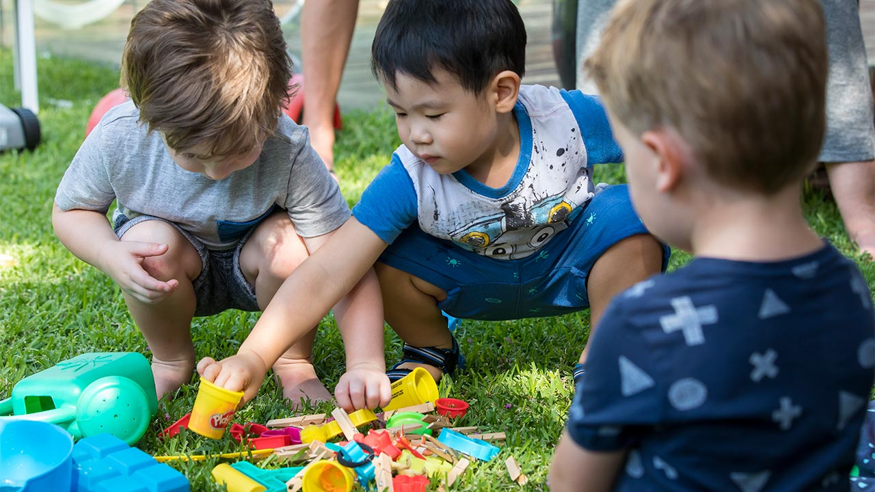
We are very proud of everything we do in Reception and love watching our children grow and become part of our wonderful school.

