Autumn 1 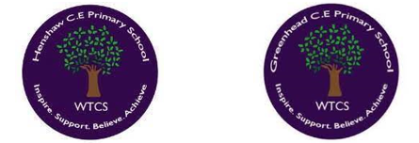
Year 5.6

God: What does it mean if Christians believe God is holy and loving?
Year 5: Foundational Skills
- Bible Timeline: I can place and order at least five key concepts within the timeline of the Bible’s ‘big story’.
- Biblical Texts: I can identify and explore at least five different types of biblical texts, such as a psalm, Gospel, story, or letter (including John 4:7-13 and Isaiah 6:1-5).
- Cathedrals & Worship: I can describe how the architecture and features of cathedrals show what Christians believe about God.
- Humanist Guidelines: I can suggest simple guidelines that Humanists might follow for living, particularly those linked to love, holiness, or justice.
- Thread Connection: I can identify how learning about God's holy and loving nature helps Christians feel a sense of belonging in their church community.
Golden RE Threads
- Belonging and community – How does learning in this theme help followers to feel belonging and a sense of community?
- Connection to our Christian Values – Which of our Federation Christian Values does learning in this theme show?
- Treating others with respect and understanding – What lessons can be learnt from learning in this theme about treating others with respect and understanding?

Autumn 1
Year 5.6
God: What does it mean if Christians believe God is holy and loving?
Year 6: Complex and Comparative Skills
- Timeline Synthesis: I can analyze the connection between five key concepts across the Bible's 'big story' timeline and explain how they build upon one another.
- Textual Analysis: I can explain the unique literary styles and theological purposes of different biblical texts, comparing passages like John 4:7-13 and Isaiah 6:1-5.
- Sacred Architecture: I can explain in detail how specific cathedral features—such as stained glass windows telling stories or the altar representing sacrifice—show that God is worth worshipping.
- Comparative Ethics: I can evaluate the similarities and differences between Christian guidelines and Humanist ethical guides for living.
- Thread Evaluation: I can evaluate how beliefs about God's holiness and love foster a global community of belonging and teach us to treat others with respect and understanding.
Golden RE Threads
- Belonging and community – How does learning in this theme help followers to feel belonging and a sense of community?
- Connection to our Christian Values – Which of our Federation Christian Values does learning in this theme show?
- Treating others with respect and understanding – What lessons can be learnt from learning in this theme about treating others with respect and understanding?

Autumn 2
Year 5.6
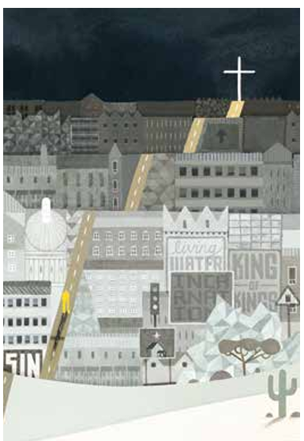
Incarnation: Was Jesus the Messiah?
Year 5: Foundational Skills
- Messianic Clues: I can identify clues in the Gospels of Matthew (such as Matthew 1:18-24 and 2:1-12) that suggest Jesus is the promised Messiah.
- Jewish Expectations: I can describe what the Jewish people expected in a Messiah and represent this using creative ideas like a wanted poster or a radio advert.
- Messiah Evidence: I can identify simple evidence showing that Christians believe Jesus was indeed the Messiah.
- Christmas Message: I can offer simple suggestions about ways to share the true Christian meaning of Christmas with others.
- Personal Reflection: I can express my own ideas about whether the world needs a Messiah today.
- Connections: I can identify basic connections between biblical texts, the Incarnation, and the concept of the Messiah.
Golden RE Threads
- Belonging and community – How does learning in this theme help followers to feel belonging and a sense of community?
- Connection to our Christian Values – Which of our Federation Christian Values does learning in this theme show?
- Treating others with respect and understanding – What lessons can be learnt from learning in this theme about treating others with respect and understanding?

Autumn 2
Year 5.6
Incarnation: Was Jesus the Messiah?
Year 6: Complex and Comparative Skills
- Scriptural Analysis: I can analyze and evaluate how Matthew 1:18-24 and Matthew 2:1-12 serve as foundational scriptural evidence for the belief that Jesus is the Messiah.
- Contextual Expectations: I can explain the historical and religious reasons why Jewish people expected a certain type of Messiah, using creative mediums to show these complex expectations.
- Living the Message: I can design and justify an effective campaign to communicate the core Christian message of Christmas to a modern audience.
- Philosophical Reflection: I can construct a structured, reasoned argument evaluating whether the world needs a Messiah today.
- Theological Connections: I can explain the complex theological connections between prophecy, the Incarnation, and the Messiah, and evaluate how this learning teaches respect and understanding.
Golden RE Threads
- Belonging and community – How does learning in this theme help followers to feel belonging and a sense of community?
- Connection to our Christian Values – Which of our Federation Christian Values does learning in this theme show?
- Treating others with respect and understanding – What lessons can be learnt from learning in this theme about treating others with respect and understanding?

Spring 1
Year 5.6

Gospel: What would Jesus do?
Year 5: Foundational Skills
- Gospel Features: I can identify different features of Gospel texts, such as teachings, parables, and narratives.
- Gospel Meanings: I can suggest simple meanings of studied Gospel texts, including The Wise and Foolish Builders (Matthew 7:24–27), elements of The Sermon on the Mount (Matthew 5–7), and The Centurion’s Servant (Luke 7:1–10).
- Christian Interpretation: I can identify how Christians use Gospel texts as a foundation for living, and how organizations like The Leprosy Mission put these teachings into action.
- Good News: I can describe how Gospel texts represent Jesus' 'good news' of peace, forgiveness, and healing.
- Personal Connection: I can relate these biblical concepts to issues of peace, forgiveness, and healing in my own life and community.
Golden RE Threads
- Belonging and community – How does learning in this theme help followers to feel belonging and a sense of community?
- Connection to our Christian Values – Which of our Federation Christian Values does learning in this theme show?
- Treating others with respect and understanding – What lessons can be learnt from learning in this theme about treating others with respect and understanding?

Spring 1
Year 5.6
Gospel: What would Jesus do?
Year 6: Complex and Comparative Skills
- Gospel Analysis: I can analyze and compare the distinct features of Gospel texts, explaining how teachings, parables, and narratives convey different messages.
- Theological Interpretation: I can explain the deeper theological meanings of Matthew 7:24–27, Matthew 5–7, and Luke 7:1–10, and discuss how they define Christian ethics.
- Critical Comparison: I can compare my own interpretations of Gospel texts with the ways Christians historically and practically interpret them to guide modern actions, such as the work of The Leprosy Mission.
- Synthesis of Good News: I can explain the deep theological connections between Gospel teachings and the concept of Jesus’ ‘good news’.
Golden RE Threads
- Belonging and community – How does learning in this theme help followers to feel belonging and a sense of community?
- Connection to our Christian Values – Which of our Federation Christian Values does learning in this theme show?
- Treating others with respect and understanding – What lessons can be learnt from learning in this theme about treating others with respect and understanding?

Spring 2
Year 5.6

Islam: What does it mean for Muslims to follow God?
Year 5: Foundational Skills
- Core Beliefs: I can identify and describe some of the core beliefs of Muslims, such as Muhammad as the Messenger and the Qur’an as the message.
- Five Pillars: I can name the Five Pillars of Islam (Shahadah, Salat, Sawm, Zakat, and Hajj) and describe what they mean to Muslims.
- Challenges: I can identify simple challenges that Muslims might face when trying to follow the Five Pillars in Britain today.
- Regional Comparisons: I can describe some similarities and differences between the lives of Muslims in the Northeast of England and those living in the United Arab Emirates.
- Mosques: I can identify different mosques around the world and describe how their simple features reflect Muslim beliefs.
Golden RE Threads
- Belonging and community – How does learning in this theme help followers to feel belonging and a sense of community?
- Connection to our Christian Values – Which of our Federation Christian Values does learning in this theme show?
- Treating others with respect and understanding – What lessons can be learnt from learning in this theme about treating others with respect and understanding?

Spring 2
Year 5.6
Islam: What does it mean for Muslims to follow God?
Year 6: Complex and Comparative Skills
- Theological Core: I can explain the spiritual and theological significance of core Muslim beliefs, including the authority of the Qur’an and the role of Muhammad.
- Systemic Living: I can analyze why the Five Pillars of Islam are central to a Muslim's identity and explain their spiritual and practical importance.
- Critical Evaluation: I can evaluate the complex socio-cultural challenges Muslims face when practicing the Five Pillars in modern British society and suggest how they overcome them.
- Comparative Geography: I can provide a detailed comparative analysis of how geographic and cultural environments shape the lives of Muslims in the Northeast of England versus the United Arab Emirates.
- Architectural Symbolism: I can explore diverse mosques around the world and explain exactly how their design, art, and architecture reflect core Muslim beliefs.
Golden RE Threads
- Belonging and community – How does learning in this theme help followers to feel belonging and a sense of community?
- Connection to our Christian Values – Which of our Federation Christian Values does learning in this theme show?
- Treating others with respect and understanding – What lessons can be learnt from learning in this theme about treating others with respect and understanding?

Summer 1
Year 5.6

Thematic: Why is pilgrimage important to some religious believers?
Year 5: Foundational Skills
- Defining Pilgrimage: I can describe what a pilgrimage is and name a significant destination for at least two groups (such as the Ummah in Islam or Mary in Roman Catholic Christianity).
- Pilgrimage Actions: I can identify specific actions that happen during a pilgrimage, such as praying at the shrine of St Bernadette of Lourdes.
- Life Impact: I can describe simple ways that going on a pilgrimage might change how a person chooses to live.
- RE Threads: I can identify how travelling together on a pilgrimage helps religious believers feel a sense of belonging to a wider global community.

Golden RE Threads
- Belonging and community – How does learning in this theme help followers to feel belonging and a sense of community?
- Connection to our Christian Values – Which of our Federation Christian Values does learning in this theme show?
- Treating others with respect and understanding – What lessons can be learnt from learning in this theme about treating others with respect and understanding?

Summer 1
Year 5.6
Thematic: Why is pilgrimage important to some religious believers?
Year 6: Complex and Comparative Skills
- Pilgrimage Theology: I can explain the profound spiritual importance of pilgrimage to religious believers, linking it to the concepts of the Muslim Ummah and Marian devotion in Roman Catholic Christianity.
- Ritual Symbolism: I can analyze the symbolic meanings behind specific pilgrimage rituals, such as the prayer and reflection that take place at the shrine of St Bernadette of Lourdes.
- Comparative Analysis: I can evaluate and compare how different religious believers undertake pilgrimages and analyze the lasting impact of these journeys on their daily values and lifestyles.
- RE Threads Evaluation: I can evaluate how the shared hardships and goals of a pilgrimage build an international community of belonging, and discuss how these journeys teach respect and understanding for other cultures.

Golden RE Threads
- Belonging and community – How does learning in this theme help followers to feel belonging and a sense of community?
- Connection to our Christian Values – Which of our Federation Christian Values does learning in this theme show?
- Treating others with respect and understanding – What lessons can be learnt from learning in this theme about treating others with respect and understanding?

Summer 2
Year 5.6
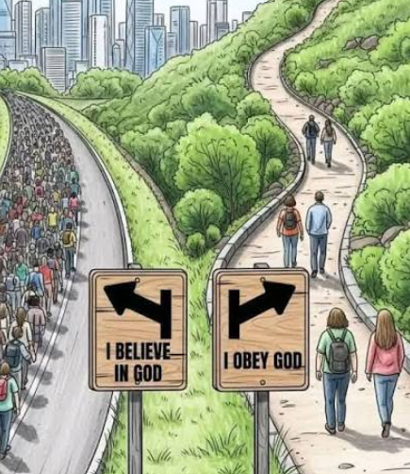
Thematic: Why do some people believe in God and some people not?
Year 5: Foundational Skills
- Vocabulary: I can define the terms 'theist', 'atheist', and 'agnostic' and identify basic statements that represent each viewpoint.
- Nature of God: I can describe what God is believed to be like by followers of the three Abrahamic faiths: Christianity, Judaism, and Islam.
- Belief Reasons: I can list simple reasons why some people choose to believe in God and why others do not.
- Disagreement: I can identify that even within the same religion (such as Christianity), people can disagree about what God is like, such as having different ways to interpret Genesis.
- RE Threads: I can discuss how people with different beliefs about God can still live together as a supportive school community.
Golden RE Threads
- Belonging and community – How does learning in this theme help followers to feel belonging and a sense of community?
- Connection to our Christian Values – Which of our Federation Christian Values does learning in this theme show?
- Treating others with respect and understanding – What lessons can be learnt from learning in this theme about treating others with respect and understanding?

Summer 2
Year 5.6
Thematic: Why do some people believe in God and some people not?
Year 6: Complex and Comparative Skills
- Philosophical Terms: I can explain the philosophical differences between being a theist, atheist, and agnostic, and analyze the reasoning behind statements reflecting these stances.
- Comparative Theology: I can compare and contrast the concepts of God held by Christians, Jews, and Muslims, highlighting key similarities and differences in their understandings.
- Critical Evaluation: I can evaluate the complex philosophical, personal, and scientific arguments that people use to explain why they do or do not believe in God.
- Interpretive Diversity: I can analyze and provide evidence of how Christians hold diverse theological views about the nature of God, specifically evaluating different interpretations of the Genesis creation account.
- RE Threads Evaluation: I can evaluate how exploring different worldviews helps us build a community of belonging and teaches us to treat people of all faiths or no faith with respect and understanding.
Golden RE Threads
- Belonging and community – How does learning in this theme help followers to feel belonging and a sense of community?
- Connection to our Christian Values – Which of our Federation Christian Values does learning in this theme show?
- Treating others with respect and understanding – What lessons can be learnt from learning in this theme about treating others with respect and understanding?

