Summary of School Packed Lunch Policy for Parents/Carers

Why?
- At the West Tyne Church Schools Federation, we believe our pupils should have a say in what they eat and give them the opportunity to look after their health, now and in the future. Over the past term, our School Council has led on the content of this policy; investigating what we do currently and what they think (in consultation with their classes) our packed lunches should contain.
- In partnership with families, we need to educate our pupils about healthy eating and healthy lifestyles. We are required to make sure children eat healthily when they are at school and this is an important aspect of our Healthy Schools Award.
- There is increased evidence that childhood obesity is increasing and complications associated with this makes children prone to a range of problems/illnesses.

Health effects of a poor diet/being an unhealthy weight include:
- Poor growth
- Obesity
- poor concentration and behavioural problems, which may have an impact on a child’s learning.
- Type 2 diabetes
- Tooth decay
- Increased risk of picking up illnesses (which affects attendance)
- Lack of energy and poor concentration (which affects learning)

During School Council sessions and in discussions thereafter with their class cohort, our children have agreed these guidelines for packed lunches:

Things we would like to see:  - A balance of different foods  - Yoghurts and cheese  - At least two pieces of fruit and/or vegetables  - Crisps which are baked and not fried  - Water or sugar free cordial  - Healthy sandwich fillings, eg cheese, tuna, ham, chicken  - Pasta  - Rice | These items are NOT allowed:  - Fizzy drinks or sugary juice (e.g. Prime)  - Sweets (including fruit winders)  - Chocolates bars  - Yoghurts with sweets in them  - Chocolate spread in sandwiches  - No nuts of any description  Waste and Disposal  The school will send any uneaten packed lunch food items back home. The rationale for this is that parents can also monitor what their child has consumed during the day and then raise any concerns over their child’s food intake with the school.
Only 1 of these items:  - A small chocolate biscuit (not a chocolate bar)  - Small cake |  | Have you thought of trying these?  - Raisins or other dried fruit  - Crackers and Cheese  - Soup  - Breadsticks

Suggested packed lunches the school council have found and we would like to see…
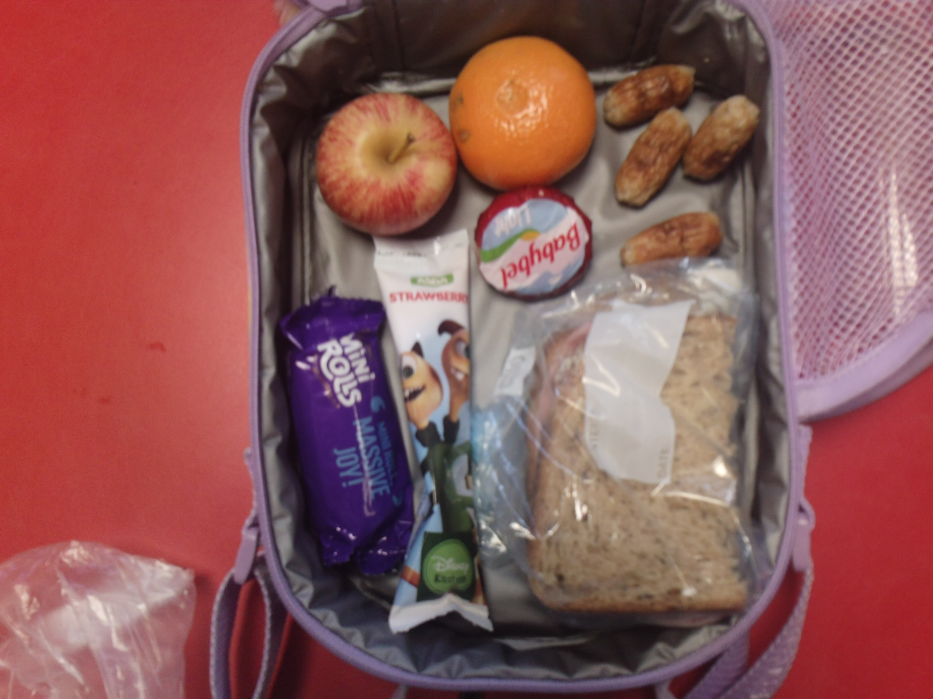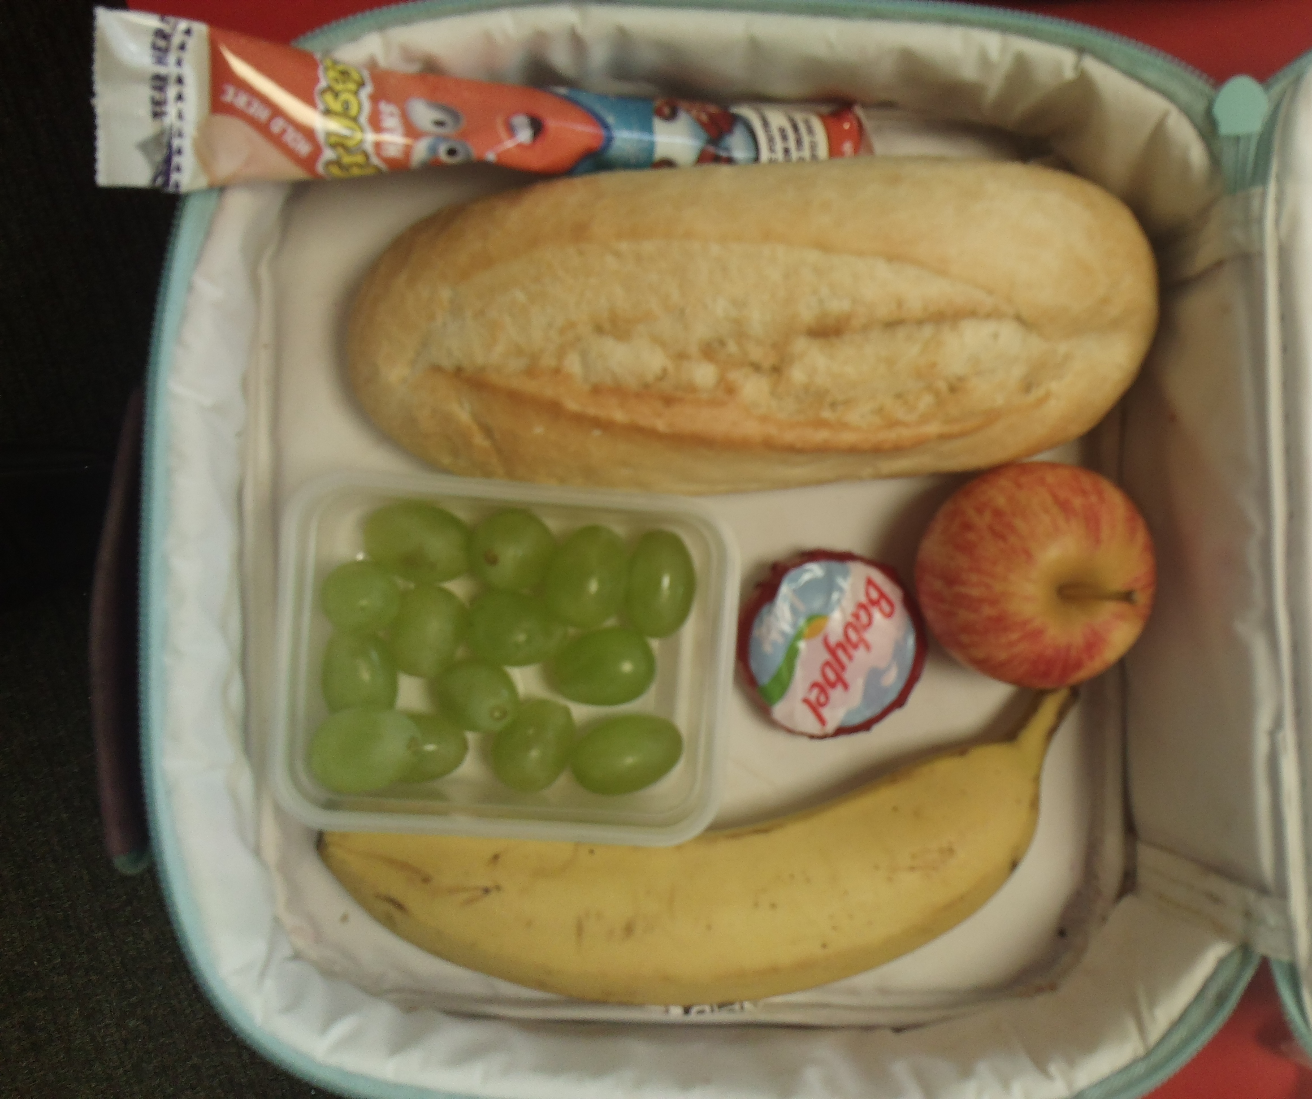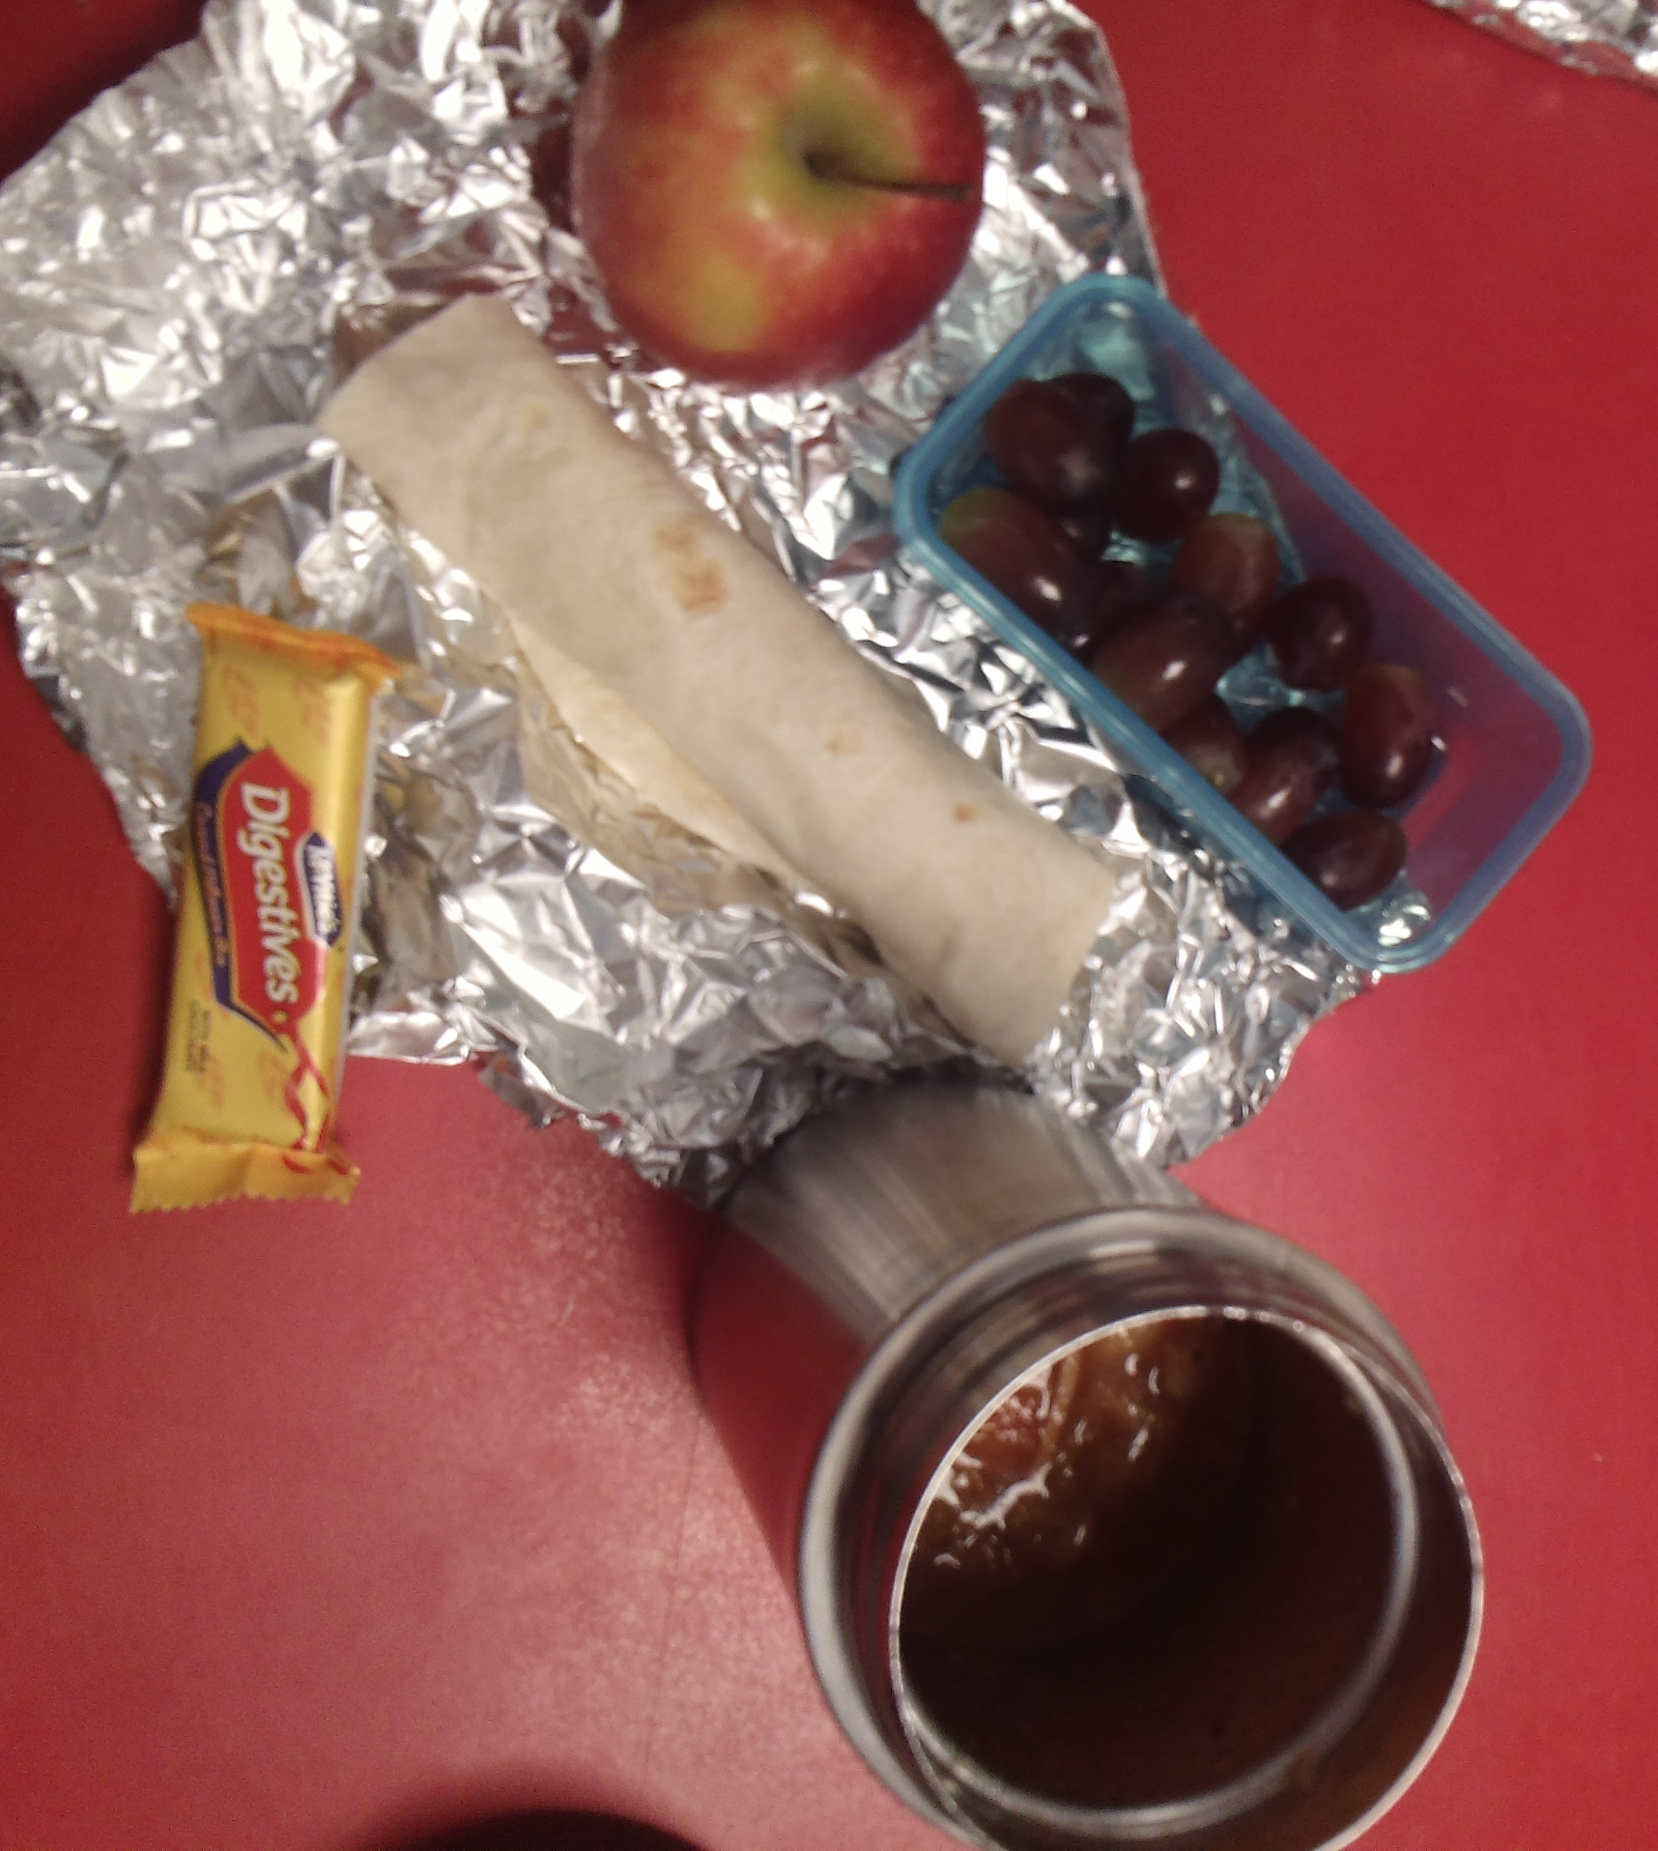

Suggested healthy and unhealthy items recorded by the School Council



