English  We are continuing with our significant author – David Walliams and our class text for this half term is Gangsta Granny. Our guided reading text is; The sword of Hervor.  Our writing styles for this half-term are:  Diary, explanation, poetry, limericks and Haiku. | R.E.  In R.E. this half-term, we will be finding out about incarnation. By the end of this unit, we will be able to identify the difference between a ‘Gospel’, which tells the story of the life and  teaching of Jesus, and a letter. We will be able to offer suggestions about what texts about baptism and Trinity might mean. Give examples of what these texts mean to some Christians  today. We will be able to describe how Christians show their beliefs about God the Trinity in worship (in baptism and prayer, for example) and in the way they live. We will also make links between some Bible texts studied and the idea of God in Christianity, expressing clearly some ideas of their own about what the God of Christianity is like. |  |  |  | Maths  In Maths during this half-term, our objectives will focus on addition and subtraction and multiplication and division. Year 4 will also look at area.  Year 3: will be taught how to add and subtract numbers up to three digits using mental and formal written methods of columnar addition and subtraction. They will recall multiplication and division facts for 3,4 and 8 times tables. They will write and calculate using the multiplication tables they know including two digit numbers times one digit numbers.  Year 4: will be taught how to add and subtract numbers with up to 4 digits using the formal written methods of columnar addition and subtraction and to check using the inverse. They will recall multiplication and division facts for multiplication tables up to 12 × 12. They will multiply two digit and three digit numbers by a one digit number using formal written layout. They will also be able to identify factor pairs. |  |  |  | PSHCE/RSE  This is all about ‘Celebrating Difference’ with a focus on what makes a community, diversity and how a community helps everyone to feel included and values the different contributions that people make. In Year 4, the focus will be how people have a shared responsibility to help protect the world around them and how everyday choices can affect the environment. We will also look at how to show care and concern for others.
The Rhine  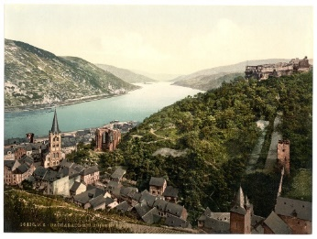  Curriculum Grid  Autumn 2  Y3/4 |  |  | Science  In science this half-term, we will be refining our application skills through working scientifically. The children will become more adept at reporting on findings from enquiries. They will use results to draw simple conclusions. They will make predictions for new values and suggest improvements. They will also learn to raise further questions, identifying differences, similarities or changes related to scientific ideas using scientific evidence to answer questions. The children will have the opportunity to devise and carry out their own scientific investigations to help embed these skills. |  |  | History  In history, we are finding out about invasion. This project teaches children about life in Britain after the Roman withdrawal. Children will learn about Anglo-Saxon and Viking invasions up to the Norman conquest. We will be looking in depth at Anglo-Saxons and ‘Sutton Hoo’. There will be some follow up work from our visit to Lindisfarne. We will then look at King Athelstan and how he took the kingdom of Northumbria. We will also continue to look at the work of St Cuthbert and his influence locally. |  | 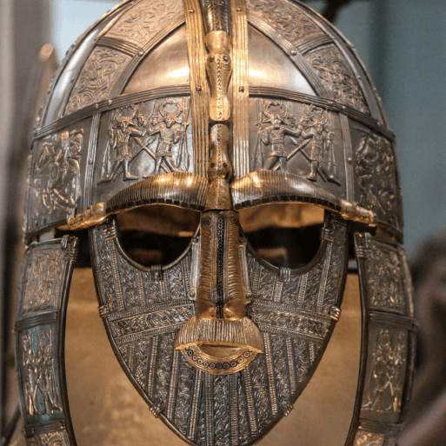
French  In French, we will continue our work on phonics and we will be completing a module on musical instruments. We will be learning to: Recognise, recall and spell up to ten instrument nouns in French with their correct definite article/determiner with improving accuracy.  say and write from memory 'I play' in French. Put together a short sentence using a determiner, a noun and the verb 'je joue' (I play) with some/all 10 instruments. |  | Art, Design and Technology  In art this half-term, we will be having an art focus for our homework.  In design and technology, we will be covering a topic entitled ‘Functional and Fancy Fabrics’ which teaches children about home furnishings and the significant designer William Morris. They learn techniques for decorating fabric, including block printing, hemming and embroidery and use them to design and make a fabric sample. |  | Music  Music will be focused around preparation for our Christmas performance. We will also be continuing our work around ‘Three Little Birds’ by Bob Marley. Themes: Reggae, happiness and animals.  We will be listening to the additional four songs/pieces in this Unit will support and enrich the children’s understanding of its theme, while deepening their musical knowledge and experience.  Most children should know the difference  between pulse and rhythm. Some children will know how pulse, rhythm and pitch work together to create a song. |  |  | Computing  In computing, we are going to be learning all about desktop publishing. We will learn how to use search technologies effectively, appreciate how results are selected and ranked, and be discerning in evaluating digital content. We will also learn how to select, use, and combine a variety of software (including internet services) on a range of digital devices to design and create a range of programs, systems, and content that accomplish given goals, including collecting, analysing, evaluating, and presenting data and information |  |  | P.E.  In P.E. this half-term, we will be focusing on gymnastics. On Wednesdays, we will be taking part in Commando Joe sessions on team-building and problem-solving.  Children will need to come in their P.E. kits on Monday and Wednesday each week.

Links to our curriculum drivers Rhine Class Autumn 2 Y3/4
The following drivers underpin our school curriculum and, with our vision and values, allow us to deliver our curriculum strategy. These key drivers are personal to our schools and reflect the locational, social and educational needs of our community.
Curriculum Driver | Links within our curriculum this half term
Christianity and Faith | - R.E. – Incarnation and The Trinity  - Remembrance Day Service at Haltwhistle, Holy Cross  - PSHE – Celebrating Difference – different faiths/beliefs  - R.E. Leaders leading weekly worship assemblies  - Community mosaic designed with our Christian Values  - Christmas celebrations, including Christingle at the Church
Our Local Area | - History and links with local area and Viking invasion  - Involvement and link to local community through Christmas  activities and performances
Outdoor Growing, Learning and Environment | - Science – growing, plants and environment  - Eco Schools representatives  - School tree planting  - Science – Investigating plants  - Outdoor learning and gardening
Wider World and Diversity | - PSHCE/RE – celebrating difference – diversity  - School Council supporting charities – Children in Need  - French – Learning about a different language  - Music from other cultures – Reggae music  - Understanding protected characteristics during Anti-bullying day  - World Cup day – Learning about traditions and cultures from somewhere far away

