Personal Social & Emotional Development  In PSED this half term we will continue to learn to get along together – playing cooperatively and taking turns. We will practise being helpful, kind and thoughtful.  We will show an understanding of our own feelings and those of others, and begin to regulate our behaviour accordingly. We will talk about bullying and will engage in some age appropriate anti-bullying activities to help us explore this topic. We will celebrate our differences and talk about our hobbies and interests outside of school. We will discuss our aspirations and dreams and create a time capsule which we will bury and dig up before we leave school in Year 6. We will further explore how families are all different. We will explore the idea that ‘home is where the heart is’ and explore why homes are places of safety, love and care. |  | R.E.  In R.E. this half-term, we will recognise that people have different beliefs and through using the story Little Glow we will explore how people celebrate special times in different ways. We will begin to explore Hinduism and the festival of Diwali.  We will be learning why Christmas is a special celebration for Christians. We will learn about Jesus’ birth and the story of the Nativity. |  | Physical Development  In P.E. this half-term, we will be focusing on Manipulation and Co-ordination and Gymnastics.  We will enjoy a range of PD activities including Joe Wicks workouts and Squiggle while you Wiggle.  We will use meditation and yoga to further strengthen our bodies and learn how to relax.  Children will need to come in their P.E. kits on Tuesday and Wednesday each week.
Tyne Class  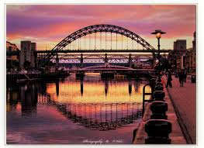  Curriculum Grid  Autumn 2  ‘Once Upon a Time’ | Literacy  This half term we will be exploring traditional tales such as Goldilocks and the Three Bears and The Gingerbread Man. We will be paying attention and responding to the pictures and the words and will be repeating words and phrases. We will explore ‘story language’. We will innovate a story, making it our own. We will explore different genres to learn new things e.g. non-fiction books about Bonfire Night, a recipe for porridge. We will explore letter writing and will write a letter to Santa. We will be developing phonological awareness so we can: spot rhymes, count or clap syllables, recognise words with the same initial sound.  We will be learning to recognise and write our names and other familiar words and will understand print has meaning.  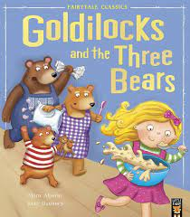  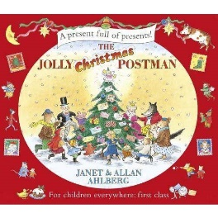  In phonics we will be continuing to learn and develop our knowledge and understanding of everyday sounds and letters and sounds and words through our Read Write Inc programme. We will use the phonemes we have learnt to read and write simple words, working towards identifying the initial, middle and final sounds in the word.  In class we encourage mark making and early and developing writing for  difference purposes e.g. a speech bubble or the Gingerbread man, a list of ingredients for porridge. |  |  |  | Understanding the World  This half term we will learn how to grow a bean. We will learn why we celebrate Bonfire Night and will read the story of the Gunpowder Plot and learn about the historical figure Guy Fawkes.  We will explore the natural world around us and enjoy weekly Forest School sessions. We will watch how seasons change and will learn about how Autumn turns into Winter.  We will practise our cooking skills, making porridge, gingerbread men and some Christmas treats.  We will conduct some science experiments, e.g. melting chocolate to make edible sparklers, and will begin to learn about fair testing, predicting and collecting data.
Expressive Art and Design  This half-term we will continue to use different tools and materials to express our ideas through art construction and, modelling.  We will explore, use and refine a variety of artistic effects such as modelling Diva lamps from clay.  Our focus artist with be Matisse and we will develop our cutting skills to create artwork in his style.  We will join in with role-play and storytelling and will develop storylines in our pretend play.  In Music we will continue to join in with whole school singing. We will also join in with Christmas performances and services. We will continue to follow the Charanga music scheme, learning new action rhymes and songs and exploring rhythm, pitch and volume through our singing and also through playing some percussion instruments.  We will create a Christmas craft, following instructions, for our Christmas fair. |  |  | Maths  In maths this half term we will continue our maths mastery journey through maths talk, practicing the skills we've learned during play and developing number sense  We will be:  * Joining in with our daily calendar, learning the days of the week, months of the year and the seasons.  *Singing number songs and rhymes and playing number games.  *Matching, sorting and comparing amounts.  * Counting, representing, comparing and understanding the composition of numbers 1, 2, 3, 4, 5.  * Learning about familiar 2D shapes and colours.  *Exploring and making patterns.  *Comparing size, mass and capacity.  *Exploring money – using pennies to pay for magic beans.

Links to our curriculum drivers Tyne Class Autumn 2 Reception
Curriculum Driver | Links within our curriculum this half term
Christianity and Faith | - R.E. - The story of The Nativity  - Why do Christians celebrate Christmas?  - Exploring Christianity and our own beliefs  - PSED - Celebrating our differences  - Christingle service  - Learning about Hinduism and Diwali
Our Local Area | - Enjoying our local church at Christmas  - Trip to Queen’s Hall Theatre – pantomime
Outdoor Growing, Learning and Environment | - Forest School – exploring our local environment  - Maths in nature  - Changing seasons – making bird feeders  - Eco Council – environmental pledge – feeding the birds
Wider World and Diversity | - PSED – celebrating differences – diversity – exploring how families are different  - School Council  - Learning about Hinduism and Diwali  - Christmas traditions around the world
The following drivers underpin our school curriculum and, with our vision and values, allow us to deliver our curriculum strategy. These key drivers are personal to our schools and reflect the locational, social and educational needs of our community.

