Autumn 2 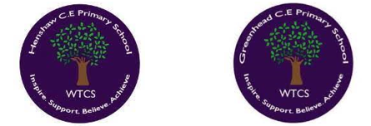
Year 5.6
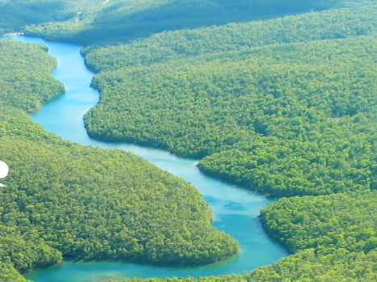
Roaring Rivers
Year 5: Foundational Skills (Roaring Rivers)
- Location & Mapping: I can name and locate some of the UK's major rivers and the longest world rivers on each continent, tracing them back to their source using atlas and digital maps.
- River Characteristics: I can recognize and name features of a river basin, such as tributaries, channels, flood plains, and confluences.
- Human Impact & Comparison: I can describe simple similarities and differences between several rivers, identifying various ways humans use them.
- Settlement: I can talk about the relative location of a river compared to other places I have studied and describe simple reasons why people make settlements there.
- Geographical Processes: I know that erosion and deposition form meanders and can describe how a river course changes from source to mouth.
- Legacy: I can identify the job of a hydrologist and know that Bernard Palissy changed the world's understanding of the water cycle.
Golden Geographical Threads
- Where is the location of this learning sequence compared to other places I have studied? What does it look like on a map?
- Why do people make settlements in this place?
- How has this environment changed over time?

Autumn 2
Year 5.6
Roaring Rivers
Year 6: Complex and Comparative Skills (Roaring Rivers)
- Location & Mapping: I can evaluate the location of major world rivers in relation to other regions and explain how they appear on a map.
- River Characteristics: I can provide a detailed evaluation of how the land changes in the upper, middle, and lower courses of a river, using the River Tyne as a specific example.
- Human Impact & Comparison: I can use evidence to write a detailed account of how a river environment has changed over time.
- Settlement: I can explain the specific geographical reasons why people originally chose to make settlements near rivers and evaluate how these environments have changed over time.
- Geographical Processes: I can explain the ways erosion and deposition change a river’s course over time and evaluate the long-term impact on the landscape.
- Legacy: I can explain exactly how Bernard Palissy’s water cycle model has influenced our lives today and evaluate the importance of modern hydrologists in managing our water resources.
Golden Geographical Threads
- Where is the location of this learning sequence compared to other places I have studied? What does it look like on a map?
- Why do people make settlements in this place?
- How has this environment changed over time?

