RE in KS1 Cycle A
God: What do Christians believe God is like?
- I can identify at least one text from the Bible. (Parable: The Lost Son)
- I can give clear, simple accounts of what the text The Lost Son means to Christians.
- I can give at least three examples of ways in which Christians use Bible concepts, stories and texts to guide their beliefs and actions.
- I can think, talk and ask questions to explore the meaning of the story to me.
Incarnation: Why does Christmas matter to Christians?
- I can tell the story of Jesus’ birth and recognise a link with a concept incarnation.
- I can identify at least two different texts from the Bible (Matthew 1:18-25 and Matthew 2:1-12)
- I can give clear, simple accounts of what Jesus’ Birth means to Christians.
- I can think, talk and ask questions about the Christmas story and the lessons they might learn from it. (About being kind and generous.)
Gospel: What is the good news that Jesus brings?
- I can outline the timeline of the ‘big story’ of the Bible (God, Creation, Incarnation and Gospel)
- I can give clear, simple accounts of what Bible texts (Matthew the tax collector) mean to Christians.
- I can give at least two examples of how Christians put these beliefs into practice in the Church community and their own lives (charity, confession)
- I can give a reason for my ideas and connections. (Jesus’ ‘good news’ is only good news for Christians, or if there are things for anyone to learn)
Salvation: Why does Easter matter to Christians?
- I can tell stories of Holy Week and Easter from the Bible and recognise a link with the idea of Salvation.
- I can give at least three examples of how Christians show their beliefs about Jesus’ death and resurrection in church worship at Easter. (Palm Sunday, Good Friday church service, Easter Sunday (joyful church service, giving and eating eggs.)
- I can think about which parts of the story of Easter shows sadness, hope or heaven, exploring different ideas.
- I can explain why Christians love God and give examples of how they show this (forgive others and follow God’s instructions on how to behave).
Islam: Who is Muslim and what do they believe?
- I can identify some of the key Muslim beliefs about God & give a description of what some of them mean.
- I can recognise the words of the Shahadah and know that it is important to Muslims.
- I can give examples of how Muslims use stories to guide their beliefs and actions (care for creation, fast in Ramadan)
- I can explore and ask questions about what Muslims celebrate and why.
Thematic: Who am I? What does it mean to belong?
- I can recognise what belongs means & give examples of groups which I belong. (school, family, religion, clubs)
- I can give an account of what happens during a traditional welcome ceremony/ Baptism (Christian and Muslim) and explain what the actions and symbols mean.
- I can identify at least two ways people show they love each other and belong to each other when married (Christian and Muslim/Judaism)
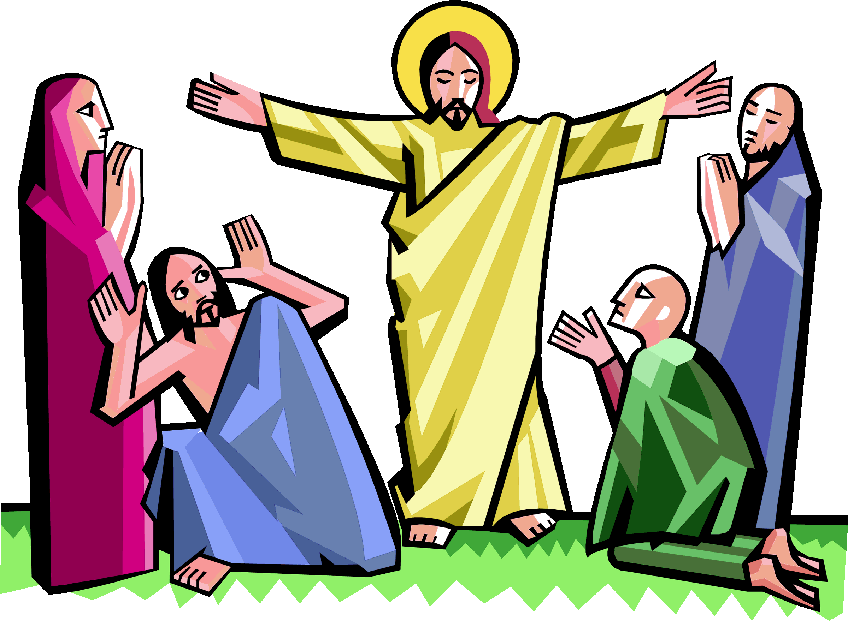
- I can give examples of ways in which people express their identity and belonging within faith and non-faith communities.

