Personal Social & Emotional Development  In PSED this half term we will be focusing on relationships and how to be a good friend. We will use songs, pieces of music, pictures, and drawings to begin to explore our emotions and discuss how others are feeling. We will use these skills to:  *Develop cooperative play to solve problems and take account of one another’s ideas.  *Be confident to try new things and to share ideas about learning.  *Accept one another for our similarities and differences, inclusive of our skills and abilities.  *Talk about feelings and how we can be sensitive to the needs and feelings of others. |  | R.E.  In R.E. this half-term, we will be exploring a range of stories from the Bible such as the story of ‘Noah’s Ark’ and ‘The Lost Sheep’. We will reflect on these stories and ask what they teach Christians. We will think about how we should behave towards other people and how we can make the world a better place. We will be able to use some religious vocabulary and retell our favourite bible stories through songs, artwork, and story sequencing. We will understand that the Bible is the Christian’s holy book and that other religions also have sacred texts which we will explore. We will also learn stories from other religions and learn the messages behind them. |  | Physical Development  In P.E. this half-term, we will be focusing on speed, agility, and travel. We will learn how to work in a team, how to move in different ways and jump and travel actions. We will learn circle dances and use strength to hold shapes. We will enjoy a range of PD activities including Dough disco, Squiggle whilst you Wiggle and handwriting activities.  We will use meditation and yoga to further strengthen our bodies and learn how to relax  Children will need to come in their P.E. kits on Monday and Wednesday each week.
Tyne Class  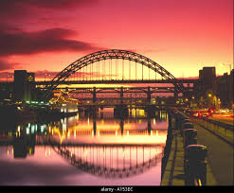  Curriculum Grid  Summer 1 2024  ‘Why do ladybirds have spots?’ | Literacy  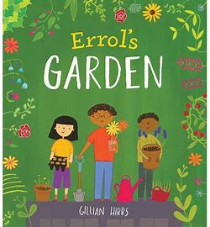  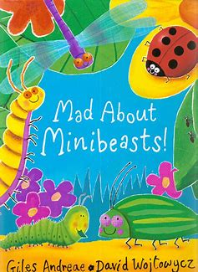  This half term we will be using non-fiction books e.g. ‘Mad about Minibeasts’ to learn about insects and their habitats. We will also enjoy a range of stories about nature such as ‘Errol’s Garden’ and ‘What the ladybird heard’.  We will be paying attention to and responding to the pictures and the  words and we will practise articulating our thoughts and ideas in well-  formed sentences. We will explore onomatopoeia and rhyming words.  We will write our own simple poetry and a fact sheet about our  favourite mini beast. We will also be writing 2 dictated sentences using  the skills taught in our phonics sessions.  In phonics we will continue to learn and develop our knowledge and understanding of sounds, letters and words through our Read Write Inc programme. We will use the phonemes we have learnt to read and write simple word and phrases. We will continue to explore capital letters, finger spaces and full stops. |  |  | Understanding the World  This half term we will learn about caring for living things and the environment. We will explore the natural world and understand important processes and changes in the natural world around us including the life cycles of plants and animals and the changing seasons. We will enjoy a picnic in our local area. We will go on a mini beast hunt and learn how we can help mini beasts. We will use technology for different purposes e.g. designing a garden. We will become gardeners and plant flowers, seeds and vegetables and look after them so they grow and can be used in our art and cooking to enjoy with the local community.  We will enjoy weekly Forest School sessions and will enjoy a range of activities such as making bug hotels.
Expressive Art and Design  This half-term we will explore, design, colour, texture, form and function though a range of challenges and activities e.g. use bees wax to create candles, use clay to create our own mini beasts. We will safely use and experiment with a range of materials, tools and techniques for example when upcycling wooden pallets to make a bird box.  Our focus artist with be Vincent Van Gogh. We will explore colour, texture and form through observational drawing and painting using oil pastels, water colours and paints.  We will join in with role-play and storytelling and will develop storylines in our pretend play using and making our own props.  In Music we will join in with whole school singing. We will continue to follow the Charanga music scheme, working through the unit ‘Big Bear Funk’. We will learn new action rhymes and songs and explore rhythm, pitch and volume through our singing and also through playing some percussion instruments. |  |  | Maths  In maths this half term we will continue our maths mastery journey through maths talk, practicing the skills we've learned during play and developing number sense.  We will:  * Continue to consolidate key skills: subitising, counting, composition, sorting & matching, comparing & ordering.  *Use a range of texts to develop mathematical understanding e.g. ‘Which One Doesn’t belong?’  *Develop spatial reasoning – complete puzzles, explore shapes using geoboards & elastic bands.  *Build and identify numbers to 20 and beyond using a range of resources.  *Taking away.  *Sharing equally.  *Odd and even numbers.  *Exploring doubling.

Curriculum Driver | Links within our curriculum this half term
Christianity and Faith | - In R.E we will explore Bible stories and how they teach us to be good Christians we will then learn about other sacred texts and religions and the messages behind them.  - We will continue to respect all god’s creations by looking after the environment, animals and plants. We will observe the life cycle of a butterfly and learn how to care for God’s creatures. We will focus on recycling and reusing products such as using plastic bottles as plant pots and watering cans to reduce plastic going to landfill.
Outdoor Learning and the Local Environment | - We will be preparing our allotment for vegetable growing by weeding, adding compost, planting and watering. We will create our own plant labels by whittling wood using vegetable peelers.  - Through growing our own produce, we will learn about the different parts of a plant and the life cycle of plants.  - In forest school we will reuse items to make habitats for animals for example by making bird boxes out of wooden crates.
Wider World and Diversity | - In Literacy through our key text Errol’s garden, we will compare different environments cities, towns, villages and explore the importance of green spaces and community.  - In RE we explore other faiths and stories which are important to them. We will read the story Hats of Faith and discuss diversity and the importance of identity and community.
Legacy and Making a Difference | - We will begin planting up our allotments to instil a love of growing your own produce. We will create snacks and meals to share with the school community. We will learn about sustainability, reducing our food miles and plastic packaging.  - We will explore the role mini beasts such as bees and worms play in our food production and how we can protect them by not using harmful pesticides and by providing habitats and food sources.
Links to our curriculum drivers Tyne Class Summer 1 Reception
The following drivers underpin our school curriculum and, with our vision and values, allow us to deliver our curriculum strategy. These key drivers are personal to our schools and reflect the locational, social and educational needs of our community.

