Spring 2 
Year 3.4
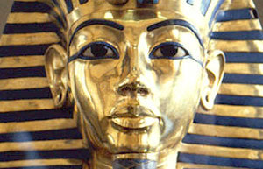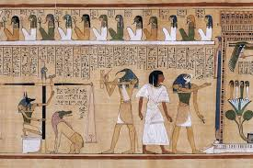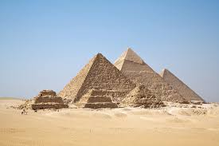
Egyptians
Year 3: Foundational Skills (Egyptians)
- Chronology: I can place the Egyptian civilisation on a timeline and compare its location to another civilisation I have studied.
- Evidence & Exploration: I can tell you about specific Egyptian artifacts I have seen and touched during my visit to the Hancock Museum.
- Context & Daily Life: I can discuss what life was like for different people in an ancient civilisation, including the hierarchy of society and the role of the Pharaoh.
- Comparison: I can identify simple similarities and differences between the Egyptian civilisation and the Vikings.
- Significance: I can describe a significant historical event and person, such as Howard Carter’s discovery of Tutankhamun’s tomb.
- Legacy: I can describe important people from the past, such as Thomas Cook, and identify how his efforts to create tourism affected the world.
Golden Historical Threads
- What evidence tells us about this period of time?
- What was significant about this period of time and person?
- How has this time or person influenced our lives today?

Spring 2
Year 3.4
Egyptians
Year 4: Complex and Comparative Skills (Egyptians)
- Chronology: I can accurately place the Egyptian civilisation on a timeline and compare this chronology to multiple other civilisations I have studied.
- Evidence & Exploration: I can evaluate and describe what different artifacts from the Hancock Museum tell us about the beliefs and daily lives of the Egyptian people.
- Context & Daily Life: I can explain the specific significance of the Egyptian hierarchy and evaluate how the power of the Pharaoh influenced the growth of their civilisation.
- Comparison: I can provide a comparison between the Egyptians and the Vikings, looking at specific themes such as religion, trade, or social structure.
- Significance: I can explain the significance of Howard Carter’s discovery and evaluate how this event changed our understanding of ancient history.
- Legacy: I can explain exactly how Thomas Cook’s legacy of creating tourism in the Victorian era has influenced our lives today
Golden Historical Threads
- What evidence tells us about this period of time?
- What was significant about this period of time and person?
- How has this time or person influenced our lives today?

