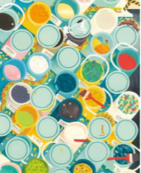
Autumn 1 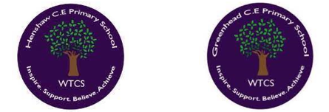
Year 1.2
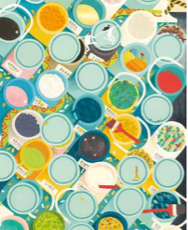
Creation – Who Made the World?
Year 1: Foundational Skills
- A Creator God: I can use simple words like "creative" or "powerful" to describe what Christians believe God is like.
- Genesis Story: I can identify key parts of the Genesis 1 creation story, such as God establishing the sky, sea, land, and living things.
- Frieze Exploration: I can find and point out different parts of the Creation story on our big story frieze.
- Relationship: I can give a simple example of why humans are special to God.
- Caring for Earth: I can describe how we can look after our world and show thankfulness, such as through prayer or celebrating harvest.
Golden RE Threads
- Belonging and community – How does learning in this theme help followers to feel belonging and a sense of community?
- Connection to our Christian Values – Which of our Federation Christian Values does learning in this theme show?
- Treating others with respect and understanding – What lessons can be learnt from learning in this theme about treating others with respect?

Autumn 1
Year 1.2
Creation – Who Made the World?
Year 2: Developing Skills
- A Creator God: I can describe in detail what Christians believe God is like, explaining concepts of beauty, diversity, and power.
- Genesis Story: I can retell the main events of Genesis 1, explaining how God establishes time, the sky, the land, the sea, and living things.
- Relationship: I can explain at least two examples of God’s unique relationship with humans as both the creator and sustainer.
- Caring for Earth: I can explain exactly why and how Christians show thankfulness to God for the world through prayer and harvest practices.

Golden RE Threads
- Belonging and community – How does learning in this theme help followers to feel belonging and a sense of community?
- Connection to our Christian Values – Which of our Federation Christian Values does learning in this theme show?
- Treating others with respect and understanding – What lessons can be learnt from learning in this theme about treating others with respect?

Autumn 2
Year 1.2
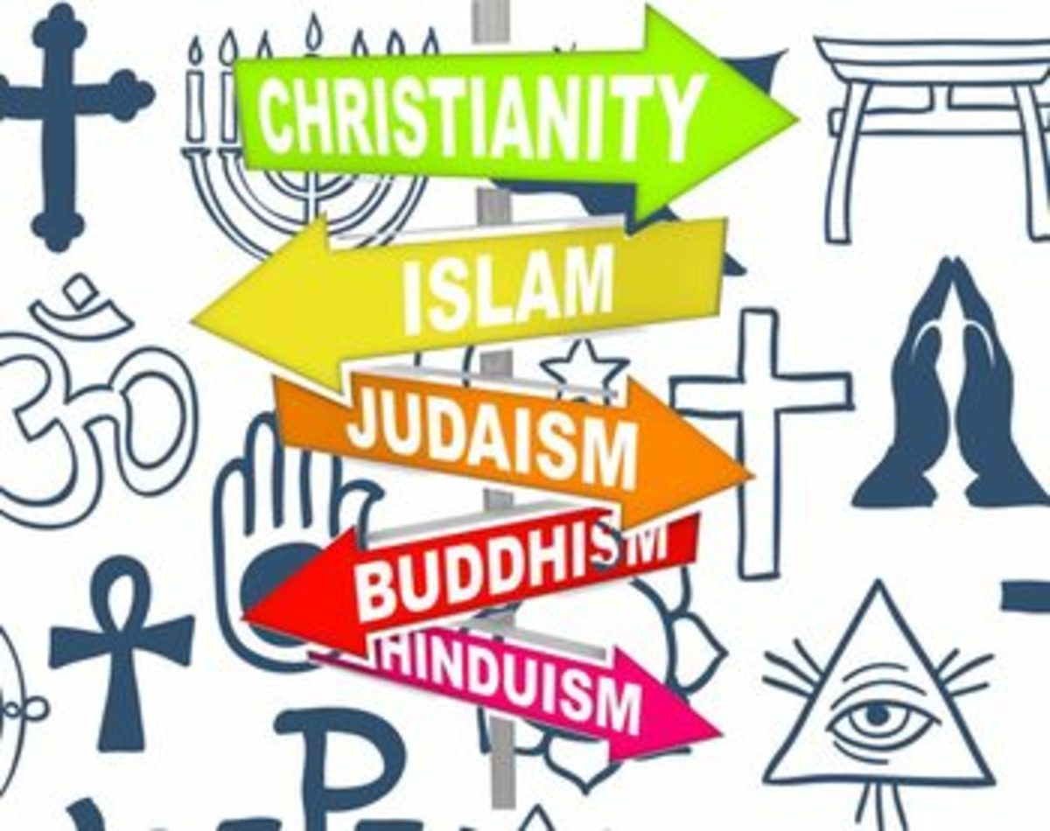
Judaism – Who is Jewish and how do Jewish People Live?
Year 1: Foundational Skills
- Jewish Prayer: I can recognise the words of the Shema as a special Jewish prayer.
- Celebration Stories: I can retell simple stories that Jewish people share during celebrations like Sukkot and Hanukkah.
- Remembering God: I can name simple ways Jewish people remember God, such as using a Mezuzah or keeping Shabbat.
- Asking Questions: I can ask simple questions about how and why Jewish families celebrate special times.
Golden Scientific Threads
- Belonging and community – How does learning in this theme help followers to feel belonging and a sense of community?
- Connection to our Christian Values – Which of our Federation Christian Values does learning in this theme show?
- Treating others with respect and understanding – What lessons can be learnt from learning in this theme about treating others with respect?

Autumn 2
Year 1.2
Judaism – Who is Jewish and how do Jewish People Live?
Year 2: Developing Skills
- Jewish Prayer: I can explain the importance of the Shema prayer in Jewish daily life.
- Celebration Stories: I can retell and explain the deeper meanings behind the stories celebrated during Sukkot and Hanukkah.
- Remembering God: I can compare different physical and practical ways Jewish people remember God, specifically detailing the purpose of a Mezuzah and the observance of Shabbat.
- Belief into Action: I can make clear links between Jewish ideas of God found in traditional stories and the way Jewish people choose to live their lives.
Golden Scientific Threads
- Belonging and community – How does learning in this theme help followers to feel belonging and a sense of community?
- Connection to our Christian Values – Which of our Federation Christian Values does learning in this theme show?
- Treating others with respect and understanding – What lessons can be learnt from learning in this theme about treating others with respect?

Spring 1
Year 1.2
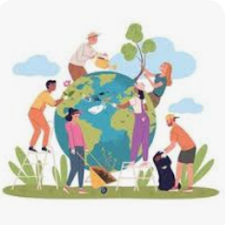
Thematic: How should we care for the world and why does it matter?
Year 1: Foundational Skills
- Unique Value: I can identify a story or text that teaches that every single person is unique and valuable.
- Genesis Guidance: I can identify what the Genesis 1 story teaches Christians and Jews about looking after the natural world.
- Helping Others: I can give a simple example of how people show care for others, such as giving to charity.
- Global Care: I can give examples of how people of faith (Christians and Jews) look after the natural world.
- Legacy: I know what the charity World Jewish Relief is and why its work is helpful.
Golden RE Threads
- Belonging and community – How does learning in this theme help followers to feel belonging and a sense of community?
- Connection to our Christian Values – Which of our Federation Christian Values does learning in this theme show?
- Treating others with respect and understanding – What lessons can be learnt from learning in this theme about treating others with respect?

Spring 1
Year 1.2
Thematic: How should we care for the world and why does it matter?
Year 2: Developing Skills
- Unique Value: I can explain how specific religious stories or texts teach that every individual is uniquely valuable.
- Genesis Guidance: I can compare what Genesis 1 tells both Christians and Jews about their responsibilities toward the natural world.
- Helping Others: I can make a clear link between a scriptural story and a practical way people show care today, such as donating to a charity.
- Shared Responsibility: I can explain the scientific and ethical reasons why everyone—both religious and non-religious—should care for other people and look after the natural world.
- Legacy: I can explain exactly what World Jewish Relief is and evaluate why its humanitarian efforts are so important.
Golden RE Threads
- Belonging and community – How does learning in this theme help followers to feel belonging and a sense of community?
- Connection to our Christian Values – Which of our Federation Christian Values does learning in this theme show?
- Treating others with respect and understanding – What lessons can be learnt from learning in this theme about treating others with respect?

Spring 2
Year 1.2
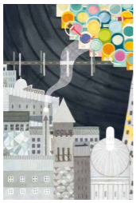
Salvation – Why does Easter Matter to Christians?
Year 1: Foundational Skills
- The Big Story: I can recognize that "Salvation" is a key chapter in the 'Big Story' of the Bible.
- Easter Stories: I can retell simple parts of the Holy Week and Easter stories, such as the Last Supper.
- The Connection: I can identify that Christians believe Jesus connects God and humans together.
- Following Jesus: I can identify simple ways Christians try to follow Jesus, like helping people who do not have a home.
Golden RE Threads
- Belonging and community – How does learning in this theme help followers to feel belonging and a sense of community?
- Connection to our Christian Values – Which of our Federation Christian Values does learning in this theme show?
- Treating others with respect and understanding – What lessons can be learnt from learning in this theme about treating others with respect?

Spring 2
Year 1.2
Salvation – Why does Easter Matter to Christians?
Year 2: Developing Skills
- The Big Story: I can explain how the concept of Salvation fits into the overarching 'Big Story' of the Bible.
- Easter Stories: I can retell the main events of Holy Week and Easter in order, including the cleansing of the temple, the Last Supper, and Jesus’ trial.
- The Connection: I can explain the Christian belief that Jesus "builds a bridge" to reconnect God and humanity.
- Following Jesus: I can explain how specific Christian actions—such as practicing forgiveness and helping the homeless—directly reflect the teachings and example of Jesus.
Golden RE Threads
- Belonging and community – How does learning in this theme help followers to feel belonging and a sense of community?
- Connection to our Christian Values – Which of our Federation Christian Values does learning in this theme show?
- Treating others with respect and understanding – What lessons can be learnt from learning in this theme about treating others with respect?

Summer 1
Year 1.2
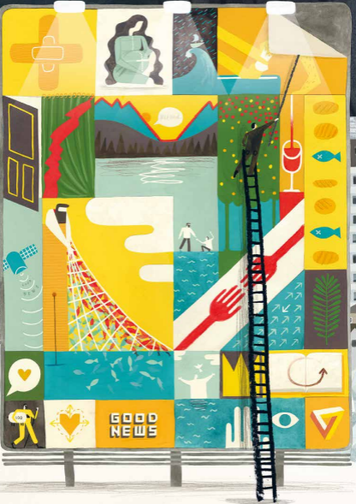
Gospel – What is the Good News that Jesus Brings?
Year 1: Foundational Skills
- Bible Timeline: I can identify key blocks on the Bible's 'big story' timeline, including God, Creation, Incarnation, Gospel, and Salvation.
- Gospel Stories: I can retell a simple account of a Gospel story, such as Jesus and the Ten Lepers.
- Prayer: I can state simple reasons why Christians pray to God, such as believing that God listens to them.
- Christian Priorities: I can identify that God is what matters most in life to Christians.
Golden Scientific Threads
- Belonging and community – How does learning in this theme help followers to feel belonging and a sense of community?
- Connection to our Christian Values – Which of our Federation Christian Values does learning in this theme show?
- Treating others with respect and understanding – What lessons can be learnt from learning in this theme about treating others with respect?

Summer 1
Year 1.2
Gospel – What is the Good News that Jesus Brings?
Year 2: Developing Skills
- Bible Timeline: I can outline and explain the chronological order of the 'big story' of the Bible: God, Creation, Incarnation, Gospel, and Salvation.
- Gospel Stories: I can give clear, simple accounts of three key Bible texts (Luke 11:9-13, Luke 17:11-19, and the story of Jesus and the Ten Lepers) and explain what they mean to Christians.
- Prayer: I can explain the theological reasons why Christians pray, linking it to Jesus' teachings and the belief that God is listening.
- Christian Priorities: I can explain why putting God first is central to a Christian's life and discuss how they show this in their daily actions.
Golden Scientific Threads
- Belonging and community – How does learning in this theme help followers to feel belonging and a sense of community?
- Connection to our Christian Values – Which of our Federation Christian Values does learning in this theme show?
- Treating others with respect and understanding – What lessons can be learnt from learning in this theme about treating others with respect?

Summer 2
Year 1.2
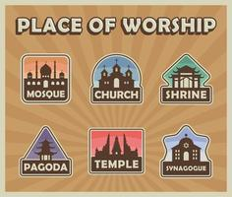
Thematic – What Makes Some Places Sacred to Believers?
Year 1: Foundational Skills
- Places of Worship: I can name and recognize special buildings where people go to worship, such as a church, synagogue, or mosque.
- Sacred Objects: I can identify at least one special object used in worship in two different religions, like a Muslim prayer mat or a Jewish Torah.
- Practicing Worship: I can describe simple things people do when they worship in their special places.
- Special Places: I can talk about places that are special to me, even if they are not religious spaces.
Golden RE Threads
- Belonging and community – How does learning in this theme help followers to feel belonging and a sense of community?
- Connection to our Christian Values – Which of our Federation Christian Values does learning in this theme show?
- Treating others with respect and understanding – What lessons can be learnt from learning in this theme about treating others with respect?

Summer 2
Year 1.2
Thematic – What Makes Some Places Sacred to Believers?
Year 2: Developing Skills
- Places of Worship: I can make clear, detailed comparisons between a church, a synagogue, and a mosque.
- Sacred Objects: I can identify and explain the significance of at least two objects used in worship across two different religions (such as the prayer mat, Quran, or Wudu in Islam, and the Torah, tallit, or kippah in Judaism).
- Practicing Worship: I can compare how people practice worship in a church, a mosque, and a synagogue.
- Sacred vs. Special: I can analyse and discuss the differences between religious sacred places and non-religious special places.
Golden RE Threads
- Belonging and community – How does learning in this theme help followers to feel belonging and a sense of community?
- Connection to our Christian Values – Which of our Federation Christian Values does learning in this theme show?
- Treating others with respect and understanding – What lessons can be learnt from learning in this theme about treating others with respect?

