Spring 1 
Year 5.6
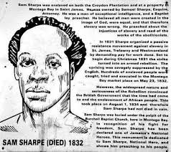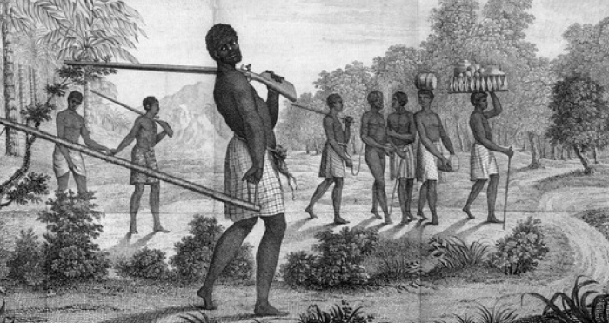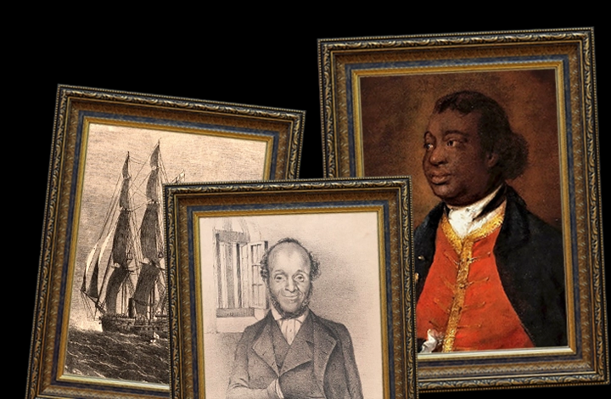
Maafa (The Slave Trade)
Year 5: Foundational Skills (Maafa)
- Chronology: I can place the Slave Trade on a timeline and compare it to other major events from the past 100 years.
- Evidence & Exploration: I can identify and describe what different types of evidence tell us about the slave trade and life during this period.
- Comparison: I can identify simple similarities and differences between the movement against the slave trade and other historical movements against racial segregation.
- Causation: I can explain the historical reasons why countries like Portugal and Spain became involved in the trade of slaves and gold.
- Human Impact: I can describe Britain’s involvement in the Triangular Trade and explain the human impact of life on plantations.
- Legacy: I can describe a significant person from the past, such as Sam Sharpe, and identify one way they affected our world today.
Golden Historical Threads
- What evidence tells us about this period of time?
- What was significant about this period of time and person?
- How has this time or person influenced our lives today?

Spring 1
Year 5.6
Maafa (The Slave Trade)
Year 6: Complex and Comparative Skills (Maafa)
- Chronology: I can accurately place the Slave Trade on a timeline and evaluate its duration and impact in relation to other periods of history I have studied.
- Evidence & Exploration: I can evaluate and describe historical evidence to explain the significance of the slave trade/its impact on the people of the time.
- Comparison: I can provide a detailed comparison between the historic movement against the slave trade and other movements against racial segregation across different periods and places.
- Causation: I can evaluate the complex economic and political motivations that led to Britain’s specific involvement in the Triangular Trade.
- Human Impact: I can analyse the human/social consequences of plantation life and evaluate the significance of this period for the countries involved.
- Legacy: I can explain exactly how significant figures like Sam Sharpe have influenced our lives today and evaluate the lasting legacy of the Maafa on modern society.
Golden Historical Threads
- What evidence tells us about this period of time?
- What was significant about this period of time and person?
- How has this time or person influenced our lives today?

