Autumn 1 

Year 1.2
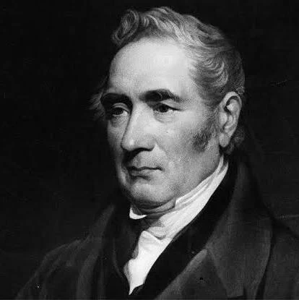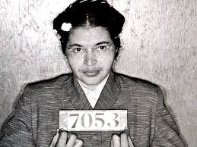
Movers and Shakers
Year 1: Foundational Skills (Movers and Shakers)
- Local & Global Knowledge: I can talk about important people from my local area, such as George Stephenson, and know about globally significant people like Neil Armstrong.
- Evidence & Exploration: I can explore simple pieces of evidence to learn about the lives of significant people from the past.
- Comparison: I can describe simple similarities between the lives of people like Emmeline Pankhurst and Mary Anning.
- Evaluating Ideas: I can explain ideas & thoughts about people from the past.
- Chronology: I can order main life events of a significant person on a timeline.
- Legacy: I can name and describe important people from the past and identify one way they affected today
Golden Historical Threads
- What evidence tells us about this period of time?
- What was significant about this period of time and person?
- How has this time or person influenced our lives today?
Autumn 1

Year 1.2
Movers and Shakers
Year 2: Complex and Comparative Skills (Movers and Shakers)
- Local & Global Knowledge: I can describe the lives of globally significant people like Christopher Columbus, explaining why they are famous.
- Evidence & Exploration: I can evaluate what different types of evidence tell us about a specific person and the period of time they lived in.
- Comparison: I can describe the similarities and the differences between the lives of different "movers and shakers," Rosa Parks & Vincent Van Gogh.
- Evaluating Ideas: I can use diamond ranking to justify my thoughts and explain which historical figures I believe were the most significant.
- Chronology: I can order the lives of several different globally significant people on a timeline to show how they fit together in history.
- Legacy: I can explain exactly how significant people like Rosa Parks and George Stephenson have influenced our lives today.
Golden Historical Threads
- What evidence tells us about this period of time?
- What was significant about this period of time and person?
- How has this time or person influenced our lives today?

