English  Our class author this year will be Julia Donaldson. We will read Stickman and the Christmas Pine.  Our guided reading tests will be looking at Lost in Space.  Our writing styles for this half-term are: Narrative, traditional tales, instructions and information texts. We will have our Read, Write, Inc phonics sessions daily as well as our reading sessions. We will continue to practise our spellings. Our Grammar and punctuation focus will be: conjunctions, nouns and verbs, plural nouns, past and present tenses, noun phrases, capital letters, full stops, apostrophes for possession and suffixes er and est. | Maths  In Maths during this half term, we will be looking at place value and addition and subtraction.  Year 1:  Addition and Subtraction: We will: Use a part whole model to find our answers. Write number sentences. Use fact families. Use systematic number bonds within 20 and write addition and subtraction related facts.  Geometry:  We will: Begin to recognise and name 2d and 3d shapes. We will sort shapes and use shapes to create or complete a shape pattern.  Year 2:  Addition and Subtraction: Add and subtract ones. Add and subtract 10s. Add 3 1-digit numbers. Compare number sentences. Look at related facts. Use concrete and pictorial representations to support our understanding.  Geometry:  We will: Begin to recognise and name 2d and 3d shapes. We will count how many vertices and faces a shape has. We will look at lines of symmetry and use lines of symmetry to complete shapes. We will use shapes to make shape patterns or complete a shape pattern. |  |  | Geography: Bright Lights Big City.  We will:  Name and locate the four countries of the UK and their capital cities on a map, atlas or globe.  We will begin to use basic geographical vocabulary to look at physical features of the United Kingdom including, mountains, hills, cliff or forest. We will begin to look at what makes a city and the features of other settlements. We will begin to look at human features in our local area and look at aerial photographs.  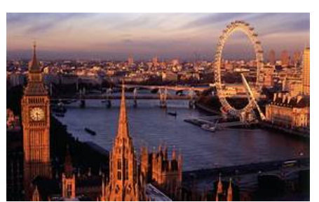
RE  We will look at Incarnation and explore the gospel Mathhew and learn that Jesus is extraordinary and that he came he came to bring good news. We will look at advent and understand that it is a time for Christians is a time of getting ready for Jesus. We will also be practising and performing our Nativity play. |  | Art: Street View:  We will: Learn about artwork depicting streets and buildings and focus on the work of the American pop artist, James Rizzi. We will create a 3D mural based on Rizzi’s artwork. We will develop a range of techniques in using colour, texture, lines and shapes. |  | Thames Class  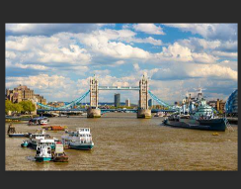  Curriculum Grid  Autumn 2 Y1/2
Music  We will continue to practise Hey you in Charanga Music and have whole school singing.  We will begin to practise the songs for our Christmas performance. |  | Science. Working Scientifically.  In Science this half-term, we will be working scientifically.  We will:  ask simple questions and find different ways to answer them.  sort objects or living things into groups.  use simple equipment to make observations.  perform simple tests.  use scientific language to talk about my observations and ideas.  gather and record data.
P.E.

In PE we will have two PE sessions every week. One session will be based on attack, defend and shoot and the other one will be Gymnastics.

PE Kit should be worn on Monday and Wednesday
Computing:  In computing, we are going to be looking at technology around us. We will:  - Develop our understanding of technology and how it can help us in our everyday lives.  - Start to become familiar with the different components of a computer by developing our keyboard and mouse skills.  - Consider how to use technology responsibly.  - Begin to use rainforest coding to embed the above skills. |  |  | PSHE/RSE We will look at the jobs people do and celebrate difference.  - how jobs help people earn money to pay for things they need and want  - about a range of different jobs, including those done by people  - they know or people who work in their community  - how people have different strengths and interests that enable them to do different jobs  - how people use the internet and digital devices in their jobs and everyday life

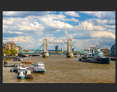
Links to our curriculum drivers Thames Class Autumn 2 Y1/2
The following drivers underpin our school curriculum and, with our vision and values, allow us to deliver our curriculum strategy. These key drivers are personal to our schools and reflect the locational, social and educational needs of our community.
Curriculum Driver | Links within our curriculum this half term
Christianity and Faith | We will explore Christian values during Collective Worship and demonstrate these throughout the school day. We will learn Bible stories and act out Bible Stories during Open the Book assemblies. We will celebrate the birth of Jesus. We will be performing our Nativity play.  We will be taking part in our Christingle service within the church.
Our Local Area | We will look at the human and physical features in our local area in Geography and identify what type of settlement we live in. How Winter affects our local area and how animals survive during the cold months.
Outdoor Growing, Learning and Environment | Observe the changes within our local area through the season Winter. Looking at features of settlements within our local area. i.e. village. Look at similarities and differences between a city and our local area. We will be visiting the Queen’s Hall to have first-hand experience of acting on stage to embed the above skills.
Wider World and Diversity | We will explore the work of the artist James Rizzi. We will look at the features unique to a city.  will be learning facts about space and creating an information text linked to space. We will learn about the countries that make up the United Kingdom and the capital cities.

