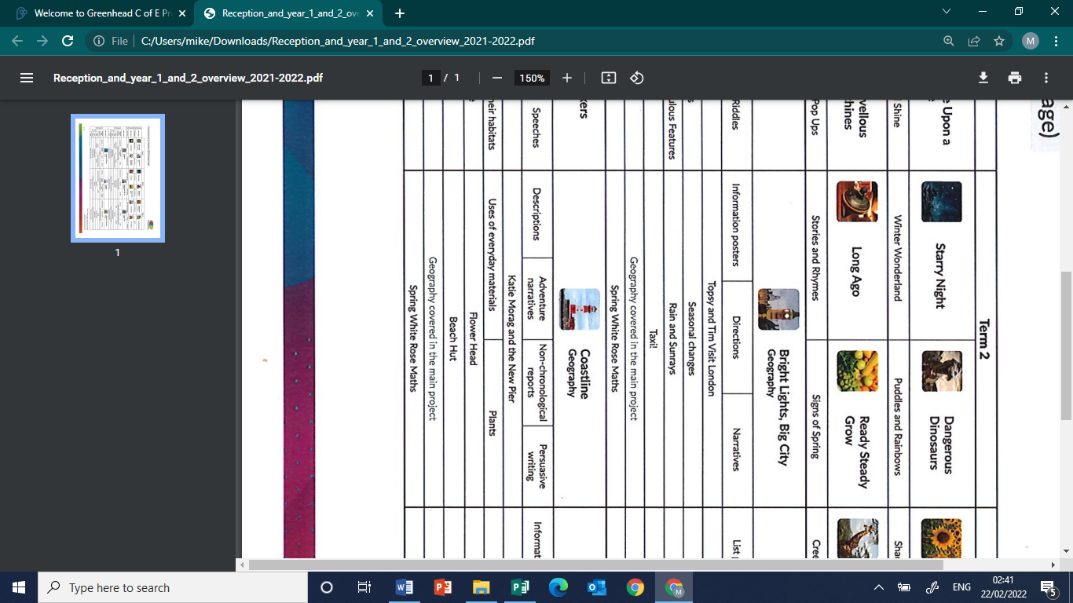
Summer 1 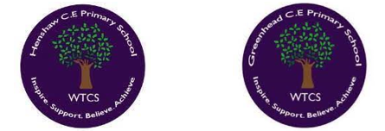
Year 1.2
Bright Lights, Big City
Year 1: Foundational Skills (Bright Lights)
- Location: I can name and locate the four countries of the United Kingdom and their surrounding seas.
- Mapping & Tech: I can use a simple map to identify the location and basic characteristics of London.
- Comparison: I can look at the UK and a non-European country (Somalia) to identify simple differences between them.
- Prioritisation: I can use basic geographical vocabulary to label features of a city, such as houses, shops, and offices.
- Settlement: I can talk about the simple reasons why people choose to live in a big city like London.
- Change & Legacy: I can identify daily weather patterns and know that people like climatologists study our world
Golden Geographical Threads
- Where is the location of this learning sequence compared to other places I have studied? What does it look like on a map?
- Why do people make settlements in this place?
- How has this environment changed over time?

Summer 1
Year 1.2
Bright Lights, Big City
Year 2: Complex and Comparative Skills (Bright Lights)
- Location: I can identify the location of the UK and its capital cities on a world map in relation to other places I have studied.
- Mapping & Tech: I can use geographical tools to identify specific human and physical features of London and plot weather patterns on a graph.
- Comparison: I can use specific characteristics and data to make detailed comparisons between life in the UK and life in Somalia.
- Prioritisation: I can use complex geographical vocabulary (such as factory, port, and harbour) to explain how different parts of a city work.
- Settlement: I can explain the geographical reasons why people make settlements in large cities; how these environments change over time.
- Change & Legacy: I can explain exactly who James Hansen is; how his work as a climatologist changed the world's understanding of climate change
Golden Geographical Threads
- Where is the location of this learning sequence compared to other places I have studied? What does it look like on a map?
- Why do people make settlements in this place?
- How has this environment changed over time?

