English  Our class texts are books by William Shakespeare – our significant author. This term we will be reading Hamlet.  Our guided reading text is ‘The Boy at the Back of the Classroom’ by Onjali Q Rauf.  Our writing styles for this half-term will be:  - Biographies  - Balanced arguments  - Persuasive writing | R.E.  Our thematic learning in R.E. this half-term poses the question of Salvation.  This will involve identifying:  - What did Jesus do to save human beings?  - What difference does the resurrection make for Christians? |  |  | Maths  In Maths during this half-term, our objectives will focus on fractions, decimals and percentages as well as area and perimeter.  This will involve:  - Finding equivalent fractions and decimals tenths & then hundredths.  - Order fractions, decimals and percentages.  - Percentage of an amount – one step.  - Finding the perimeter of rectangles and squares.  - Working out the area of simple and compound shapes. |  | History  In History, we are finding out about Maafa and black history.  This will involve:  - Studying Africa’s past.  - The development and end of the slave trade.  - Britain’s role in the transatlantic slave trade  - The causes and consequences of the European colonisation of Africa.
PSHE/RSE  This half term is all about ‘Healthy Me’.  This will involve:  - Looking after ourselves; growing up; becoming independent; taking more responsibility, mental health.  The children will also be continuing their work on the Young Leaders Award. |  | 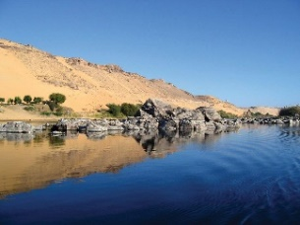  Nile  Curriculum Grid  Spring 2 Y5/6 |  |  | Science  In Science this half-term, we will be finding out about Animals including Humans.  This will involve:  - Describing the changes as humans develop to old age.  - Identify and name parts of the human circulatory system and describe the functions of heart, blood and blood vessels.  - Describing the ways in which nutrients and water are transported within animals. |  | Maafa  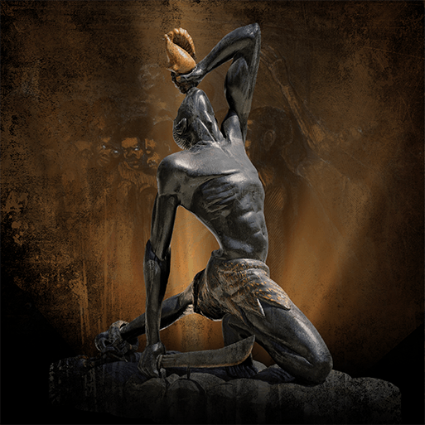
French  In French, this half-term, we will be learning about At the Weekend.  This will include:  - How to tell the time in French.  - Say and write in French what we have done at the weekend.  - Use conjunctions to make more interesting sentences. | Art  In Art, this half-term, we are going to be looking at Trail Blazers.  This unit will include:  - Researching significant black artists and their work.  - Analysing and creating artwork inspired by the artists studied. |  | Music  In Music, we will be receiving Ukulele lessons.  We will also be taking part in whole school singing lessons.  This will include, sing in unison with others. |  | Computing  In computing, we are going to explore web creation. This will involve:  - Exploring websites created for a chosen purpose.  - Identify what makes a good web page, creating a checklist.  - Using what makes a good webpage checklist to design and evaluate their own website using Google Sites.  - Learning about copyright and fair use of media, the aesthetics of the site, and navigation paths. |  | P.E.  In P.E. this half-term, we will be focusing on Dance ready to perform in front of the school in our Dance Festival.  We will also be focussing on Commando Jo’s in our NUFC lessons.  Children will need to come in their P.E. kits on Monday and Wednesday.

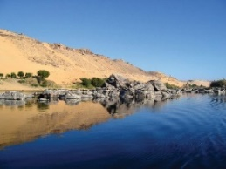
Links to our curriculum drivers Nile Class Spring 2 Y5.6
The following drivers underpin our school curriculum and, with our vision and values, allow us to deliver our curriculum strategy. These key drivers are personal to our schools and reflect the locational, social and educational needs of our community.
Curriculum Driver | Links within our curriculum this half term
Christianity and Faith | - PSHCE – Myself – different faiths/beliefs/cultures as people mature and age.  - RE - Young Leaders.  - The celebration and events leading up to Easter.
Our Local Area | - Exploring the animals within our local area and how they have adapted over time.  - Visit to ‘The Rum Story’ to explore black history.  - Year 6 study project linked with Durham University.
Outdoor Growing, Learning and Environment | - Science – identifying and comparing animals within the local area.  - Exploring how we are all different and how our body will grow and change.  - Eco Schools representatives to monitor class pledges in school.  - Following our environmental pledge – litter picking.
Wider World and Diversity | - PSHCE/RE – how we change and how we are all different.  - Black history and black artists.  - Young leaders.  - Studying a different language – French.  - Preparing to attend a university.  - Celebrate a range of authors during World Book Day.  - Explore and celebrate dances from a range of cultures at the school dance festival.

