Summer 1 
Year 5.6
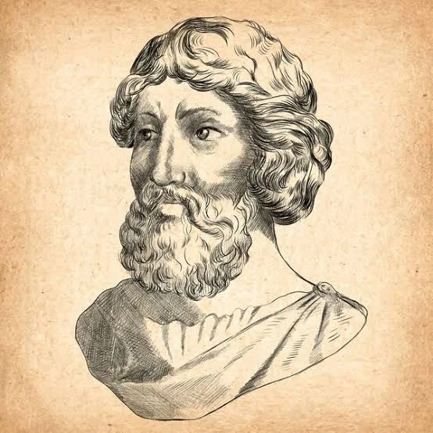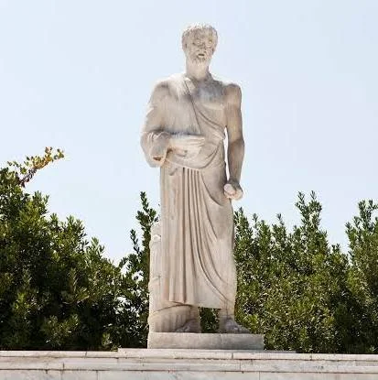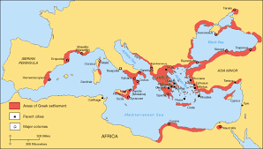
Ground-Breaking Greeks
Year 6: Complex and Comparative Skills (Ground-Breaking Greeks)
- Chronology: I can accurately place the Greek civilisation on a timeline and evaluate its duration and development in relation to other periods of history.
- Evidence & Exploration: I can evaluate and describe the reliability of different sources to explain exactly what the evidence tells us about this period of time.
- Civilisation Periods: I can provide a comparison between Minoan, Mycenaean, Archaic, and Dark Age periods of how the civilisation changed over time.
- Daily Life & Society: I can analyse the significance of city-states and democracy and evaluate how these systems influenced the lives of different groups in ancient Greek society.
- Civilisation Comparison: I can provide a complex comparison between the Greeks, Egyptians, and Romans, evaluating the specific cultural or political factors that made each civilisation unique.
- Legacy: I can explain exactly how the contributions of significant figures like Hippocrates and Aristarchus have influenced our lives today and describe their lasting legacy.
Golden Historical Threads
- What evidence tells us about this period of time?
- What was significant about this period of time and person?
- How has this time or person influenced our lives today?

Summer 1
Year 5.6
Ground-Breaking Greeks
Year 5: Foundational Skills (Ground-Breaking Greeks)
- Chronology: I can place the Greek civilisation on a timeline and compare its location to other civilisations I have studied.
- Evidence & Exploration: I can identify different sources of information and talk about whether they are primary or secondary sources.
- Civilisation Periods: I can recall facts from and describe different periods in ancient Greek history, such as the Minoans, Mycenaeans, and the Archaic period.
- Daily Life & Society: I can explain what life was like in ancient Greece, including the roles of men and women, the hierarchy of society, and the use of democracy.
- Civilisation Comparison: I can identify simple similarities/differences between three ancient civilisations: the Egyptians, the Romans, and the Greeks.
- Legacy: I can describe significant people from the past, such as Hippocrates and Aristarchus, and identify one way they affected our world today.
Golden Historical Threads
- What evidence tells us about this period of time?
- What was significant about this period of time and person?
- How has this time or person influenced our lives today?

