Spring 1 
Year 3.4
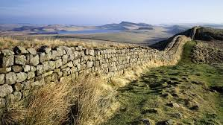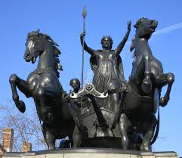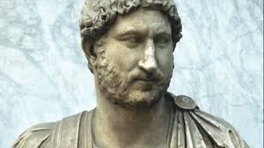
Emperors and Empires (The Romans)
Year 3: Foundational Skills (Empires and Emperors)
- Chronology: I can place the Roman civilizations on a timeline.
- Evidence & Local Study: I can tell you about what I have learnt through a local study and an educational visit to the Romans at Vindolanda.
- Civilization Growth: I can describe how the Roman Empire grew into a major civilization.
- Significant People: I can describe an important historical person from the past, such as Boudicca or Emperor Hadrian.
- Causation: I can evaluate why an important event happened in the past, such as the building of Hadrian’s Wall.
- Legacy: I can describe people from the past who were important and identify one way they have affected life today

Golden Historical Threads
- What evidence tells us about this period of time?
- What was significant about this period of time and person?
- How has this time or person influenced our lives today?

Spring 1
Year 3.4
Emperors and Empires (The Romans)
Year 4: Complex and Comparative Skills (Empires and Emperors)
- Chronology: I can place the Roman civilizations on a timeline and compare this to other civilizations I have studied, such as the Stone Age or Iron Age.
- Evidence & Local Study: I can evaluate what different pieces of evidence from our local study tell us about this specific period of time.
- Civilization Growth: I can explain the specific reasons why the Romans invaded Britain and describe the lasting legacy they left behind.
- Significant People: I can explain how the actions of historical figures like Boudicca and her rebellion influence us now.
- Causation: I can evaluate the significance of major events like the Roman invasion and explain how they influenced the country's development.
- Legacy: I can discuss in detail how the Roman civilization and its emperors have influenced our lives today, using the "Golden Historical Threads" to justify my thoughts
Golden Historical Threads
- What evidence tells us about this period of time?
- What was significant about this period of time and person?
- How has this time or person influenced our lives today?

