English  We are continuing with our significant author – David Walliams and our class text for this half term is ‘The World’s Worst Teachers’. Our guided reading text is ‘The Island at the End of the Bed’’ by Alice Kuipers. We will also be looking at the ‘River’ poem by our significant poet – Valerie Bloom.  In writing, our focus will be diary writing, historical narrative, non-chronological report writing, explanation texts, newspaper reports and poetry. |  |  | R.E.  In R.E. this half-term, we will be learning about Salvation:  - The events of Holy Week;  - Good Friday and Maundy Thursday;  - The sacrifice and resurrection of Jesus, and  - the Last supper  This will all lead up to our Easter celebrations. |  |  | Art  In art, we will be looking at statues and stories. This will include:  -Investigating statues, statuettes and figurines;  -Figure drawing;  -Ancient sculpture, and  -making Egyptian style figurines. |  | Maths  In maths, we will be working on fractions and decimals for Year 4 and fractions, mass and capacity for Year 3. We will continue our work on multiplication in readiness for the Year 4 multiplication test in June and we will use TT Rockstars and other resources to help support this.  We are going to be looking at word problems with our children too to help consolidate this skill. We will be identifying key information from the word problem, deciding which operation is needed and then learning how to solve them. |  |  |  | PSHCE/RSE  In PSHCE/RSE, our theme is Healthy Me. This year, we will be looking at keeping ourselves safe. Our weekly themes include:  - Recognising, predicting, assessing and managing risk;  - Keeping safe in the local environment;  - Peer influence;  - Keeping safe online – how online actions can impact;  - How to report concerns, and  - Rules and laws and how they are there to keep people safe.
The Rhine  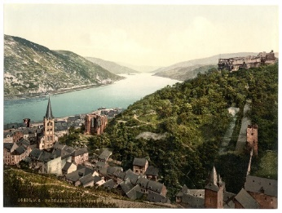  Curriculum Grid  Spring 2  Y3/4 |  | Science  In science, we will be finding out about sound:  -How they are made;  -Vibration as sound;  -How sound transfers through different materials;  We will look at the work of the percussion band STOMP and explore pitch and volume.  We will also continue our work on scientific investigation with a focus on recording and concluding investigations. |  |  | Design and Technology  We are linking our design and technology to our new theme ‘The Egyptians’ which starts mid-way through this half-term. We will be finding out how simple machines make life easier and then working with levers, wheels and axles to make our own simple machines. |  | History  In history, we are finding out about the Egyptians. We will study:  -Ancient Egypt;  -City life in Ancient Egypt;  - Heirarchy;  - The role of the Pharoah;  - Tales from the tomb, and  - comparing the Romans to the Egyptians. |  |  | Geography  In Geography, we will be finalising our work on our Misty Mountain, winding river.  The children will learn about Rivers; Maps; Grid references; Contour lines; Physical processes – erosion, transportation and deposition; World rivers; Aerial images; Mountains; UK mountains; World mountains; Compass points; Water cycle; Soil; Altitudinal zones; Data analysis |  |  | Misty Mountain, Winding River  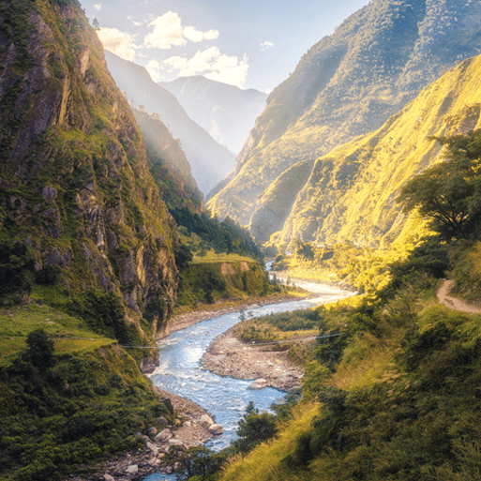
French  In French, we will be learning about ancient Britain – l’ancienne histoire de la Grande Bretagne. As part of this, we will be learning the language for key periods in Ancient Britain. We will learn how to say and use ‘Je suis;, J’ai and J’habite. | Music  In music, we will be following our Charanga theme – our focus will be ‘Stop’. This is a rap song about bullying. We will be finding the pulse, performing and sharing and finishing by writing our own rap verses. We are also learning how to play the Ukelele with Mr Reed. We will also continue our weekly singing. |  |  | Beneath our Feet  Alongside our themes, we are also taking part in a project entitled ‘Beneath our Feet’, which we started a few months ago now. We have already produced some murals of our schools in the style of Norman Cornish and Dorothy and John Cornish are due to come and visit this month to talk about his work and life. This work leads us into looking at local mines and the mining industry of the past and ties in working with our local community and school partnership. |  |  |  |  | Computing  In computing, our theme is events and actions in programs. As part of this, we will:  - make a sprite;  - maze movement;  - drawing lines;  - adding features;  - debugging movement,  and making a project. |  | P.E.  In P.E. this half-term, we will be focusing on swimming. In Commando Joe sessions, we will learn more about teamwork, social development and resilience.  We will also be taking part in the Dance Festival at the end of March.  Children will need to come in their P.E. kits on Monday and Wednesday each week.

Links to our curriculum drivers Rhine Class Spring 2 Y3/4
The following drivers underpin our school curriculum and, with our vision and values, allow us to deliver our curriculum strategy. These key drivers are personal to our schools and reflect the locational, social and educational needs of our community.
Curriculum Driver | Links within our curriculum this half term
Christianity and Faith | - R.E. – Salvation. We are working towards our Easter celebrations in our local church.  - R.E. Leaders and Y5/6 leading our ‘Roots and Fruits’ worships weekly.  - Regular worships with Father Stephen.
Our Local Area | - Salmon Eggs to be released into the local river system – supplied by River Trust.  - History – local mines; virtual classroom experience – Norman Cornish provided by Beamish.  - Working with Dorothy and John Cornish as part of the project – Beneath our Feet.  - P.E. - Allendale Dance Festival.  - P.E. - Swimming lessons at Wentworth Leisure Centre.  - PSHE – Keeping safe in our local community.
Outdoor Growing, Learning and Environment | - Eco Schools Representatives  - Geography - Links with the Royal Horticultural Society for the school allotment – going for level 5 award  - Environmental pledges – to look after and encourage wildlife into our school grounds  - Salmon Egg rearing to be released into the local riverTyne supplied by the River Trust  - Science - Class fish
Wider World and Diversity | - School Council  - French – Learning about a different language  - Poet – Valerie Bloom  - History – The Egyptians  - Design and Technology – Tomb Builders  - Design and Technology – making Dandia Raas dance sticks  - Art – Making Egyptian style figurines  - P.E. - Allendale Dance Festival – Dandia Raas dance

