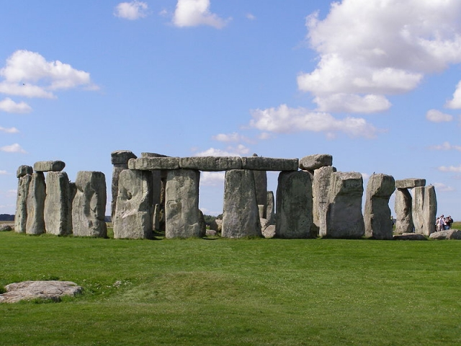
Spring 1 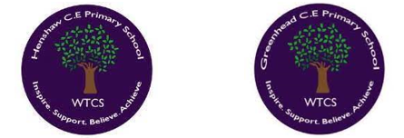
Year 3.4
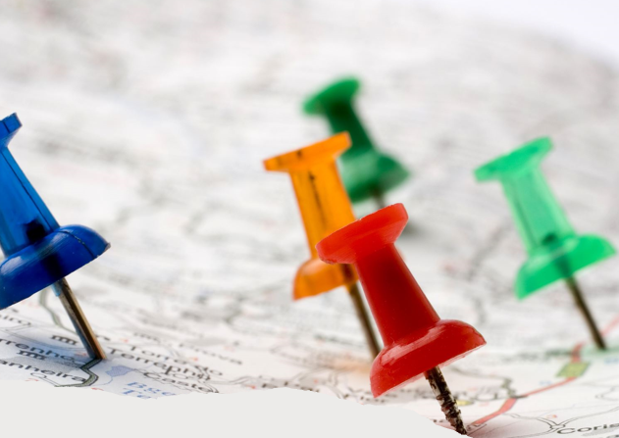
Regional Know How
Year 3: Foundational Skills (Regional Know How)
- Location: I can describe the relative location of the region in which we live (the North East).
- Mapping & Tech: I can explore different maps and know that they can take various forms, such as paper, digital, or a globe.
- Characteristics: I can identify and provide simple examples of the physical and human characteristics of the North East.
- Economic Context: I can identify characteristics of the North East linked to the economy and identify simple changes over time.
- Settlement: I can talk about the simple reasons why people choose to make settlements in our region.
- Change & Legacy: I can identify the job of a cartographer and know that William Roy changed the world through mapping.

Golden Geographical Threads
- Where is the location of this learning sequence compared to other places I have studied? What does it look like on a map?
- Why do people make settlements in this place?
- How has this environment changed over time?

Spring 1
Year 3.4
Regional Know How
Year 4: Complex and Comparative Skills (Regional Know How)
- Location: I can describe the location of the North East in relation to other places I have studied and explain what it looks like on a map.
- Mapping & Tech: I can practice reading aerial photos and OS map extracts, using the OS map legend and symbols to read a regional map.
- Characteristics: I can use specific map evidence to describe and compare the detailed physical and human characteristics of the North East.
- Economic Context: I can explain the links between regional characteristics and the economy, describing how these factors have caused change over time.
- Settlement: I can explain the specific geographical reasons why people originally chose to make settlements in this region.
- Change & Legacy: I can explain exactly how William Roy changed the world through Ordnance Survey Mapping and describe in detail how our environment has changed over time.
Golden Geographical Threads
- Where is the location of this learning sequence compared to other places I have studied? What does it look like on a map?
- Why do people make settlements in this place?
- How has this environment changed over time?

