English  Our class author this year will be Julia Donaldson.  Our guided reading tests will be looking at a Walk in Paris and a Walk in London by Salvatore Rubbino.  Our writing styles for this half-term are: Narrative, traditional tales, instructions and information texts. We will have our Read, Write, Inc phonics sessions daily as well as our reading sessions. We will continue to practise our spellings. Our Grammar and punctuation focus will be: conjunctions, nouns and verbs, plural nouns, past and present tenses, noun phrases, capital letters, full stops, apostrophes for possession and suffixes er and est. | Maths  In Maths during this half term, we will be looking at Geometry, Fractions and multiplication and division.  Year 1:  Multiplication and division: We will begin to count in 2s, 5s and 10s using different representations and singing songs or rhymes. We will develop our understanding of the language associated with multiplication and division. We will practise making equal and unequal groups and use this knowledge to move on to identifying and recording a number sentence to match the groups.  Geometry:  We will: Begin to recognise and name 2d and 3d shapes. We will sort shapes and use shapes to create or complete a shape pattern.  Year 2:  Multiplication and division: We will explore multiplying and dividing by 2, 5 and 10. We will begin to make the connection between repeated addition and multiplication by making equal and unequal groups. We will represent equal groups by using concrete resources or drawing pictures. We will develop our understanding of the multiplication symbol and begin to recognise commutativity by using arrays. We will  Geometry:  We will: Begin to recognise and name 2d and 3d shapes. We will count how many vertices and faces a shape has. We will look at lines of symmetry and use lines of symmetry to complete shapes. We will use shapes to make shape patterns or complete a shape pattern. |  |  | Geography: Bright Lights Big City.  We will:  Name and locate the four countries of the UK and their capital cities on a map, atlas or globe.  We will begin to use basic geographical vocabulary to look at physical features of the United Kingdom including, mountains, hills, cliff or forest.  We will begin to look at what makes a city and the features of other settlements. We will begin to look at human features in our local area and look at aerial photographs.  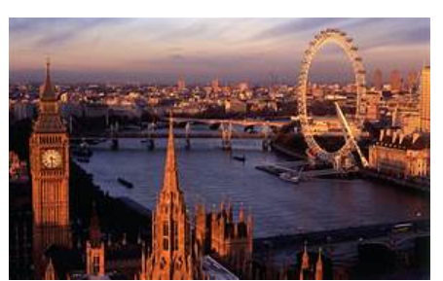
RE  We will look at Judaism.  We will introduce Jewish beliefs about God as expressed in the Shema (Deuteronomy 6:4-9) i.e. God is one, that it is important to love God. We will explore words of the Shema as a Jewish prayer. We will look at some Jewish festivals. |  |  | Design and Technology: Taxi  This project teaches children about wheels, axles and chassis and how they work together to make a vehicle move. We will explore the form and function of a London taxi to design our own taxi. | Thames Class  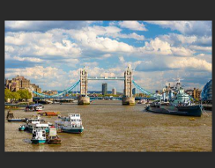  Curriculum Grid  Spring 1 Y 1./ 2
Music  We will continue to do our weekly singing session with Mr Reed. During Charanga we will be doing the unit: Rhythm in the way we walk. |  |  | Science. Animals including humans.  In Science this half-term, we will name at least seven different parts of the human body. (draw a diagram and label).  We will name the five senses and identify the part of the human body it is linked with (smell, taste, hear, see, touch)  We will identify offspring for a variety of animals (baby, lamb, chick, tadpole, hatchling) and describe how an offspring grows into a full growing animal (life cycle of a tadpole and a baby)  We will describe why it is important for humans to exercise, eat healthily and have good hygiene.
P.E.

In PE we will have two PE sessions every week. One session will be based on Commando Joe’s and the other one will be gymnastics.

PE Kit should be worn on Monday and Wednesday

Computing:  In computing this half-term, we will continue to utilise our new resource ‘Rainforest Coding’ and will begin ‘Module 3 which includes – The Robot’s plan where children will introduce and repeat loop and sounds, whilst debugging their code. |  | PSHE: We will look at dreams, goals and aspirations – self-care, support and safety. We will look at what we can do with money. What money is - that money comes in different forms  - how money is obtained (e.g. earned, won, borrowed, presents)  - how people make choices about what to do with money,  - including spending and saving  - the difference between needs and wants - that people may not always be able to have the things they want.

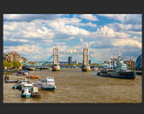
Links to our curriculum drivers Thames Class Spring 1 Y1/2
The following drivers underpin our school curriculum and, with our vision and values, allow us to deliver our curriculum strategy. These key drivers are personal to our schools and reflect the locational, social and educational needs of our community.
Curriculum Driver | Links within our curriculum this half term
Legacy and making a difference | We will look at dreams, goals and aspirations in PSHE.  What is the legacy of Thomas Kitchin?  What is the legacy of Elon Musk?  What is a Rabbi and how do they a make a difference to Jewish communities?
Christianity and Faith | We will explore Christian values during Collective Worship and demonstrate these throughout the school day. We will learn Bible stories and act out Bible Stories during. We will explore Judaism.  Morning, lunch time and Lord’s Prayer every day.
Outdoor learning and local area | We will look at the human features in our local area in Geography and identify what type of settlement we live in. We will continue with our eco-pledge (feeding the birds).  In maths we will see which 2D and 3D shapes we can find within our school grounds.
Wider World and Diversity | We will look at lifecycles and identify offspring from a variety of animals.  Observe the changes within our local area through the season Spring.  We look at how Jewish people around the world celebrate festivals.  We will be looking at similarities and differences between London and France and creating information texts about these places.

