Autumn 2 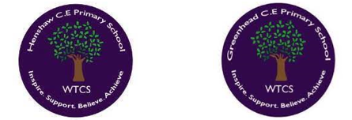
Year 1.2
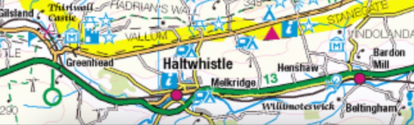
Let’s Explore our World
Year 1: Foundational Skills (Let’s Explore our World)
- Location: I can use world atlases and maps to locate different countries and continents.
- Mapping & Tech: I can identify hot and cold areas of the world in relation to the Equator and the North and South Poles.
- Comparison: I can identify simple similarities and differences between the United Kingdom and a contrasting non-European country like Greenland.
- Prioritisation: I can identify the key geographical features that make a country "hot" or "cold".
- Settlement: I can talk about why people choose to live in different parts of the world.
- Change & Legacy: I can identify simple ways the environment has changed over time and know that cartographers make maps.

Golden Geographical Threads
- Where is the location of this learning sequence compared to other places I have studied? What does it look like on a map?
- Why do people make settlements in this place?
- How has this environment changed over time?

Autumn 2
Year 1.2
Let’s Explore our World
Year 2: Complex and Comparative Skills (Let’s Explore our World)
- Location: I can describe the location of the countries I am studying in relation to other places I have already learned about.
- Mapping & Tech: I can explain the job of a cartographer and how William Smith changed the world through his mapping of Britain.
- Comparison: I can collect weather and population data and record it in tables to make detailed comparisons between countries.
- Prioritisation: I can evaluate which geographical factors (such as climate or location) are most important for people living in Greenland compared to the UK.
- Settlement: I can explain the specific reasons why people choose to make settlements in contrasting environments like the Arctic or the UK.
- Change & Legacy: I can explain how William Smith's legacy impacted our understanding of the world and describe in detail how specific environments have changed over time.
Golden Geographical Threads
- Where is the location of this learning sequence compared to other places I have studied? What does it look like on a map?
- Why do people make settlements in this place?
- How has this environment changed over time?

