Autumn 1 
Year 5.6
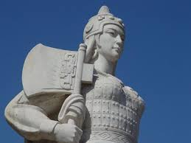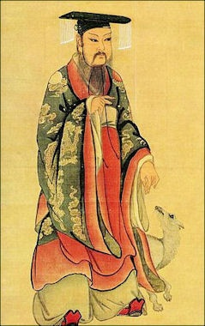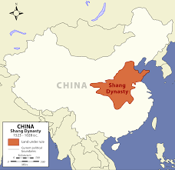
Dynamic Dynasties (Shang)
Year 5: Foundational Skills (Dynamic Dynasties - Shang)
- Chronology: I can place the Shang civilisation on a timeline and compare its location to other civilisations I have studied.
- Evidence & Exploration: I can identify archaeological evidence, such as the dig at Yinxu, and describe what it tells us about the past.
- Beliefs & Practices: I can explain the five key elements of religious beliefs and practices of the people in the Shang Dynasty.
- Materials & Daily Life: I can identify and describe the importance of specific materials and minerals in the Shang Dynasty, such as jade, bronze, and silk.
- Significant People: I can identify Fu Hao and describe her significance to religion and the military at that time.
- Legacy: I can describe important developments from the past, such as writing, astronomy, and maths, and identify how they have affected our world today.

Golden Historical Threads
- What evidence tells us about this period of time?
- What was significant about this period of time and person?
- How has this time or person influenced our lives today?

Autumn 1
Year 5.6
Dynamic Dynasties (Shang)
Year 6: Complex and Comparative Skills (Dynamic Dynasties - Shang)
- Chronology: I can accurately place the Shang civilisation on a timeline and evaluate its development in relation to multiple other global civilisations.
- Evidence & Exploration: I can evaluate and describe how specific archaeological finds from Yinxu tell us about the social hierarchy and daily life of the period.
- Beliefs & Practices: I can analyse the significance of Shang religious beliefs and evaluate how these practices influenced the dynasty's governance and military.
- Materials & Daily Life: I can explain the specific importance of bronze and jade and evaluate how these materials influenced the economic and social growth of the Shang civilisation.
- Significant People: I can provide a detailed comparison between Fu Hao and other significant leaders from different civilisations, evaluating her impact on history.
- Legacy: I can explain exactly how the legacies of Shang writing, astronomy, and maths have influenced our lives today and evaluate their long-term importance to modern society.
Golden Historical Threads
- What evidence tells us about this period of time?
- What was significant about this period of time and person?
- How has this time or person influenced our lives today?

