Spring 2 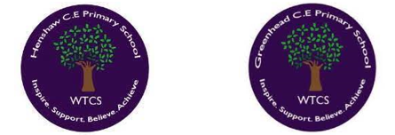
Year 5.6
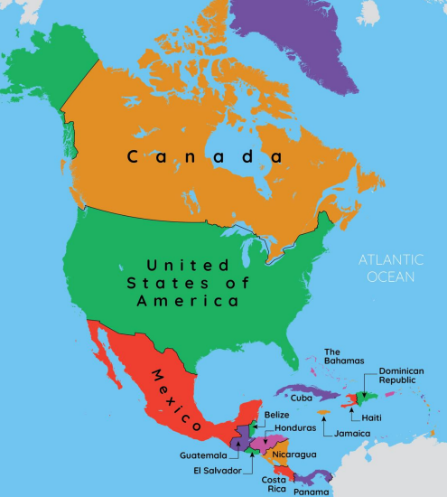
North America and the USA
Year 5: Foundational Skills (North America and the USA)
- Location & Mapping: I can use an atlas and digital maps to name and place different countries of North America on a map.
- Climate & Vegetation: I know that climate and vegetation vary depending on latitude and can give simple examples of this.
- Physical & Human Comparison: I can give examples of similarities/differences between the physical and human geographical features of the UK and the USA.
- Migration: I can describe the different waves of migration into the US since the 1700s and give basic reasons why people moved there.
- Settlement: I can talk about the location of this region compared to other places I have studied and describe reasons why people choose to live there.
- Legacy: I can identify Christopher Columbus and describe how his discovery changed the way Europeans began to map the world.
Golden Geographical Threads
- Where is the location of this learning sequence compared to other places I have studied? What does it look like on a map?
- Why do people make settlements in this place?
- How has this environment changed over time?

Spring 2
Year 5.6
North America and the USA
Year 6: Complex and Comparative Skills (North America and the USA)
- Location & Mapping: I can evaluate the location of North American countries to the rest of the world and how they appear on various map types.
- Climate & Vegetation: I can explain why climate and vegetation vary depending on latitude and evaluate how these factors affect the environment over time.
- Physical & Human Comparison: I can provide comparisons between the UK & USA, evaluating the impact of their physical and human geographical features.
- Migration: I can analyze the complex social and economic reasons for migration into the US since the 1700s and evaluate how these waves changed the country.
- Settlement: I can explain the specific geographical reasons why people made settlements in certain North American regions and evaluate how these environments have changed over time.
- Legacy: I can explain exactly how Christopher Columbus’ discovery changed the course of history and evaluate its legacy on how we map the world today.
Golden Geographical Threads
- Where is the location of this learning sequence compared to other places I have studied? What does it look like on a map?
- Why do people make settlements in this place?
- How has this environment changed over time?

