English  Our class author this year will be Julia Donaldson.  Our guided reading texts will be Toby and the Great Fire of London and Chocolate Cake by Michael Rosen.  Our writing styles for this half-term are: Narrative, Poetry, traditional tales, instructions and information texts. We will have our Read, Write, Inc phonics sessions daily as well as our reading sessions. We will continue to practise our spellings. Our Grammar and punctuation focus will be: conjunctions, nouns and verbs, plural nouns, past and present tenses, noun phrases, capital letters, full stops, apostrophes for possession and suffixes er and est. | Maths  In Maths during this half term, we will be looking a Place Value within 50, Fractions and multiplication and division.  Place value within 50:  We will look at the place value of numbers within 50. We will understand numbers up to 50 and represent them using concrete and pictorial representations. We will practise reading and writing numbers to 50.  Fractions:  We will explore recognising a half or two halves for the first time, looking at both objects and shapes. We will be introduced to recognising a quarter of an object or a shape. We will develop our understanding of equal parts and non-equal parts and relate this to a shape or object being split into four equal parts.  Year 2:  Multiplication and division: We will continue to explore multiplying and dividing by 2, 5 and 10. We will begin to make the connection between repeated addition and multiplication by making equal and unequal groups. We will represent equal groups by using concrete resources or drawing pictures. We will develop our understanding of the multiplication symbol and begin to recognise commutativity by using arrays.  Fractions:  We will use our understanding of parts and wholes to recognise equal and unequal parts. We will be introduced to the formal notation of fractions and consolidate our understanding of halves and quarters being equal parts. We will identify a fraction of a shape, a length and an amount. |  | Geography:  Bright Lights Big City.  We will:  Name and locate the four countries of the UK and their capital cities on a map, atlas or globe.  We will begin to use basic geographical vocabulary to look at physical features of the United Kingdom including, mountains, hills, cliff or forest. We will begin to look at what makes a city and the features of other settlements. We will begin to look at human features in our local area and look at aerial photographs.  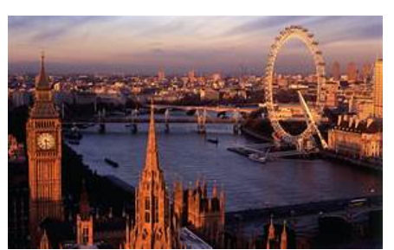  History:  We will begin to look at life in a Victorian classroom and make comparisons with school life now. We will use artefacts to support our understanding and look at significant events that have taken place in our own school in the past.
RE  We will look at Salvation (Digging Deeper)  Why does Easter matter to Christians?  Recognise that God, Incarnation, Gospel and  Salvation are part of the ‘big story’ of the Bible.  We will tell stories of Holy Week and Easter and make a link with the idea of Salvation (Jesus rescuing people). Give at least three examples of how Christians show their beliefs about Jesus as saviour in church worship. | Design and Technology: Taxi  We will continue this project to complete our taxi design and explore the form and function of our finished product by completing an evaluation. | Art: Funny Faces  We will look at the artwork of famous portrait artists and make comparisons. We will explore how to join materials and build upon the skills learnt to create our own funny face out of collage materials. | Thames Class  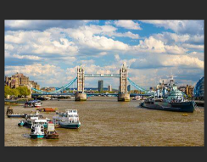  Curriculum Grid  Spring 2 - Y 1/ 2
Music  We will continue to do our weekly singing session with Mr Reed. During Charanga we will be doing the unit: Rhythm in the way we walk. | Science. Everyday Materials.  In Science this half-term, we will be finding out about materials and which materials are suitable for a particular purpose.  We will learn that objects are made from materials. We will identify a range of everyday materials and their sources. We will investigate the properties of materials and begin to recognise that a material's properties define its use.
P.E.
In PE we will have two PE sessions every week. One session will be based on Commando Joe’s and the other one will be dance.
PE Kit should be worn on Monday and Wednesday
Computing:  In computing this half-term, we will continue to utilise our new resource ‘Rainforest Coding’ and will begin Module 3 which includes – The Robot’s plan where children will introduce and repeat loop and sounds, whilst debugging their code. | PSHE: We will look healthy me – self-care, support and safety; what being healthy means and who helps us to stay healthy (e.g. parent, dentist, doctor);  why hygiene is important and how simple hygiene routines can stop germs from being passed on; what we can do to take care of ourselves on a daily basis, e.g. brushing teeth and hair, hand washing

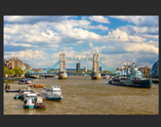
Links to our curriculum drivers Thames Class Spring II Y1/2
The following drivers underpin our school curriculum and, with our vision and values, allow us to deliver our curriculum strategy. These key drivers are personal to our schools and reflect the locational, social and educational needs of our community.
Curriculum Driver | Links within our curriculum this half term
Legacy and making a difference | We will look at dreams, goals and aspirations in PSHE.  What is the legacy of Samuel Wilderspin?  What is the legacy of Elon Musk?  We will look at the Legacy of Jane Roy and Glen Pearson the founders of the first food banks.  In Science we will explore the impact of Charles Mackintosh.
Christianity and Faith | We will explore Christian values during Collective Worship and demonstrate these throughout the school day. We will learn Bible stories and act out Bible Stories during worship.  We will look at key events from the Easter story and learn about how Christians follow Jesus by helping others. Morning, lunch time and Lord’s Prayer every day.
Outdoor learning and local area | We will look at the human features in our local area in Geography and identify what type of settlement we live in. We will continue with our eco-pledge (feeding the birds).  We will begin to look at the history of our school.  Observe the changes within our local area through the season Spring.
Wider World and Diversity | We will look at lifecycles and identify offspring from a variety of animals. This will involve a visit to a farm.  We will look at everyday materials and investigate their uses.  We will look at which Easter events during Holy week have had an impact on Christians around the world.

