Summer 1 
Year 3.4
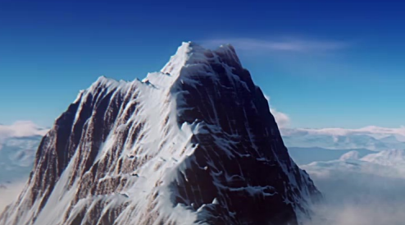
Mapping and Measuring Mountains
Year 3: Foundational Skills (Mapping and Mountains)
- Location: I can give examples of mountain names and locations and explain what latitude and longitude are.
- Mapping & Tech: I can identify that contours join places of equal height on a map and use them to find the height of the land.
- Characteristics: I can describe how mountains are formed and understand that water and ice shape them.
- Human Impact: I can identify simple benefits and disadvantages of mountainous areas attracting visitors.
- Settlement: I can describe how the location of a mountain affects where people choose to make settlements.
- Change & Legacy: I can identify who Sir Chris Bonington is and name the major achievements he has accomplished.
Golden Geographical Threads
- Where is the location of this learning sequence compared to other places I have studied? What does it look like on a map?
- Why do people make settlements in this place?
- How has this environment changed over time?

Summer 1
Year 3.4
Mapping and Measuring Mountains
Year 4: Complex and Comparative Skills (Mapping and Mountains)
- Location: I can use latitude and longitude to accurately locate mountain ranges and compare their location to other regions I have studied.
- Mapping & Tech: I can use contours to represent the shape of the land and explain how the closeness of these lines shows the steepness of a slope.
- Characteristics: I can explain the detailed processes of mountain formation and evaluate how environmental changes over time have affected their shape.
- Human Impact: I can evaluate interconnected benefits and disadvantages of tourism in mountainous regions, explaining how visitors affect the environment.
- Settlement: I can explain the specific geographical reasons why settlements are affected by their location in mountainous terrain and how these environments change over time.
- Change & Legacy: I can evaluate how Sir Chris Bonington’s legacy and achievements have influenced our understanding of mountains today.
Golden Geographical Threads
- Where is the location of this learning sequence compared to other places I have studied? What does it look like on a map?
- Why do people make settlements in this place?
- How has this environment changed over time?

