English  Our class texts are books by Roald Dahl – our significant author. We are going to continue reading ‘The Witches’ this term.  Our guided reading text is ‘The Last Days of Pompeii’.  We will also be working on Benjamin Zephaniah’s poem ‘Nature Trail’.  Our writing styles for this half-term are:  Diary, issues and dilemma narrative, newspaper report and playscript. In poetry, we will be learning about cinquain poems.  We will also be continuing our work on spellings, grammar and handwriting skills. | R.E.  In R.E. this half-term, we will be completing a module on Salvation and it will be looking at the question: Why do Christians remember the events of Holy Week every year? The children will know that: Christians see Holy Week as the culmination of Jesus’ earthly life, leading to his death and resurrection.  • The various events of Holy  Week, such as the Last Supper,  were important in showing the  disciples what Jesus came to do.  • Christians today trust that Jesus  really did rise from the dead, and  so is still alive today.  • Christians remember and  celebrate Jesus’ last week, death  and resurrection. |  |  | Maths  In Maths, during this half-term, our objectives For Year 3, the focus will be fractions followed by Mass and Capacity. In fractions, we will be finding out about the meaning of the numerator and denominator. We will be counting in fractions and comparing fractions. In Mass and Capacity, we will be using scales, measuring mass in kilograms and grams. We will be finding out about capacity and measuring capacity in litres and millilitres. In Year 4, we will be doing fractions followed by decimals. In fractions, we will be adding and subtracting fractions, comparing fractions and finding out about mixed numbers. In decimals, we will be learning how to use tenths and hundredths. There will also be a big focus on multiplication tables in readiness for the multiplication quizzes that Year 4 children take in June. |  | History  Our history theme is entitled ‘Emperors and Empires’. In this project, we will learn about the growth and decline of the Roman Republic and the Roman Empire. We will discover the absolute power of the Roman emperors and study the hierarchies of Roman society and the Roman army. We will study the first invasions of Britain in 55 and 54 BC and the Roman conquest of Britain in AD 43. We will learn about Boudicca’s rebellion, Hadrian’s Wall and the Romanisation of Britain, including how Christianity came to Britain and investigate the legacy of Roman Britain in our local area. |  | PSHCE/RSE  In PSHCE, we are continuing work on being the best that we can be. This module is entitled: Why should we eat well and look after our teeth? It follows on from the theme last half-term entitled: Why should we keep active and sleep well’. We will be looking at what makes a healthy balanced diet, food groups and what vitamins and nutrients our body needs. We will be comparing fresh foods with processed foods and looking at the differences. In the final session, we will be preparing a healthy meal, based on our research, to bring home for you to try. We will also be thinking about our teeth and finding out how we can keep protect our teeth, including the role of the dentist.
Rhine  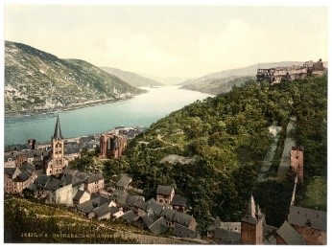  Curriculum Grid  Spring 2  Y3/4 |  |  | Computing  In computing, we are investigating branching databases. Learners will develop their understanding of what a branching database is and how to create one. They will use yes/no questions to gain an understanding of what attributes are and how to use them to sort groups of objects. Learners will create physical and on-screen branching databases. To conclude the unit, they will create an identification tool using a branching database, which they will test by using it. They will also consider real-world applications for branching databases. |  | MFL – French  In this unit, we will learn how to:  Name and recognise up to 10 fruits in French.  Attempt to spell some of these nouns.  Ask somebody in French if they like a particular fruit.  Say what fruits they like and dislike. |  | Emperors and Empires  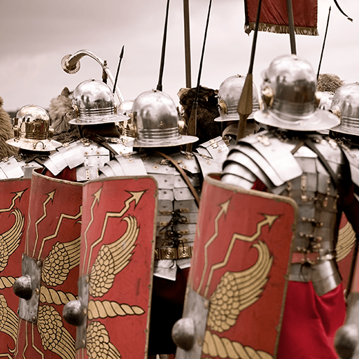
Science  Our science for this half term is ‘Animals, including Humans’. We will be identifying that humans and some other animals have skeletons and muscles for support, protection and movement. We will learn how to describe the functions of the digestive system in humans and identify the different types of teeth in humans and their simple functions. This will link well with our PSHCE theme. |  | Art  Our art focus for this half term is mosaics. We will be learning what mosaics are - pictures or patterns made using many small pieces of coloured stone or glass called tesserae. We will find out what other materials can be used – including paper, foil, pebbles or recycled materials. We will find examples of mosaics and how they were used to decorate floors, walls, ceilings and objects. We will find out about the history of mosaic making – how they were a common sight in Roman homes and public buildings across the Roman Empire. Mosaics were highly decorative. Their popular themes were everyday life, gods, gladiators, nature, animals and geometric patterns. |  |  | Music  In music this half-term, we are going to be continuing with our singing practice with Mr Read. He will also be holding our second round of ukulele teaching meaning that we will build upon the skills that we already have. Our Charanga theme is entitled Mama Mia. It is focused around the songs of Abba. The children will get the opportunity to listen to a selection of tracks and play along using the glockenspiels. |  |  |  | P.E.  In P.E. this half-term, we will be learning how to play hockey and we will be practising our dance routine for the dance festival coming soon.  Children will need to come in their P.E. kits on Thursday and Friday each week.
Links to our Curriculum Drivers - Rhine Class Spring 2 - Year 3.4
The following drivers underpin our school curriculum and, with our vision and values, allow us to deliver our curriculum strategy. These key drivers are personal to our schools and reflect the locational, social and educational needs of our community.
Curriculum Driver | Links within our curriculum this half term
Christianity and Faith | - R.E. – Exploring the concept of Salvation  - Easter Celebrations at All Hallow’s Church followed by Easter Egg competition in school hall.  - Roman Empire and its links to Christianity.
Outdoor learning and the local environment | - Use of allotment for planting and growing.  - Establishment of planted pots at front of school.  - Eco Pledge – to encourage more living things into our environment  - RHS level 5 certification work involving the community.  - Looking after livestock – chickens.  - Roman links with the local community – Hadrian’s wall and Vindolanda.  - Eco Schools Representatives checking and maintaining our Eco Green Flag status.  - Visit to Haltwhistle Leisure Centre for Dance Festival.  - Mosaic pathway made from pebbles.
Legacy and making a difference | - Roald Dahl – our class reader  - Benjamin Zephaniah – our class poet and his work  - Desmond Tutu and his work on anti-apartheid and human rights.  - Emperor Hadrian – his achievements and work in our local area.  - Jane Goodall and the impact of her research with chimpanzees.
Wider World and Diversity | - PSHCE/RE – Healthy lifestyles.  - French – Learning about a different language  - History – Romans and their impact on Britain.

