- ow has this time or person influenced our lives today?
Spring 2 
Year 1.2
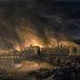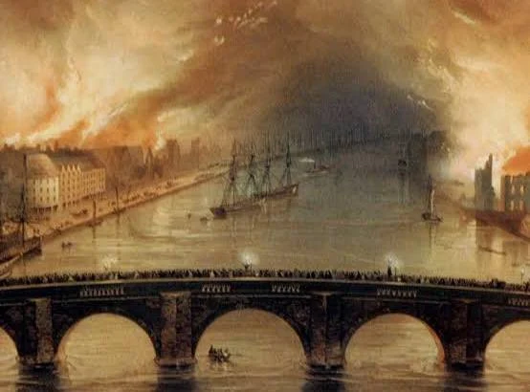
The Great Fires of the Past – Gateshead and London
Year 1: Foundational Skills (Great Fires of the Past)
- Location: I can identify the locations of London and Gateshead where the Great Fires took place.
- Evidence & Exploration: I can explore historical objects such as written accounts, photographs, and paintings to see what happened.
- Comparison: I can look at the Great Fire of London and the Great Fire of Gateshead to see simple differences between them.
- Causation: I can use historical evidence to figure out the simple causes of the Great Fires.
- Buildings & Settlement: I can compare buildings from 1666 and 1854 to how buildings look today.
- Legacy: I can name and describe important people from the past, such as Samuel Pepys and Robert Pattinson.

Golden Historical Threads
- What evidence tells us about this period of time?
- What was significant about this period of time and person?
- How has this time or person influenced our lives today?

- ow has this time or person influenced our lives today?
Spring 2
Year 1.2
The Great Fires of the Past – Gateshead and London
Year 2: Complex and Comparative Skills (Great Fires of the Past)
- Location: I can explain how the specific location and environment of these cities influenced the impact of the fires.
- Evidence & Exploration: I can evaluate what different pieces of evidence (paintings vs. written accounts) tell us about this period of time.
- Comparison: I can order specific events and stages on a timeline to show how the fires unfolded over time.
- Causation: I can reason why the historical events happened and explain exactly why the fires were able to spread so quickly.
- Buildings & Settlement: I can contrast the materials and styles of buildings in 1666, 1854, and today to explain how fire safety has changed.
- Legacy: I can explain how significant people like Samuel Pepys and Robert Pattinson have influenced and affected our lives today
Golden Historical Threads
- What evidence tells us about this period of time?
- What was significant about this period of time and person?
- How has this time or person influenced our lives today?

