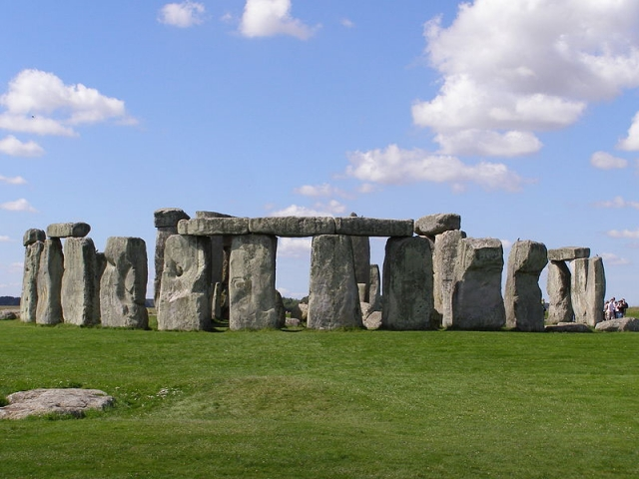
Autumn 1 
Year 3.4
Through the Ages (Stone Age to Iron Age)
Year 3: Foundational Skills (Through the Ages)
- Chronology & Vocabulary: I can place the Stone Age, Bronze Age, and Iron Age on a timeline using the terms BC and AD.
- Evidence & Exploration: I can explore evidence from the past to describe what life was like, including the tools and settlements people used.
- Comparison: I can describe simple similarities and differences between people from different periods, such as the Beaker folk.
- National Context: I can talk about important developments across the country, such as the introduction of farming in the Iron Age.
- Significance: I can identify what was significant about a person from the past, such as the Amesbury Archer, and the insights they give us into history.
- Legacy: I can describe how people from the past have affected our understanding of history and identify one way their lives influenced the future

Golden Historical Threads
- What evidence tells us about this period of time?
- What was significant about this period of time and person?
- How has this time or person influenced our lives today?

Autumn 1
Year 3.4
Through the Ages (Stone Age to Iron Age)
Year 4: Complex and Comparative Skills (Through the Ages)
- Chronology & Vocabulary: I can accurately place the Stone, Bronze, and Iron Ages on a timeline and compare this to other civilizations studied.
- Evidence & Exploration: I can evaluate and describe what different types of evidence tell us about the period, including the religion and Celtic beliefs of the people.
- Comparison: I can provide detailed comparisons and contrasts between specific aspects of everyday life in the Stone Age and the Iron Age.
- National Context: I can explain the specific effect that major changes, such as the transition to farming, had on the country's development.
- Significance: I can explain the significance of a particular period of time, evaluating how the innovations of that era influenced the way people lived.
- Legacy: I can explain how the people and developments from the Stone Age to the Iron Age have influenced our lives today and describe their lasting legacy
Golden Historical Threads
- What evidence tells us about this period of time?
- What was significant about this period of time and person?
- How has this time or person influenced our lives today?

