Autumn 1 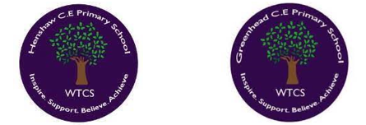
Year 5.6
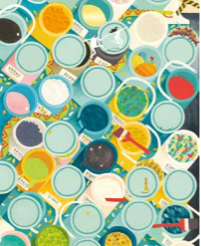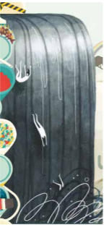
Creation and Fall: Creation and Science - conflicting or complementary?
- I can explain the important of Creation on a timeline of the Bible’s ‘Big Story’.
- I can identify what type of text some Christians say Genesis 1 is and its purpose.
- I can suggest what Genesis 1 might mean and compare my ideas with what Christians may interpret it as.
- I can show a clear understanding of why some Christians find science and faith go together.
- I can give reasons why I think Genesis 1 Creation is in conflict, or is complementary, with a scientific account.
Golden RE Threads
- Belonging and community – How does learning in this theme help followers to feel belonging and a sense of community?
- Connection to our Christian Values – Which of our Federation Christian Values does learning in this theme show?
- Treating others with respect and understanding – What lessons can be learnt from learning in this theme about treating others with respect and understanding?

Autumn 2
Year 5.6
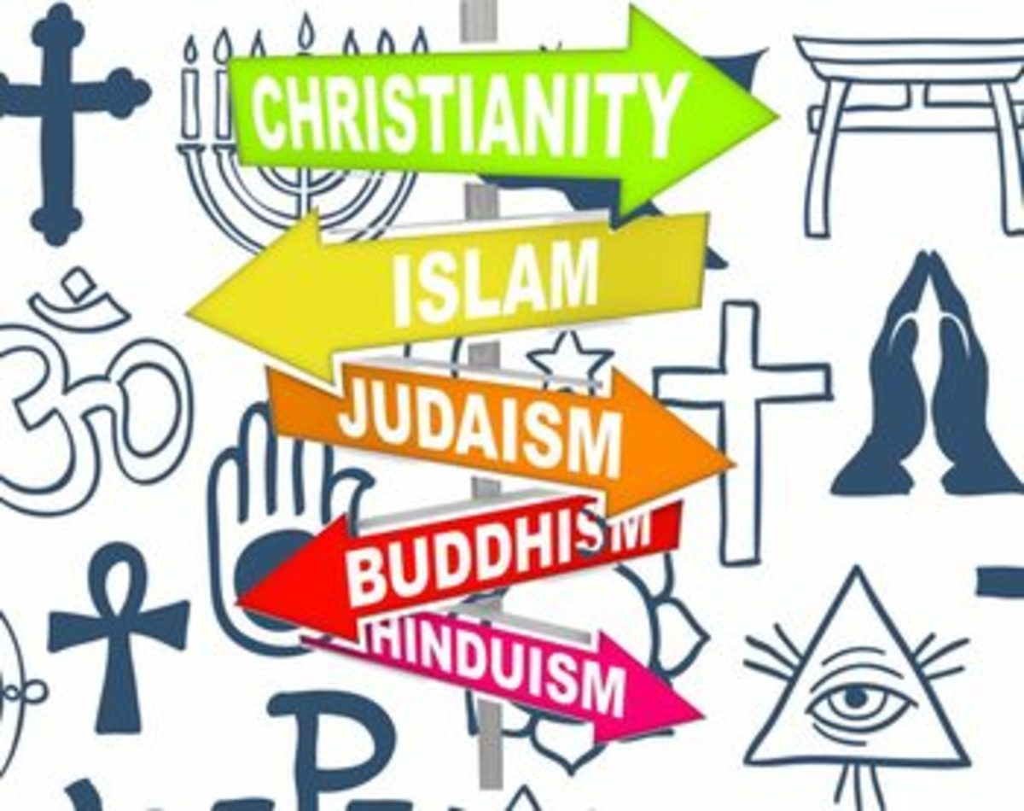
Judaism - What does it mean for a Jewish person to follow God?
- I can identify and explain Jewish beliefs about God. (Believe in one God and the command to love God with all their heart, soul and might).
- I can give examples of some texts that say what God is like and explain how Jewish people interpret them.
- I can make connections between Jewish beliefs about Torah & how they use it.
- I can make clear connections between Jewish commandments and how Jews live. (In relation to Kosher laws).
- I can give evidence and examples to show how Jewish people put their beliefs into practice in different ways (explaining differences between Orthodox and Progressive Jewish practise).
Golden RE Threads
- Belonging and community – How does learning in this theme help followers to feel belonging and a sense of community?
- Connection to our Christian Values – Which of our Federation Christian Values does learning in this theme show?
- Treating others with respect and understanding – What lessons can be learnt from learning in this theme about treating others with respect and understanding?

Spring 1
Year 5.6
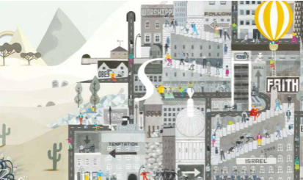
People of God - How can following God bring freedom and justice?
- I can explain connections between the story of Moses and the concepts of freedom and salvation.
- I can make clear connections between Bible texts (The story of Moses and the Exodus) and what Christians believe about being the People of God.
- I can explain ways in which some Christians put their beliefs into practice by trying to bring freedom to others. (Loving others, caring for them, bringing health, food, justice and telling the story of Jesus.)
- I can explain which of the ten commandments I believe, would have the most impact on the world today.

Golden RE Threads
- Belonging and community – How does learning in this theme help followers to feel belonging and a sense of community?
- Connection to our Christian Values – Which of our Federation Christian Values does learning in this theme show?
- Treating others with respect and understanding – What lessons can be learnt from learning in this theme about treating others with respect and understanding?

Spring 2
Year 5.6
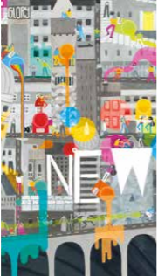
Kingdom Of God - What kind of King is Jesus?
- I can explain connections between biblical texts & the concept of Kingdom of God.
- I can consider different possible meanings for the biblical texts studied (The Feast: Luke 14:12–24, The Tenants in the Vineyard: Matthew 21: 33–46), showing my understanding of different interpretations.
- I can make clear connections between belief in the Kingdom of God and how Christians put their beliefs into practise in different ways (worship and serving the community).
- I can suggest how Christian beliefs about God’s kingdom could relate to my own life and the lives in our community.
Golden RE Threads
- Belonging and community – How does learning in this theme help followers to feel belonging and a sense of community?
- Connection to our Christian Values – Which of our Federation Christian Values does learning in this theme show?
- Treating others with respect and understanding – What lessons can be learnt from learning in this theme about treating others with respect and understanding?

Summer 1
Year 5.6
Hindus – Why do Hindus try to be good?

- I can identify and explain Hindu beliefs, e.g. dharma, karma, samsara, moksha using technical vocab.
- I can give meanings for the story of the man in the well and explain how it relates to Hindu beliefs (Samsara, moksha).
- I can make clear connections between Hindu beliefs about dharma, karma, samsara and moksha and ways in which Hindus live.
- I can connect the four Hindu aims of life and the four stages of life with beliefs about dharma, karma, moksha.
- I can explain how and why Hindu beliefs are important.
Golden RE Threads
- Belonging and community – How does learning in this theme help followers to feel belonging and a sense of community?
- Connection to our Christian Values – Which of our Federation Christian Values does learning in this theme show?
- Treating others with respect and understanding – What lessons can be learnt from learning in this theme about treating others with respect and understanding?

Summer 2
Year 5.6
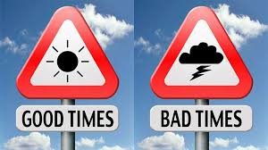
Thematic - How does faith help when life gets hard?
- I can describe three examples of ways in which religions guide people in how to respond to good and hard times in life (use of colour: Christians in Holy Week, candlelight: Hindu Diwali celebrations, Jewish: festival of Hanukkah explores struggling against evil.)
- I can identify and compare beliefs about life after death in two religious traditions.
- I can make clear connections between what people believe about God and how they respond to challenges in life (suffering and bereavement).
- I can use examples to show how beliefs about resurrection, judgement, Heaven, Karma, reincarnation make a difference to how someone lives.
- I can talk about the value of gratitude in the lives of people, whether believers and non-religious, including my own views.
Golden RE Threads
- Belonging and community – How does learning in this theme help followers to feel belonging and a sense of community?
- Connection to our Christian Values – Which of our Federation Christian Values does learning in this theme show?
- Treating others with respect and understanding – What lessons can be learnt from learning in this theme about treating others with respect and understanding?

Autumn 1: Creation and Fall: Creation and Science – conflicting or complementary?
Year 5: Foundational Skills
- Timeline Placement: I can explain the importance of Creation on a timeline of the Bible’s ‘Big Story’.
- Text & Purpose: I can identify what type of text some Christians say Genesis 1 is and explain its general purpose.
- Genesis Meaning: I can suggest what Genesis 1 might mean and outline how Christians may interpret these ideas.
- Science and Faith: I can show a clear understanding of why some Christians find that science and faith can go together.
- Conflict vs. Complementary: I can give simple reasons why I think the Genesis 1 Creation account is in conflict, or is complementary, with a scientific account.
Year 6: Complex and Comparative Skills
- Timeline Integration: I can evaluate the significance of Creation and analyze how it connects to other major chapters on the Bible's 'Big Story' timeline.
- Textual Analysis: I can analyze and explain the varying views Christians hold regarding the genre, style, and theological purpose of the Genesis 1 text.
- Comparative Interpretations: I can compare my own suggestions of what Genesis 1 means with diverse, complex Christian interpretations.
- Synthesis of Science & Faith: I can explain in detail how and why some Christians harmonize scientific discoveries with their personal faith.
- Critical Evaluation: I can formulate a structured, reasoned argument evaluating why the Genesis 1 Creation account can be seen as either in conflict or complementary with scientific accounts.

Autumn 2: Judaism – What does it mean for a Jewish person to follow God?
Year 5: Foundational Skills
- Beliefs about God: I can identify and explain Jewish beliefs about God, such as believing in one God and the command to love God with all their heart, soul, and might.
- Sacred Texts: I can give examples of some texts that describe what God is like and explain how Jewish people interpret them.
- Torah Connections: I can make simple connections between Jewish beliefs about the Torah and how they handle and use it.
- Commandments & Daily Life: I can make clear connections between Jewish commandments and how Jewish people live, especially in relation to Kosher laws.
- Practicing Faith: I can identify some ways Jewish people put their beliefs into practice, noting basic differences between Orthodox and Progressive Jewish practices.
Year 6: Complex and Comparative Skills
- Beliefs about God: I can analyze the theological meaning and daily impact of the Jewish command to love one God with all one's heart, soul, and might.
- Textual Interpretation: I can evaluate different texts that describe the nature of God, comparing how various Jewish groups interpret them.
- Torah & Authority: I can explain the profound spiritual connection between Jewish beliefs about the divine nature of the Torah and its practical use.
- Systemic Living (Kosher): I can analyze the reasons for the Jewish commandments and explain how Kosher laws shape the daily life, identity, and choices of Jewish people.
- Comparative Practice: I can provide detailed evidence and examples to compare and contrast how Orthodox and Progressive Jewish communities put their core beliefs into practice.

Spring 1: People of God – How can following God bring freedom and justice?
Year 5: Foundational Skills
- Moses, Freedom, & Salvation: I can explain simple connections between the story of Moses and the concepts of freedom and salvation.
- People of God: I can make connections between Bible texts like the story of Moses and the Exodus and what Christians believe about being the 'People of God'.
- Freedom for Others: I can explain ways in which some Christians put their beliefs into practice by trying to bring freedom to others, such as loving others, caring for them, or bringing health, food, and justice.
- The Ten Commandments: I can explain which of the Ten Commandments I believe would have an impact on the world today.
Year 6: Complex and Comparative Skills
- Moses, Freedom, & Salvation: I can explain complex theological connections between the narrative of Moses and the concepts of physical and spiritual freedom and salvation.
- Exodus & Covenant: I can analyze the relationship between the Exodus story and the Christian concept of belonging to the 'People of God'.
- Justice in Action: I can evaluate the specific ways modern Christians work to bring freedom, justice, healthcare, and food security to others as a direct reflection of their faith.
- Commandments Analysis: I can present a reasoned argument to evaluate and justify which of the Ten Commandments would have the most significant positive impact on global society today.

Spring 2: Kingdom Of God – What kind of King is Jesus?
Year 5: Foundational Skills
- Kingdom Concept: I can explain simple connections between biblical texts and the concept of the 'Kingdom of God'.
- Parable Interpretations: I can consider different possible meanings for the biblical texts studied, such as The Feast (Luke 14:12–24) and The Tenants in the Vineyard (Matthew 21: 33–46).
- Worship & Service: I can make clear connections between belief in the Kingdom of God and how Christians put their beliefs into practice, such as through worship and serving the community.
- Personal Connection: I can suggest how Christian beliefs about God’s kingdom could relate to my own life and the lives in our community.
Year 6: Complex and Comparative Skills
- Kingdom Concept: I can explain the deep theological connections between biblical texts and the concept of the 'Kingdom of God'.
- Comparative Parable Analysis: I can analyze and compare different possible interpretations of complex parables, such as The Feast and The Tenants in the Vineyard, showing a clear understanding of different viewpoints.
- Worship & Service: I can explain how and why Christians put their beliefs about the Kingdom of God into practice specifically through communal worship and serving others.
- Analytical Application: I can analyze and evaluate how Christian values of God's kingdom can be applied practically to address challenges in my own life and the wider community.

Summer 1: Hindus – Why do Hindus try to be good?
Year 5: Foundational Skills
- Key Vocabulary: I can identify and explain Hindu beliefs, such as dharma, karma, samsara, and moksha, using technical vocabulary.
- Story Analysis: I can give meanings for the story of the 'man in the well' and explain how it relates to Hindu beliefs like samsara and moksha.
- Daily Living: I can make connections between Hindu beliefs about dharma, karma, samsara, and moksha and the ways in which Hindus live.
- Aims & Stages: I can connect the four Hindu aims of life and the four stages of life with beliefs about dharma, karma, and moksha.
- Value of Belief: I can describe why Hindu beliefs are important to a Hindu follower.
Year 6: Complex and Comparative Skills
- Key Vocabulary: I can explain in detail the complex relationships between the concepts of dharma, karma, samsara, and moksha using precise technical vocabulary.
- Symbolic Analysis: I can analyze the metaphorical layers of the story of the 'man in the well' to explain its profound connection to samsara and moksha.
- Belief into Action: I can explain the clear, practical connections between a Hindu's understanding of dharma, karma, samsara, and moksha and their daily moral actions.
- Systemic Synthesis: I can analyze how the four aims of life and the four stages of life are dynamically linked to the overarching concepts of dharma, karma, and moksha.
- Evaluative Significance: I can evaluate how and why Hindu ethical frameworks remain highly significant in guiding actions in the modern world.

Summer 2: Thematic – How does faith help when life gets hard?
Year 5: Foundational Skills
- Responding to Hard Times: I can describe three examples of ways in which religions guide people in how to respond to good and hard times in life, such as the use of colour during Christian Holy Week, candlelight during Hindu Diwali celebrations, and the Jewish festival of Hanukkah.
- Life After Death: I can identify and compare beliefs about life after death in two religious traditions.
- Belief and Challenges: I can make connections between what people believe about God and how they respond to challenges in life, such as suffering and bereavement.
- How Belief Shapes Life: I can use examples to show how beliefs about resurrection, judgement, Heaven, Karma, and reincarnation make a difference to how someone lives.
- Value of Gratitude: I can talk about the value of gratitude in the lives of people, whether believers or non-religious, including sharing my own views.
Year 6: Complex and Comparative Skills
- Symbolic Coping Mechanisms: I can explain and evaluate how specific religious practices—such as Holy Week colours, Diwali candles, or Jewish stories of Hanukkah—symbolize hope and resilience during difficult times.
- Comparative Eschatology: I can compare and contrast the theological beliefs about life after death in two distinct religious traditions.
- Belief and Resilience: I can analyze the profound connections between a believer's understanding of God and their emotional or practical response to suffering and bereavement.
- Behavioral Impact of Belief: I can evaluate, using specific examples, how distinct concepts (such as resurrection, judgement, Heaven, Karma, and reincarnation) fundamentally transform a person's lifestyle, ethics, and choices.
- Critical Discussion on Gratitude: I can critically discuss the psychological and spiritual value of gratitude across both secular and religious groups, justifying my own personal stance.

