Summer 2 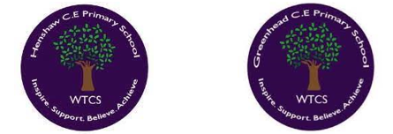
Year 3.4
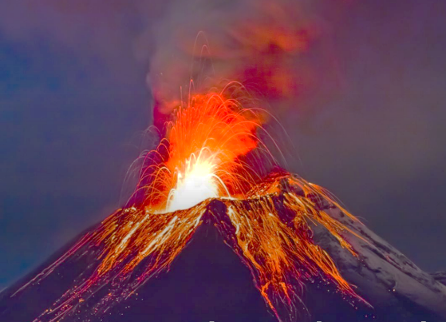
Earthquakes and Volcanoes
Year 3: Foundational Skills (Earthquakes and Volcanoes)
- Location: I can identify that the earth is made of layers (core, mantle, and crust) and name the general locations where most earthquakes and volcanoes happen.
- Mapping & Tech: I can use maps to identify volcanic regions and understand that the Earth's crust is divided into several large tectonic plates.
- Comparison & Characteristics: I can use key geographical vocabulary to describe the structure of a volcano and distinguish between shield and composite volcanoes.
- Prioritisation & Vocabulary: I can explain the simple difference between a natural hazard and a natural disaster.
- Settlement: I can talk about the simple reasons why people choose to make settlements in areas with volcanic or seismic activity.
- Change & Legacy: I can identify the job of a seismologist and describe simple ways that a volcanic eruption or earthquake changes the environment
Golden Geographical Threads
- Where is the location of this learning sequence compared to other places I have studied? What does it look like on a map?
- Why do people make settlements in this place?
- How has this environment changed over time?

Summer 2
Year 3.4
Earthquakes and Volcanoes
Year 4: Complex and Comparative Skills (Earthquakes and Volcanoes)
- Location: I can describe the location of volcanic and seismic zones in relation to other places I have studied and explain what these look like on a map.
- Mapping & Tech: I can describe how tectonic plates move in different directions /explain what happens at constructive, destructive and conservative boundaries.
- Comparison & Characteristics: I can provide specific examples of the benefits of volcanic activity (such as in Iceland) and compare these to the negative long and short-term effects of earthquakes.
- Prioritisation & Vocabulary: I can evaluate how a single event like a volcanic eruption can create a series of interconnected effects in the real world.
- Settlement: I can explain the specific geographical reasons why people originally made settlements in these high-risk areas and how these environments have changed over time.
- Change & Legacy: I can explain who Margarita Segou is and describe how her use of AI has changed the world's approach to natural disasters.
Golden Geographical Threads
- Where is the location of this learning sequence compared to other places I have studied? What does it look like on a map?
- Why do people make settlements in this place?
- How has this environment changed over time?

