Spring 2 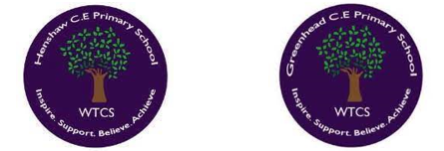
Year 1.2
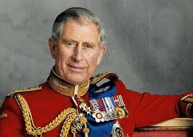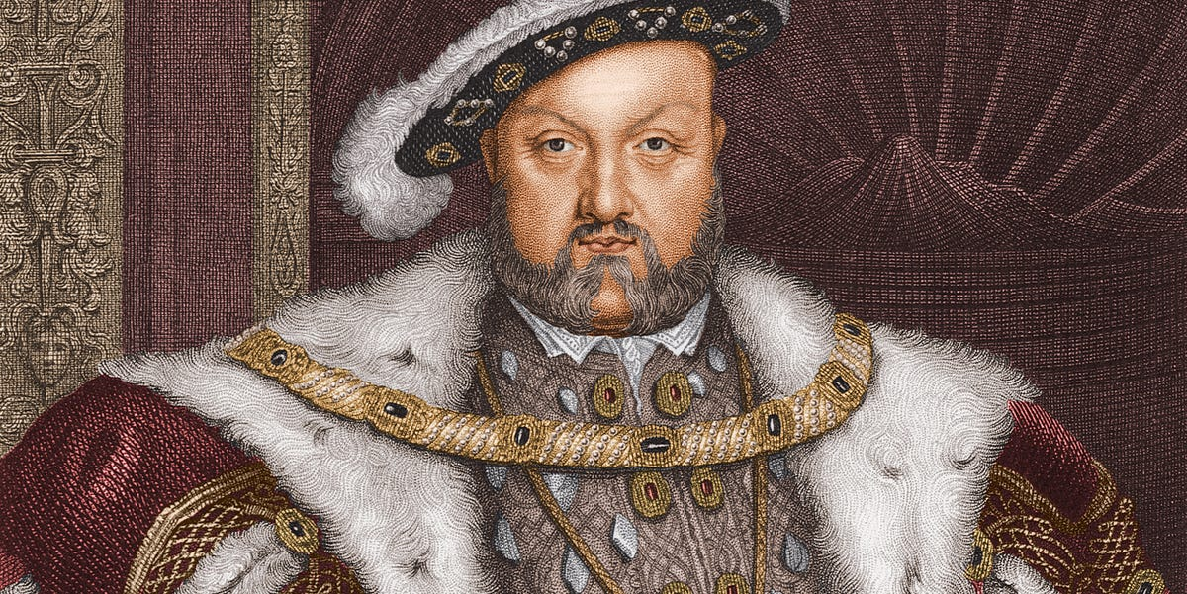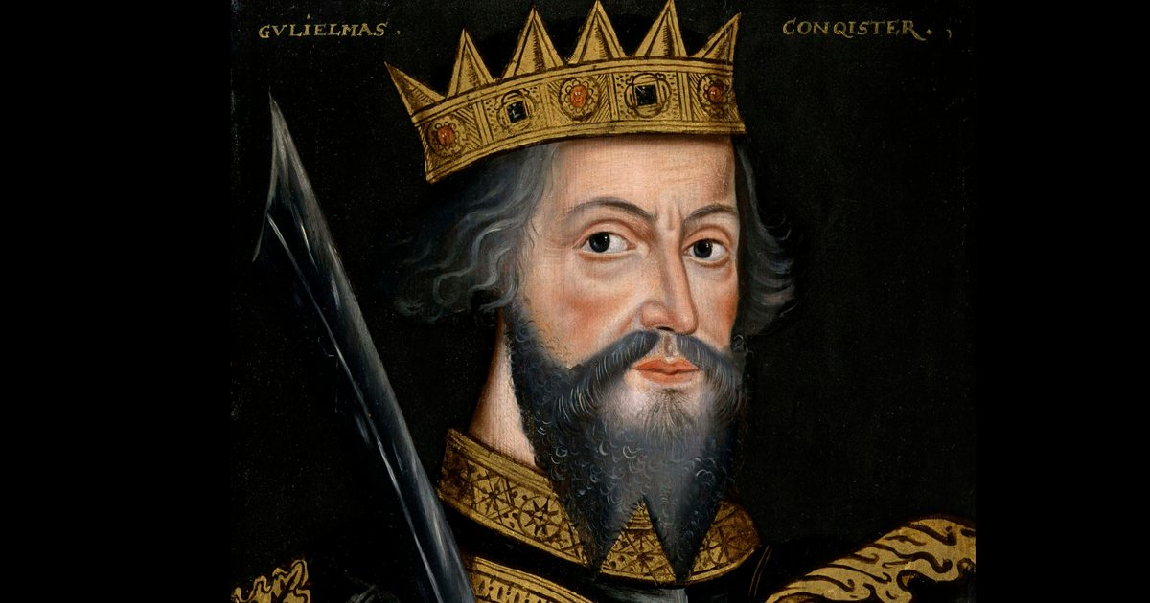
Marvellous Monarchs
Year 1: Foundational Skills (Marvellous Monarchs)
- Country & Context: I can talk about events beyond living memory that are important across the country, such as the lives of different monarchs.
- Evidence & Exploration: I can explore primary sources of information, such as paintings from the distant past and interviews, to learn about monarchs.
- Comparison: I can describe simple similarities and differences between the lives of monarchs of the past and the present.
- Significance: I can identify what was significant about the life of a specific monarch or a period of time.
- Chronology & Vocabulary: I can use historical vocabulary, such as 'past', 'present', and 'years ago', to talk about monarchs.
- Legacy: I can name and describe important people from the past, like King Charles III, and talk about how they have affected today

Golden Historical Threads
- What evidence tells us about this period of time?
- What was significant about this period of time and person?
- How has this time or person influenced our lives today?

Spring 2
Year 1.2
Marvellous Monarchs
Year 2: Complex and Comparative Skills (Marvellous Monarchs)
- Country & Context: I can explain the specific effect that different monarchs had on the country beyond just their own lifetimes.
- Evidence & Exploration: I can evaluate and describe primary sources to explain exactly what the evidence tells us about a specific period of time.
- Comparison: I can provide detailed comparisons between the lives of several monarchs, identifying how their roles and influences have changed.
- Significance: I can explain the significance of a particular person and evaluate how they have influenced our lives today.
- Chronology & Vocabulary: I can accurately use complex historical vocabulary, including 'decade', 'century', 'period', and 'AD', to describe when monarchs lived.
- Legacy: I can explain exactly how monarchs like William the Conqueror or Henry VIII have affected our world today and describe their lasting legacy
Golden Historical Threads
- What evidence tells us about this period of time?
- What was significant about this period of time and person?
- How has this time or person influenced our lives today?

