Reading in Year 4
- Apply growing knowledge of root words, prefixes and suffixes (etymology and morphology) - English Appendix 1, both to read aloud and to understand the meaning of new words they meet.
- Read further exception words, noting the unusual correspondences between spelling and sound, and where these occur in the word.
- Develop positive attitudes to reading & understanding of what they rea
- Listen to and discuss a wide range of fiction, poetry, plays, non-fiction and reference books or textbooks.
- Use dictionaries to check the meaning of words that they have read
- Increase familiarity with a wide range of books, including fairy stories, myths and legends, and retelling some of these orally. ·
- Identify themes and conventions in a wide range of books
- Prepare poems and play scripts to read aloud and to perform, showing understanding through intonation, tone, volume and action
- Discuss and clarifying the meanings of words, linking new meanings to known vocabulary.
- Discuss words and phrases that capture the reader’s interest and imagination
- Recognise some different forms of poetry [for example, free verse, narrative poetry]
- Check that the text makes sense, discussing their understanding and explaining the meaning of words in context
- Ask questions to improve their understanding of a text
- Draw inferences such as inferring characters’ feelings, thoughts and motives from their actions, and justifying inferences with evidence
- Predict what might happen from details stated and implied.
- Identify main ideas drawn from more than one paragraph and summarise these.
- Identify how language, structure, and presentation contribute to meaning
- To retrieve and record information from non-fiction
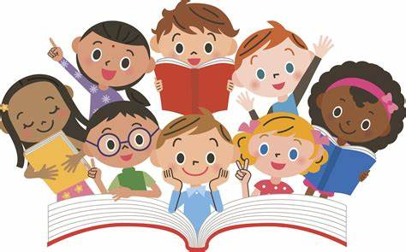
- Participate in discussion about both books that are read to us and those we can read for ourselves, taking turns and listening to what others say.

