Autumn 1 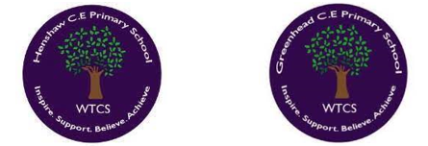
Year 3.4
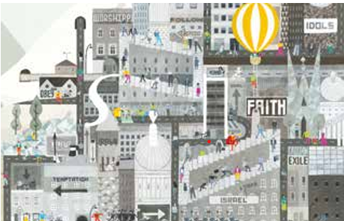
People of God:
What is it like for someone to follow God?
Year 3: Foundational Skills
- Noah’s Covenant: I can retell the story of Noah and identify that a covenant is a special, holy promise.
- Vows & Weddings: I can make simple links between the promises in the story of Noah and the promises Christians make today in a wedding ceremony.
- School & World: I can describe how the lessons from the story of Noah can guide the way we treat each other in our school and in the wider world.
- Community & Belonging: I can identify how making and keeping promises helps people build a strong, supportive community where they feel they belong.
Golden RE Threads
- Belonging and community – How does learning in this theme help followers to feel belonging and a sense of community?
- Connection to our Christian Values – Which of our Federation Christian Values does learning in this theme show?
- Treating others with respect and understanding – What lessons can be learnt from learning in this theme about treating others with respect?

Autumn 1
Year 3.4
People of God:
What is it like for someone to follow God?
Year 4: Complex and Comparative Skills
- Covenant Theology: I can explain the theological connection between the story of Noah and the biblical concept of a covenant.
- Comparing Promises: I can analyze and explain the detailed links between God’s covenant with Noah and the solemn vows made in a Christian wedding ceremony.
- Values in Action: I can explain how the moral lessons of Noah’s story relate to our own lives, linking them directly to our school’s Christian Values.
- Respect & Understanding: I can evaluate how living by shared promises encourages us to treat others with respect and builds a cohesive community.
Golden RE Threads
- Belonging and community – How does learning in this theme help followers to feel belonging and a sense of community?
- Connection to our Christian Values – Which of our Federation Christian Values does learning in this theme show?
- Treating others with respect and understanding – What lessons can be learnt from learning in this theme about treating others with respect?

Autumn 2
Year 3.4
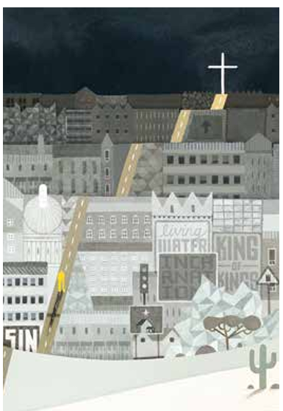
Incarnation (core)
What is Trinity?
Year 3: Foundational Skills
- Understanding Gospels: I can identify John 1 as a passage from a Gospel and point out simple differences in style between John and the other Gospels.
- Text Meaning: I can offer simple suggestions about what the descriptions of God in John 1:1–14 mean to Christians.
- The Trinity: I can describe what Christians believe about God the Trinity (Father, Son, and Holy Spirit).
- Living the Belief: I can give simple examples of how Christians show their beliefs about the Trinity in the way they choose to live.
Golden RE Threads
- Belonging and community – How does learning in this theme help followers to feel belonging and a sense of community?
- Connection to our Christian Values – Which of our Federation Christian Values does learning in this theme show?
- Treating others with respect and understanding – What lessons can be learnt from learning in this theme about treating others with respect?

Autumn 2
Year 3.4
Incarnation (core)
What is Trinity?
Year 4: Complex and Comparative Skills
- Gospel Analysis: I can analyse the unique theological nature of John 1, comparing its structure and opening themes with other Gospels in the Bible.
- Textual Interpretation: I can provide interpretations of John 1:1–14, explaining what "the Word became flesh" teaches Christians about the nature of God.
- Theological Action: I can explain how the concept of God the Trinity is represented in Christian worship and everyday lifestyle choices.
- Belief Connections: I can make clear connections between Bible teachings about the Trinity and modern Christian ideas of belonging and community, expressing my own views clearly.
Golden RE Threads
- Belonging and community – How does learning in this theme help followers to feel belonging and a sense of community?
- Connection to our Christian Values – Which of our Federation Christian Values does learning in this theme show?
- Treating others with respect and understanding – What lessons can be learnt from learning in this theme about treating others with respect?

Spring 1
Year 3.4

Sikhism: What does it mean to be Sikh in Britain today?
Year 3: Foundational Skills
- Sikh Beliefs: I can name key beliefs of Sikhism, such as the belief in one God and the teachings of Guru Nanak.
- The Mool Mantar: I can identify the Mool Mantar as a special Sikh prayer and describe what it says about God.
- Guru Legacies: I can make simple links between the life of Guru Nanak and the practice of Langar, or Guru Gobind Singh and the Khalsa.
- Triple Duties: I can identify that remembering God, working hard, and serving others are important duties to Sikhs today.
Golden RE Threads
- Belonging and community – How does learning in this theme help followers to feel belonging and a sense of community?
- Connection to our Christian Values – Which of our Federation Christian Values does learning in this theme show?
- Treating others with respect and understanding – What lessons can be learnt from learning in this theme about treating others with respect?

Spring 1
Year 3.4
Sikhism: What does it mean to be Sikh in Britain today?
Year 4: Complex and Comparative Skills
- Prayer & Practice: I can explain the detailed links between the Mool Mantar prayer and the everyday actions and beliefs of Sikhs today.
- Historical Legacy: I can explain exactly how the historical actions of Guru Nanak (creating the Langar free kitchen) and Guru Gobind Singh (establishing the Khalsa community) shape the modern lives of British Sikhs.
- Values in Action: I can analyse and evaluate how Sikh values of remembering God, working hard, and serving others (Seva) in local communities today.
- Community Belonging: I can evaluate how eating together in the Langar and joining the Khalsa help Sikhs build a strong sense of belonging and community and teach respect and understanding for all.
Golden RE Threads
- Belonging and community – How does learning in this theme help followers to feel belonging and a sense of community?
- Connection to our Christian Values – Which of our Federation Christian Values does learning in this theme show?
- Treating others with respect and understanding – What lessons can be learnt from learning in this theme about treating others with respect?

Spring 2
Year 3.4

Kingdom Of God: When Jesus left, what was the impact of Pentecost?
Year 3: Foundational Skills
- Pentecost Story: I can retell the story of the Day of Pentecost and link it to Christian beliefs about the Kingdom of God on Earth.
- Acts 2 Meaning: I can offer simple suggestions about what the description of Pentecost in Acts 2 might mean to Christians.
- The Holy Spirit: I can describe how Christians believe the Holy Spirit helps them live their lives and support their church communities.
- Following God: I can give simple examples of what people believe about following God in the world today.

Golden RE Threads
- Belonging and community – How does learning in this theme help followers to feel belonging and a sense of community?
- Connection to our Christian Values – Which of our Federation Christian Values does learning in this theme show?
- Treating others with respect and understanding – What lessons can be learnt from learning in this theme about treating others with respect?

Spring 2
Year 3.4
Kingdom Of God: When Jesus left, what was the impact of Pentecost?
Year 4: Complex and Comparative Skills
- Kingdom of God: I can make connections between the biblical story of Pentecost and Christian beliefs about establishing the Kingdom of God on Earth.
- Scriptural Interpretation: I can analyse the description of Pentecost in Acts 2, explaining the symbolic meaning of the Holy Spirit's arrival.
- Church Communities: I can explain the impact of the Day of Pentecost on how early Christians lived and how it continues to shape modern church communities.
- Global Connection: I can evaluate how Christian ideas about the Kingdom of God influence social actions in the world today, active listening to others and expressing my own ideas clearly.
Golden RE Threads
- Belonging and community – How does learning in this theme help followers to feel belonging and a sense of community?
- Connection to our Christian Values – Which of our Federation Christian Values does learning in this theme show?
- Treating others with respect and understanding – What lessons can be learnt from learning in this theme about treating others with respect?

Summer
Year 3.4
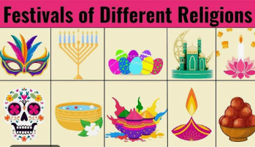
Thematic- What are the deeper meanings of festivals?
Year 3: Foundational Skills
- Identifying Festivals: I can identify the central beliefs at the heart of at least two religious festivals, such as Holy Week (Christianity) or Diwali (Hinduism).
- Stories & Beliefs: I can make simple links between the stories recalled at these festivals and how believers celebrate them.
- Home & Community: I can describe the different ways believers mark celebrations in their homes and within their wider religious communities.
- Reflecting on Celebrations: I can raise simple questions about what makes an event worth celebrating and remembering in my own life and in religious communities.
Golden RE Threads
- Belonging and community – How does learning in this theme help followers to feel belonging and a sense of community?
- Connection to our Christian Values – Which of our Federation Christian Values does learning in this theme show?
- Treating others with respect and understanding – What lessons can be learnt from learning in this theme about treating others with respect?

Summer
Year 3.4
Thematic- What are the deeper meanings of festivals?
Year 4: Complex and Comparative Skills
- Four-Religion Synthesis: I can identify and analyse the central beliefs at the heart of festivals across four major religions: Holy Week (Christianity), Diwali (Hinduism), Ramadan/Eid (Islam), and Yom Kippur (Judaism).
- Scriptural Connections: I can make clear links between sacred scriptures and stories and the specific ways these festivals are celebrated today.
- Comparative Festival Analysis: I can compare and contrast at least two different religious festivals, analysing how they are celebrated differently at home versus in the wider community.
- Values & Respect: I can evaluate how shared festival traditions help religious communities build a sense of belonging and how understanding these celebrations helps us treat others with respect and understanding.
Golden RE Threads
- Belonging and community – How does learning in this theme help followers to feel belonging and a sense of community?
- Connection to our Christian Values – Which of our Federation Christian Values does learning in this theme show?
- Treating others with respect and understanding – What lessons can be learnt from learning in this theme about treating others with respect?

