Autumn 1 
Year 3.4
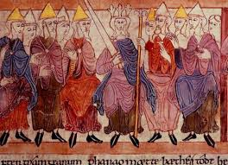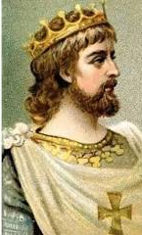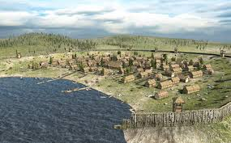
Invasion (Anglo Saxons and Vikings)
Year 3: Foundational Skills (Invasion)
- Chronology: I can place the Anglo Saxon and Viking civilizations on a timeline.
- Invasion Reasons: I can tell you about when and why Britain was invaded by the Anglo Saxons and Vikings in the distant past.
- Finding Evidence: I can describe what Sutton Hoo is and identify the types of objects that were found there.
- Site Exploration: I can understand and describe what happened during the Viking invasion of Lindisfarne based on a historical site visit.
- Daily Life: I can identify simple similarities and differences in the everyday lives of Anglo Saxons and Vikings.
- Basic Legacy: I can describe the legacy left by these civilizations, such as law and language from the Anglo Saxons and trade from the Vikings

Golden Historical Threads
- What evidence tells us about this period of time?
- What was significant about this period of time and person?
- How has this time or person influenced our lives today?

Autumn 1
Year 3.4
Invasion (Anglo Saxons and Vikings)
Year 4: Complex and Comparative Skills (Invasion)
- Chronology: I can place the Anglo Saxon and Viking civilizations on a timeline and compare this to other civilizations I have studied.
- Strategic Analysis: I can evaluate the specific reasons why Britain was invaded and explain how these invasions changed the country over time.
- Evaluating Evidence: I can explain what the evidence tells us about the Anglo Saxon period by analyzing the significance of the finds at Sutton Hoo.
- Significant Events: I can explain the significance of the Viking invasion of Lindisfarne and how this specific event influenced British history.
- Comparative Detail: I can provide a detailed comparison between the daily lives of Anglo Saxons and Vikings, looking at their different approaches to manufacturing and social structure.
- Complex Legacy: I can explain how significant people like King Athelstan and the creation of a unified English Kingdom have influenced our lives today
Golden Historical Threads
- What evidence tells us about this period of time?
- What was significant about this period of time and person?
- How has this time or person influenced our lives today?

