Autumn 1 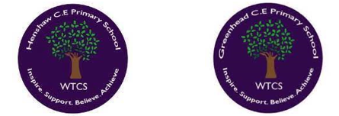
Year 3.4
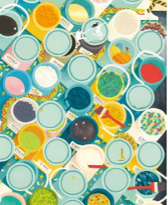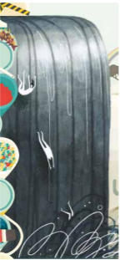
Creation and Fall: What do Christians learn from the Creation story?
Year 3: Foundational Skills
- The Big Story: I can place the concepts of God and Creation on a timeline of the Bible’s ‘Big Story’.
- Genesis Links: I can make simple links between the teachings of Genesis 1 and what Christians believe about God and Creation.
- Caring for Earth: I can describe what Christians do because they believe God is the Creator (such as caring for the earth in specific ways).
- Asking Questions: I can think of simple questions about what might be important in the creation story for Christians living today.
- Discussions: I can share simple answers, after class discussions, about what might be important in the creation story.
Golden RE Threads
- Belonging and community – How does learning in this theme help followers to feel belonging and a sense of community?
- Connection to our Christian Values – Which of our Federation Christian Values does learning in this theme show?
- Treating others with respect and understanding – What lessons can be learnt from learning in this theme about treating others with respect?
Autumn 1
Year 3.4
Creation and Fall: What do Christians learn from the Creation story?
Year 4: Complex and Comparative Skills
- The Big Story: I can explain how the concepts of God and Creation connect to other key chapters on the Bible’s ‘Big Story’ timeline.
- Genesis Links: I can explain the detailed theological links between Genesis 1 teachings and the Christian responsibility to actively care for the world.
- Caring for Earth: I can analyse and provide specific examples of how Christians put their faith into practice by protecting and preserving the environment.
- Deeper Inquiry: I can formulate and evaluate insightful questions and answers regarding why the creation story remains highly significant for Christians today.
Golden RE Threads
- Belonging and community – How does learning in this theme help followers to feel belonging and a sense of community?
- Connection to our Christian Values – Which of our Federation Christian Values does learning in this theme show?
- Treating others with respect and understanding – What lessons can be learnt from learning in this theme about treating others with respect with respect?

Autumn 2
Year 3.4

Thematic – How and why do people try to make the world a better place?
Year 3: Foundational Skills
- The Problem of Evil: I can identify some basic beliefs about why the world is not always a good place.
- Guides for Living: I can explore teachings that act as a guide for living in two different religions, such as Sikh Selfless Service and the two commandments of Jesus.
- Inspirational Ideas: I can explore ideas that inspire people to make the world better, such as the Jewish concept of Tikkun Olam and the charity World Jewish Relief.
- Inspirational Figures: I can research and retell key facts about the lives of inspirational Christians like Martin Luther King Jr. and Mother Teresa.
- Humanism: I can identify at least two Humanist ideas used to guide their way of living, such as the Golden Rule.
Golden RE Threads
- Belonging and community – How does learning in this theme help followers to feel belonging and a sense of community?
- Connection to our Christian Values – Which of our Federation Christian Values does learning in this theme show?
- Treating others with respect and understanding – What lessons can be learnt from learning in this theme about treating others with respect?

Autumn 2
Year 3.4
Thematic – How and why do people try to make the world a better place?
Year 4: Complex and Comparative Skills
- The Problem of Evil: I can explain and compare religious and non-religious beliefs regarding why the world is not always a good place.
- Guides for Living: I can compare how specific teachings (the two commandments of Jesus & Sikh Selfless Service) guide the daily lives of believers.
- Inspirational Ideas: I can explain how religious concepts like Tikkun Olam directly influence the work of humanitarian organisations like World Jewish Relief.
- Inspirational Figures: I can evaluate how the faith and actions of figures like Martin Luther King Jr. and Mother Teresa have actively worked to make the world a better place.
- Humanism: I can compare and contrast the moral guides of Humanism (including the Golden Rule and the life of Annie Besant) with religious ways of living.
Golden RE Threads
- Belonging and community – How does learning in this theme help followers to feel belonging and a sense of community?
- Connection to our Christian Values – Which of our Federation Christian Values does learning in this theme show?
- Treating others with respect and understanding – What lessons can be learnt from learning in this theme about treating others with respect?

Spring 1
Year 3.4

Gospel: What kind of world did Jesus want?
Year 3: Foundational Skills
- Defining Gospel: I can identify that a Gospel is a book that tells the story of the life and teachings of Jesus.
- Discipleship: I can make simple links between the calling of the first disciples and how Christians try to follow Jesus today.
- Action Examples: I can give at least two simple examples of how Christians try to make the kind of world Jesus wanted, such as supporting the Hexham Food Bank or celebrating Advent.
- Jesus and the Leper: I can recite the story of Jesus and the leper.
- Applying Teachings: I can suggest a simple meaning behind Jesus’ actions towards the leper.
Golden RE Threads
- Belonging and community – How does learning in this theme help followers to feel belonging and a sense of community?
- Connection to our Christian Values – Which of our Federation Christian Values does learning in this theme show?
- Treating others with respect and understanding – What lessons can be learnt from learning in this theme about treating others with respect?

Spring 1
Year 3.4
Gospel: What kind of world did Jesus want?
Year 4: Complex and Comparative Skills
- Defining Gospel: I can make clear links between the wider Bible and the Gospels, explaining how they "spread the good news".
- Discipleship: I can explain exactly how the calling of the first disciples translates into modern Christian duties, such as loving your neighbour and putting others first.
- Action Examples: I can evaluate how local and seasonal actions, like the Hexham Food Bank and church Advent celebrations, put Jesus' teachings into action.
- Jesus and the Leper: I can analyse the story of Jesus and the leper to explain its deeper social and religious significance.
- Applying Teachings: I can explain how Jesus' compassionate treatment of the leper serves as an model for modern Christians to love and help everyone.
Golden RE Threads
- Belonging and community – How does learning in this theme help followers to feel belonging and a sense of community?
- Connection to our Christian Values – Which of our Federation Christian Values does learning in this theme show?
- Treating others with respect and understanding – What lessons can be learnt from learning in this theme about treating others with respect?

Spring 2
Year 3.4

Salvation - Why do Christians call the day Jesus died ‘Good Friday’?
Year 3: Foundational Skills
- The Big Story: I can recognize that Salvation is a key chapter in the ‘Big Story’ of the Bible.
- Holy Week Stories: I can retell three specific Bible stories from Holy Week and Easter: the cleansing of the temple, the Last Supper, and Jesus’ trial.
- The Connection: I can identify that Christians believe Jesus acts as a bridge to connect God and humans.
- Following Jesus: I can give simple examples of how Christians follow Jesus' teachings, such as forgiving others and helping the homeless.

Golden RE Threads
- Belonging and community – How does learning in this theme help followers to feel belonging and a sense of community?
- Connection to our Christian Values – Which of our Federation Christian Values does learning in this theme show?
- Treating others with respect and understanding – What lessons can be learnt from learning in this theme about treating others with respect?
Spring 2
Year 3.4
Salvation - Why do Christians call the day Jesus died ‘Good Friday’?
Year 4: Complex and Comparative Skills
- The Big Story: I can explain the theological role of Salvation within the overall story of the Bible.
- Holy Week Stories: I can compare the events of the cleansing of the temple, the Last Supper, Jesus' trial, explaining significance in the Easter narrative.
- The Connection: I can explain the Christian belief that humanity's connection to God was broken and describe how Jesus "built a bridge" to reconnect them.
- Following Jesus: I can explain how practical actions, like actively practicing forgiveness and supporting those without a home, are direct outcomes of Christian beliefs about Salvation.
Golden RE Threads
- Belonging and community – How does learning in this theme help followers to feel belonging and a sense of community?
- Connection to our Christian Values – Which of our Federation Christian Values does learning in this theme show?
- Treating others with respect and understanding – What lessons can be learnt from learning in this theme about treating others with respect?
Summer 1
Year 3.4
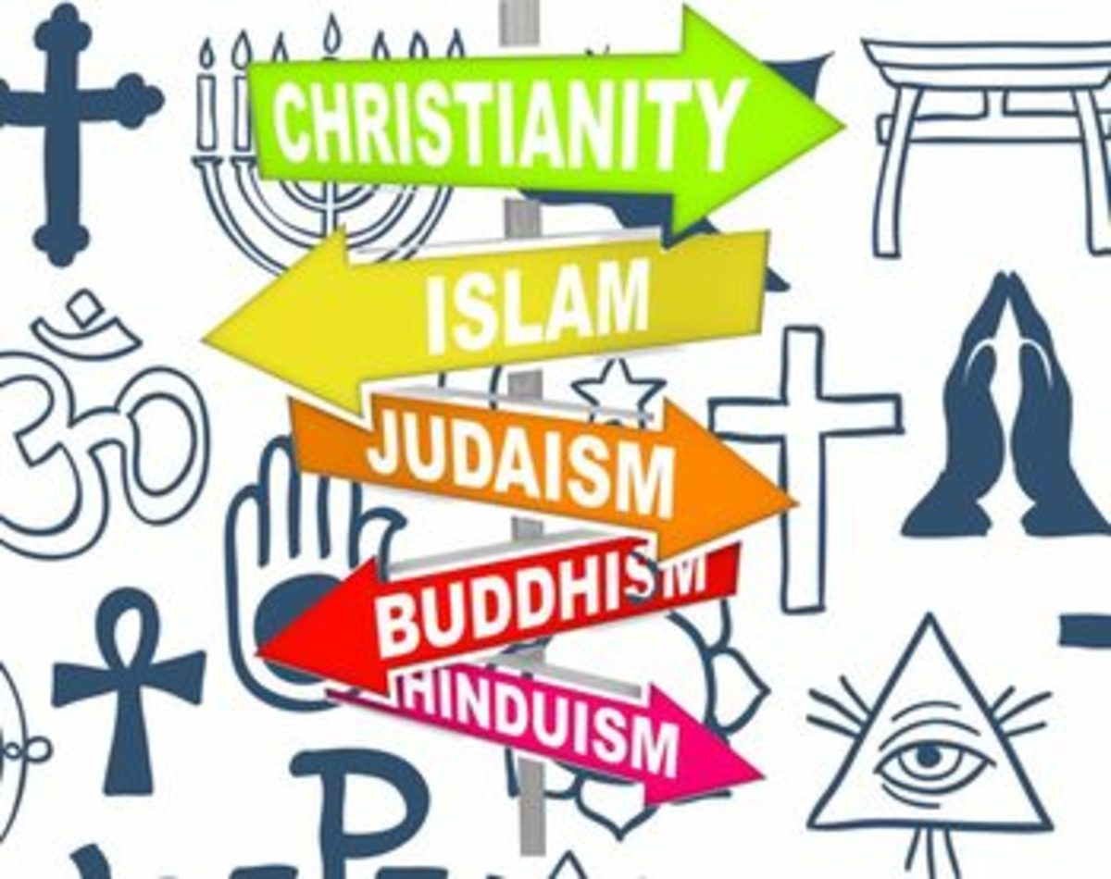
Hinduism - What does it mean to be a Hindu in Britain today?
Year 3: Foundational Skills
- Beliefs about God: I can identify two Hindu deities and describe basic beliefs about God, such as Brahman and the Trimurti.
- Aims of Life: I can identify what Karma is and make simple links between this belief and the aims of a Hindu life.
- Family Faith: I can explain how Hindus show their faith within their families through home puja.
- Community Faith: I can identify ways British Hindus practice their faith in their communities today, such as celebrating Diwali.
- The Divine Spark: I can explain the Hindu idea that everyone has a ‘spark’ of God inside them.
Golden RE Threads
- Belonging and community – How does learning in this theme help followers to feel belonging and a sense of community?
- Connection to our Christian Values – Which of our Federation Christian Values does learning in this theme show?
- Treating others with respect and understanding – What lessons can be learnt from learning in this theme about treating others with respect?

Summer 1
Year 3.4
Hinduism - What does it mean to be a Hindu in Britain today?
Year 4: Complex and Comparative Skills
- Beliefs about God: I can explain how the different deities of the Trimurti represent distinct aspects of the ultimate reality, Brahman.
- Aims of Life: I can explain in detail how the law of Karma governs a Hindu’s actions and shapes their lifelong spiritual goals.
- Family Faith: I can explain the symbolic meaning of different rituals performed during home puja and how they reinforce family beliefs.
- Community Faith: I can explain the role of communal worship (such as arti and bhajans at the mandir) and festivals like Diwali in helping British Hindus build a sense of community belonging.
- The Divine Spark: I can analyze how the belief in a divine ‘spark’ inside every person influences Hindu practices of treating others with respect and understanding.
Golden RE Threads
- Belonging and community – How does learning in this theme help followers to feel belonging and a sense of community?
- Connection to our Christian Values – Which of our Federation Christian Values does learning in this theme show?
- Treating others with respect and understanding – What lessons can be learnt from learning in this theme about treating others with respect?

Summer 2
Year 3.4

Thematic - How and why do people mark the significant events of life?
Year 3: Foundational Skills
- Promises & Commitments: I can identify beliefs about love, commitment, and promises in two different religious traditions, such as a Christian Baptism and a Bar Mitzvah.
- Ceremonies: I can describe what happens during Christian commitment ceremonies like baptism and marriage.
- Beliefs and Celebrations: I can make simple links between beliefs about love/commitment and how families celebrate unions in Judaism and Christianity.
- Faith Differences: I can identify simple differences in how these ceremonies of commitment are marked across different faiths.
Golden RE Threads
- Belonging and community – How does learning in this theme help followers to feel belonging and a sense of community?
- Connection to our Christian Values – Which of our Federation Christian Values does learning in this theme show?
- Treating others with respect and understanding – What lessons can be learnt from learning in this theme about treating others with respect?

Summer 2
Year 3.4
Thematic - How and why do people mark the significant events of life?
Year 4: Complex and Comparative Skills
- Promises & Commitments: I can compare how promises and milestones of commitment are shown through a Christian Baptism and a Jewish Bar Mitzvah.
- Ceremonies: I can explain the deeper symbolic meanings behind the specific rituals, words, and actions used in Christian baptism and marriage.
- Beliefs and Celebrations: I can analyse how core religious beliefs about love, covenant, and promise are directly expressed through marriage unions in both Judaism and Christianity.
- Faith Differences: I can compare and contrast the celebrations and theological meanings of commitment rituals across different religious communities.
Golden RE Threads
- Belonging and community – How does learning in this theme help followers to feel belonging and a sense of community?
- Connection to our Christian Values – Which of our Federation Christian Values does learning in this theme show?
- Treating others with respect and understanding – What lessons can be learnt from learning in this theme about treating others with respect?

