Autumn 1 
Year 5.6
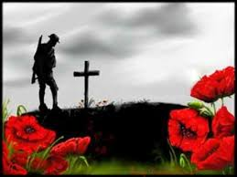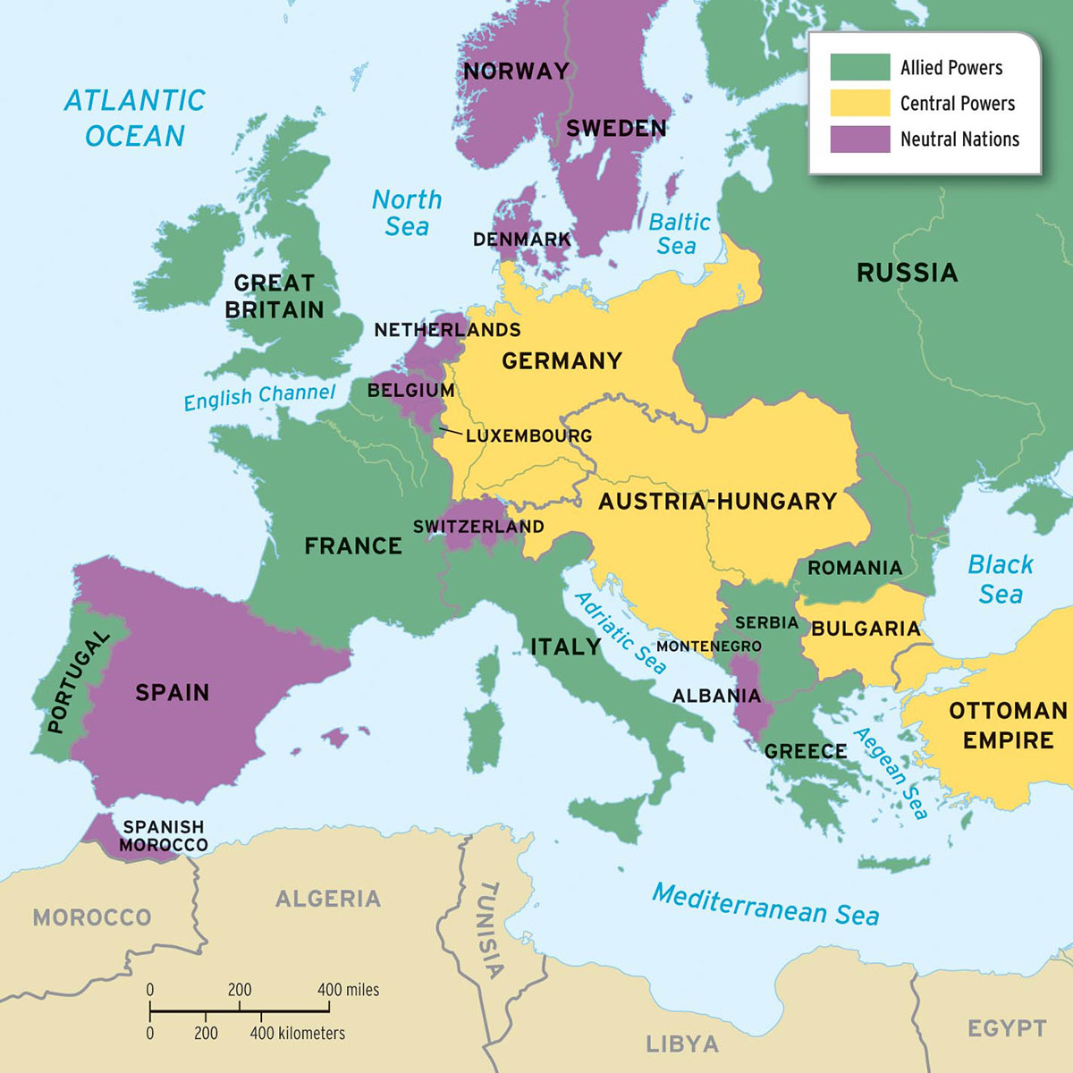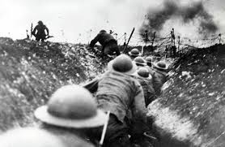
Britain at War (WW1)
Year 5: Foundational Skills (Britain at War)
- Chronology: I can place World War 1 and World War 2 on a timeline and compare them to other major events from the past 100 years.
- Causation: I can identify the main causes and important events that led to the start of World War One.
- Social Impact: I can describe what life was like for ordinary people in Britain during the First World War and how their everyday lives were affected.
- Evidence & Fieldwork: I can use real-life re-enactments, such as at Beamish, to help me understand the experiences of people during the war.
- Significance: I can understand how the end of the First World War helped lead to the start of World War Two.
- Legacy: I can describe significant people like Archduke Franz Ferdinand and Winston Churchill and talk about how they affected the world.

Golden Historical Threads
- What evidence tells us about this period of time?
- What was significant about this period of time and person?
- How has this time or person influenced our lives today?

Autumn 1
Year 5.6
Britain at War (WW1)
Year 6: Complex and Comparative Skills (Britain at War)
- Chronology: I can accurately place World War 1 and World War 2 on a timeline and analyse how these conflicts effected Britain’s development since then.
- Causation: I can evaluate the complex political and social reasons why World War One started and explain the significance of key turning points.
- Social Impact: I can analyse the lasting impact of the First World War on British society, comparing the differing experiences of various social groups.
- Evidence & Fieldwork: I can evaluate what different pieces of evidence, Beamish re-enactment, tell us about the significance of this period of time.
- Significance: I can explain the specific ways the conclusion of the First World War influenced future global events and the eventual start of World War Two.
- Legacy: I can explain exactly how significant figures like Winston Churchill have influenced our lives today and evaluate the lasting legacy of the World Wars on modern Britain.
Golden Historical Threads
- What evidence tells us about this period of time?
- What was significant about this period of time and person?
- How has this time or person influenced our lives today?

