Autumn 1 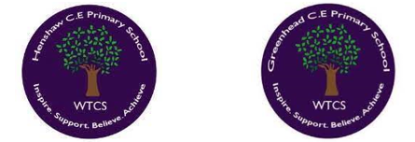
Year 1.2

God – What do Christians believe God to be like?
Year 1: Foundational Skills
- Bible Stories: I can identify the parable of The Lost Son as a story from the Bible.
- Story Meaning: I can listen to the story of The Lost Son and talk about what it means.
- Personal Reflection: I can think, talk, and ask simple questions about how the story makes me feel.
- Belonging: I can share basic ideas about what it means to belong to a community, like my school or family.

Golden RE Threads
- Belonging and community – How does learning in this theme help followers to feel belonging and a sense of community?
- Connection to our Christian Values – Which of our Federation Christian Values does learning in this theme show?
- Treating others with respect and understanding – What lessons can be learnt from learning in this theme about treating others with respect?

Autumn 1
Year 1.2
God – What do Christians believe God to be like?
Year 2: Developing Skills
- Core Beliefs: I can explain what the parable of The Lost Son teaches Christians about what God is like.
- Faith in Action: I can give 3 examples of how Christians use Bible stories, concepts, and texts to guide their daily beliefs and actions.
- Community Links: I can explain how sharing Bible stories helps Christians build a sense of belonging and community.
- Values & Respect: I can explain how the lessons from this theme show our Christian Values and teach us to treat others with respect and understanding.
Golden RE Threads
- Belonging and community – How does learning in this theme help followers to feel belonging and a sense of community?
- Connection to our Christian Values – Which of our Federation Christian Values does learning in this theme show?
- Treating others with respect and understanding – What lessons can be learnt from learning in this theme about treating others with respect?

Autumn 2
Year 1.2
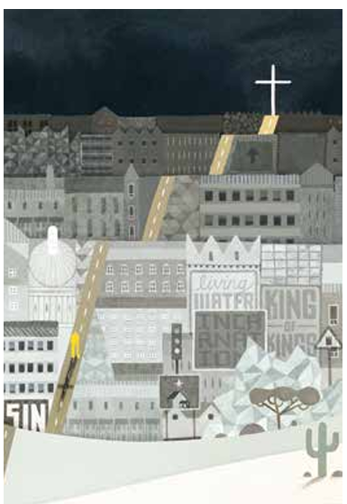
Incarnation: Why does Christmas matter to Christians?
Year 1: Foundational Skills
- Christmas Story: I can retell the story of Jesus’ birth in a simple way.
- Story Lessons: I can ask questions about the Christmas story and identify simple lessons from it, such as being kind and generous.
- Simple Connections: I can recognise that Jesus' birth is linked to a special Christian concept called the Incarnation.
Golden Scientific Threads
- Belonging and community – How does learning in this theme help followers to feel belonging and a sense of community?
- Connection to our Christian Values – Which of our Federation Christian Values does learning in this theme show?
- Treating others with respect and understanding – What lessons can be learnt from learning in this theme about treating others with respect?

Autumn 2
Year 1.2
Incarnation: Why does Christmas matter to Christians?
Year 2: Developing Skills
- Textual Evidence: I can identify at least two different Bible texts about the Christmas story (Matthew 1:18-25 and Matthew 2:1-12).
- Theological Meaning: I can explain clearly what the Incarnation and Jesus’ birth mean to Christians today.
- Living the Values: I can explain how the Christmas message of kindness and generosity connects to our value of treating others with respect and understanding.
- Inquiry: I can ask thoughtful questions to evaluate how the Christmas story teaches us to help others in our community feel like they belong.
Golden Scientific Threads
- Belonging and community – How does learning in this theme help followers to feel belonging and a sense of community?
- Connection to our Christian Values – Which of our Federation Christian Values does learning in this theme show?
- Treating others with respect and understanding – What lessons can be learnt from learning in this theme about treating others with respect?

Spring 1
Year 1.2
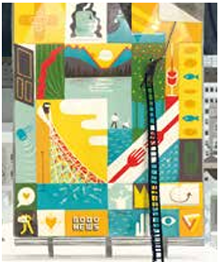
Gospel: What is the good news that Jesus brings?
Year 1: Foundational Skills
- The Big Timeline: I can name the key parts of the Bible's 'big story' timeline: God, Creation, Incarnation, and Gospel.
- Gospel Stories: I can listen to and identify the Bible story of Matthew the tax collector.
- Church Community: I can point out simple ways people show they are part of a church community.

Golden RE Threads
- Belonging and community – How does learning in this theme help followers to feel belonging and a sense of community?
- Connection to our Christian Values – Which of our Federation Christian Values does learning in this theme show?
- Treating others with respect and understanding – What lessons can be learnt from learning in this theme about treating others with respect?

Spring 1
Year 1.2
Gospel: What is the good news that Jesus brings?
Year 2: Developing Skills
- Timeline Mastery: I can outline the chronological order of the Bible's 'big story' timeline and explain how the Gospel fits into it.
- Text Interpretation: I can give clear, simple accounts of what the story of Matthew the tax collector means to Christians.
- Practical Action: I can give at least 2 examples of how Christians put Gospel teachings into practice through charity and confession.
- Thread Integration: I can explain how actions like charity and confession show respect and understanding and help church members feel a sense of belonging and community.
Golden RE Threads
- Belonging and community – How does learning in this theme help followers to feel belonging and a sense of community?
- Connection to our Christian Values – Which of our Federation Christian Values does learning in this theme show?
- Treating others with respect and understanding – What lessons can be learnt from learning in this theme about treating others with respect?

Spring 2
Year 1.2

Islam
Who is Muslim and what do they believe?
Year 1: Foundational Skills
- Beliefs about God: I can identify key Muslim beliefs about God.
- The Shahadah: I can recognize the words of the Shahadah and know that it is a very important statement of faith for Muslims.
- Guiding Stories: I can listen to Muslim stories and identify a simple way they teach people to care for creation.
- Curiosity: I can ask simple questions about what Muslim families celebrate.
Golden RE Threads
- Belonging and community – How does learning in this theme help followers to feel belonging and a sense of community?
- Connection to our Christian Values – Which of our Federation Christian Values does learning in this theme show?
- Treating others with respect and understanding – What lessons can be learnt from learning in this theme about treating others with respect?

Spring 2
Year 1.2
Islam
Who is Muslim and what do they believe?
Year 2: Developing Skills
- Theological Understanding: I can describe the meanings behind Muslim beliefs about God and explain the deep importance of the Shahadah.
- Belief into Action: I can explain how Muslims use traditional stories to guide their actions, caring for creation or fasting during Ramadan.
- Celebration & Community: I can explain what Muslims celebrate, why they do so, and how these celebrations foster a strong sense of belonging and community.
- Interfaith Respect: I can discuss how learning about Muslim practices helps us treat others with respect and understanding.
Golden RE Threads
- Belonging and community – How does learning in this theme help followers to feel belonging and a sense of community?
- Connection to our Christian Values – Which of our Federation Christian Values does learning in this theme show?
- Treating others with respect and understanding – What lessons can be learnt from learning in this theme about treating others with respect?

Summer
Year 1.2

Thematic: Who am I? What does it mean to belong in a faith community?
Year 1: Foundational Skills
- Defining Belonging: I can explain what belonging means and name different groups I belong to, such as my school, family, clubs, or a religion.
- Welcome Ceremonies: I can retell what happens during a traditional welcome ceremony or Baptism (Christian and Muslim).
- Promises of Love: I can identify at least two ways people show they love and belong to each other when they get married (Christian, Muslim, and Jewish).
- Ceremony Comparison: I can point out simple similarities and differences between different life celebrations.

Golden Scientific Threads
- Belonging and community – How does learning in this theme help followers to feel belonging and a sense of community?
- Connection to our Christian Values – Which of our Federation Christian Values does learning in this theme show?
- Treating others with respect and understanding – What lessons can be learnt from learning in this theme about treating others with respect?

Summer
Year 1.2
Thematic: Who am I? What does it mean to belong in a faith community?
Year 2: Developing Skills
- Symbolic Meaning: I can explain exactly what the actions and symbols represent within traditional welcome ceremonies and Baptism in Christian, Muslim, and Jewish traditions.
- Expressing Identity: I can give clear examples of how people express their identity and belonging within both faith and non-faith communities.
- Comparative Marriage Promises: I can compare the promises made in a Christian wedding with those in a Jewish ketubah (wedding contract).
- Secular Comparisons: I can compare religious wedding promises with promises made in non-religious ceremonies.
- Thread Evaluation: I can evaluate how weddings and welcome ceremonies help couples and families feel a deep sense of belonging and community.
Golden Scientific Threads
- Belonging and community – How does learning in this theme help followers to feel belonging and a sense of community?
- Connection to our Christian Values – Which of our Federation Christian Values does learning in this theme show?
- Treating others with respect and understanding – What lessons can be learnt from learning in this theme about treating others with respect?

