Spring 1 
Year 5.6
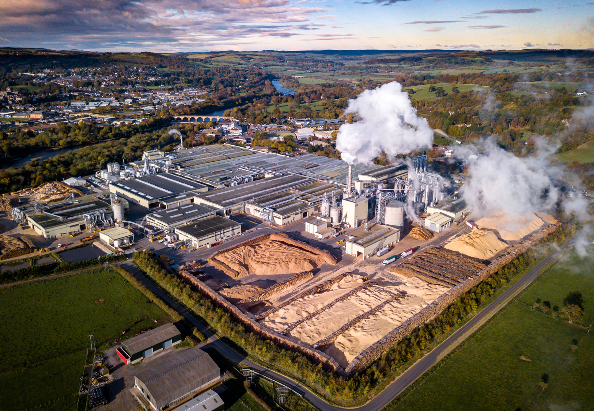
From Forest to Factory
Year 5: Foundational Skills (Forest to Factory)
- Location & Settlement: I can give simple reasons why the company Egger is located in Hexham and identify its impact on our local area.
- Mapping & Tech: I can use an OS map to identify and describe a route to transport timber from Kielder to Egger, including measuring simple distances.
- Employment & Economy: I can explain the difference between primary, secondary, and tertiary employment sectors and provide examples of jobs in each.
- Fieldwork & Data: I can ask relevant geographical questions and complete a questionnaire accurately to gather information.
- Environmental Impact: I can discuss how manufacturing can have a negative impact on the environment and identify what sustainability means.
- Change & Legacy: I can explore how the Forestry Commission changed the landscape of Kielder by creating a forest and promoting tourism.

Golden Geographical Threads
- Where is the location of this learning sequence compared to other places I have studied? What does it look like on a map?
- Why do people make settlements in this place?
- How has this environment changed over time?

Spring 1
Year 5.6
From Forest to Factory
Year 6: Complex and Comparative Skills (Forest to Factory)
- Location & Settlement: I can explain the specific geographical reasons why people make settlements in this region and evaluate how the industrial environment has changed over time.
- Mapping & Tech: I can use map-reading skills to evaluate the best transport routes for industry, using OS symbols and measurements to justify my choices.
- Employment & Economy: I can analyze and explain exactly how employment in Hexham has changed over time and evaluate the reasons for these shifts.
- Fieldwork & Data: I can explain the employment habits of the local community (such as travel distances) and illustrate this data through detailed graphs.
- Environmental Impact: I can evaluate how negative environmental impacts can be mitigated or managed and provide specific examples of how manufacturing can be made more sustainable.
- Change & Legacy: I can explain exactly how the Forestry Commission’s large-scale projects have influenced our lives today and evaluate their lasting legacy
Golden Geographical Threads
- Where is the location of this learning sequence compared to other places I have studied? What does it look like on a map?
- Why do people make settlements in this place?
- How has this environment changed over time?

