Autumn 1 
Year 5.6
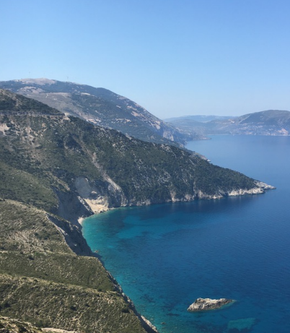
Let’s Explore Greece
Year 5: Foundational Skills (Let’s Explore Greece)
- Location & Mapping: I can map countries within the continent of Europe, pinpoint where Greece is, and use directional vocabulary and atlases.
- Physical & Human Characteristics: I can recognize different human and physical characteristics of Greece and understand what the terms topography and relief mean.
- Comparison & Lifestyle: I can identify simple ways that the area, temperature, and population of Greece compared to the UK affect food and lifestyle.
- Settlement & Movement: I can understand the term ‘pull’ factors and explain what attracts people to move to Greece.
- Evidence & Change: I can practice reading photographs of a place to draw simple conclusions and describe how Kefalonia has changed over time.
- Legacy: I can describe the legacy of the European Union and what it means for the free movement of people across Europe.
Golden Geographical Threads
- Where is the location of this learning sequence compared to other places I have studied? What does it look like on a map?
- Why do people make settlements in this place?
- How has this environment changed over time?

Autumn 1
Year 5.6
Let’s Explore Greece
Year 6: Complex and Comparative Skills (Let’s Explore Greece)
- Location & Mapping: I can evaluate the location of Greece compared to other places I have studied and explain what it looks like on various map types.
- Physical & Human Characteristics: I can explain exactly what topography and relief mean and evaluate how these features shape the unique human and physical identity of Greece.
- Comparison & Lifestyle: I can plot and interpret temperature data to analyse exactly how the climate and population of Greece and the UK create different lifestyles and food sources.
- Settlement & Movement: I can analyse the geographical reasons why people make settlements in Greece, evaluating significance of various "pull" factors.
- Evidence & Change: I can evaluate the positive and negative impacts of environmental change in Kefalonia over time, using photographic evidence.
- Legacy: I can explain the detailed legacy of the European Union and evaluate the impact of free movement on over 400 million EU nationals.
Golden Geographical Threads
- Where is the location of this learning sequence compared to other places I have studied? What does it look like on a map?
- Why do people make settlements in this place?
- How has this environment changed over time?

